Student Guide

Lesson 8.08: Language and Symbols
Name:
Date:
Bellringer: Read the directions below and then answer the related questions.

Lisez les instructions puis répondez à la question.

- What do you think the sentence is saying?

- What helped you to make your guess?

- How could the directions be made easier to understand?

Guideline – Language & Symbols

Language & Symbol

Language & Symbols
Guideline | Examples | Nonexamples
Clarify vocabulary and symbols
Clarify syntax and structure
Promote understanding across languages
Present key concepts through multiple media

Options for Language and Symbols: Checklist
- Provide a definition of the word.
- Share examples of how to use the word in a sentence.
- Make connections to other languages (translations, cognates).
- Use multi-media and non-linguistic supports (pictures, videos, movement, etc.).

Role Play Scenarios
Scenario 1 (“heating”)
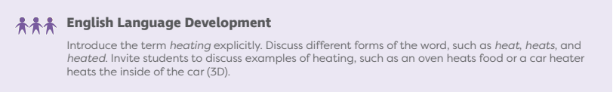
Scenario 2 (“suited”)
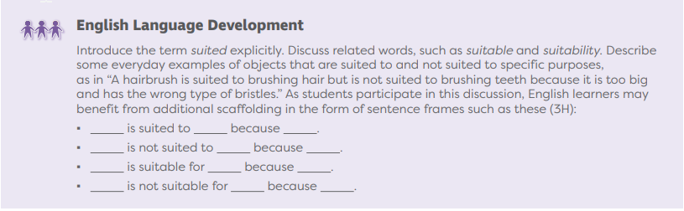
Scenario 3 (“material”)
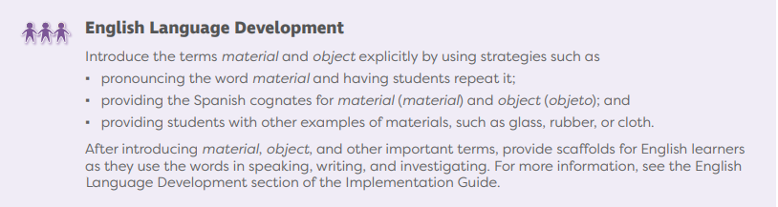

Role Play Feedback
Use the checklist and graphic organizer below to provide feedback to your peers and to take notes on feedback from your peers.
Checklist | Evidence from Role Play | Suggestions for Improvement
Teacher: __________________

- Provide a definition of the word.
- Share examples of how to use the word in a sentence.
- Make connections to other languages (translations, cognates).
- Use multi-media and non-linguistic supports (pictures, videos, movement, etc.).

Teacher: __________________

- Provide a definition of the word.
- Share examples of how to use the word in a sentence.
- Make connections to other languages (translations, cognates).
- Use multi-media and non-linguistic supports (pictures, videos, movement, etc.).

Teacher: __________________

- Provide a definition of the word.
- Share examples of how to use the word in a sentence.
- Make connections to other languages (translations, cognates).
- Use multi-media and non-linguistic supports (pictures, videos, movement, etc.).

