Student Guide – Answer Key

Lesson 8.08: Language and Symbols
Name:
Date:
Bellringer: Read the directions below and then answer the related questions.

Lisez les instructions puis répondez à la question.

- What do you think the sentence is saying?
Answers will vary.

- What helped you to make your guess?
Answers will vary but may include reference to words that looked the same or familiar as their counterparts in other languages.

- How could the directions be made easier to understand?
Answers will vary but may include teaching vocabulary or providing images.

Guideline – Language & Symbols

Language & Symbol | A teacher provides alternative explanations and representations for key language or terms and symbols used in the classroom.

Language & Symbols
Guideline | Examples | Nonexamples
Clarify vocabulary and symbols | - Pre-teach vocabulary and symbols  - Provide definitions, explanations, and illustrations | - Teacher provides students with a list of vocabulary words for lesson and asks students to look up the definitions using a dictionary
Clarify syntax and structure | - Explain how words and phrases are arranged to form a proper sentence  - Highlight transition words in a text  - Use a concept map to show connections between ideas | - Students record definitions from the board and practice solving 1-step equations using a learned procedure.
Promote understanding across languages | - Make vocabulary and key information available in a student’s first language  - Make connections in both English and a student’s heritage language | - The teacher introduces a new word but doesn’t explain how it relates to a student’s heritage language  - Key information is only shared in English
Present key concepts through multiple media | - Provide images, audio, or videos to help students access the content  - Provide charts or posters around the room that decode vocabulary and symbols | - Information is only presented through a PPT.  - Students read an information passage and discuss the main idea as a class

Options for Language and Symbols: Checklist
- Provide a definition of the word.
- Share examples of how to use the word in a sentence.
- Make connections to other languages (translations, cognates).
- Use multi-media and non-linguistic supports (pictures, videos, movement, etc.).

Role Play Scenarios
Scenario 1 (“heating”)
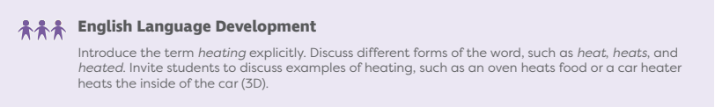
Scenario 2 (“suited”)
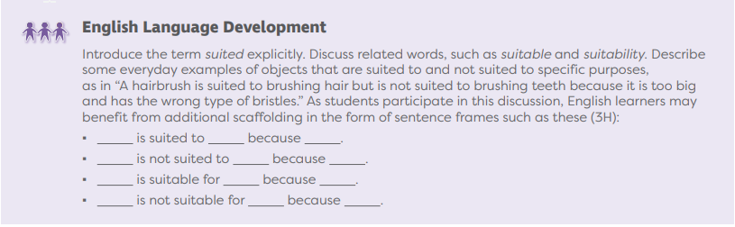
Scenario 3 (“material”)
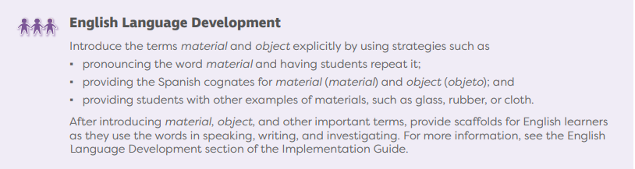

Role Play Feedback
Use the checklist and graphic organizer below to provide feedback to your peers and to take notes on feedback from your peers.
Checklist | Evidence from Role Play | Suggestions for Improvement
Teacher: __________________

- Provide a definition of the word.
- Share examples of how to use the word in a sentence.
- Make connections to other languages (translations, cognates).
- Use multi-media and non-linguistic supports (pictures, videos, movement, etc.).

Teacher: __________________

- Provide a definition of the word.
- Share examples of how to use the word in a sentence.
- Make connections to other languages (translations, cognates).
- Use multi-media and non-linguistic supports (pictures, videos, movement, etc.).

Teacher: __________________

- Provide a definition of the word.
- Share examples of how to use the word in a sentence.
- Make connections to other languages (translations, cognates).
- Use multi-media and non-linguistic supports (pictures, videos, movement, etc.).

