Student Guide

Lesson 8.09: Comprehension
Name:
Date:
Bellringer: A fourth-grade math teacher is introducing the concept of adding fractions with a common denominator. He wants to use multiple means of representation in his lesson to ensure all students can access the content.

What are some ways the teacher could incorporate multiple means of representation into the lesson?

Guideline – Comprehension
Multiple Means of Representation | Presenting information and content in different ways to support learning for all students.
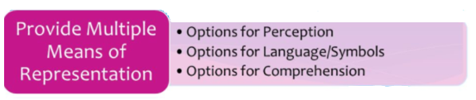

Comprehension

Video Viewing Guide:
- What are the two paths to learning according to the video?
- What is the difference between the two paths to learning?
- Why is one path to learning more effective than the other?

Comprehension
Guideline | Examples | Nonexamples
Activate background knowledge
Highlight patterns, critical features, big ideas, and relationships
Guide information processing and visualization
Maximize transfer and generalization

- Why is it important to provide options for comprehension?

Examples of strategies to support comprehension:
Strategy Image | Alignment to Comprehension Guideline | When to Use
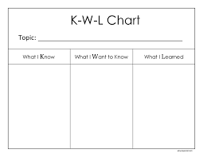
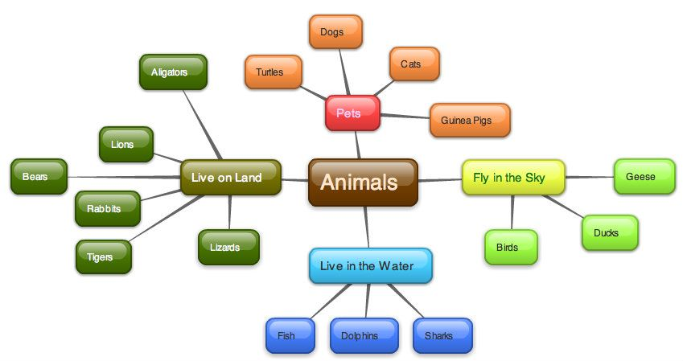
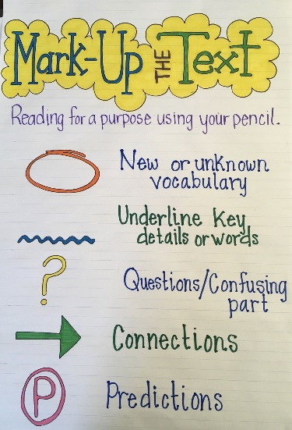
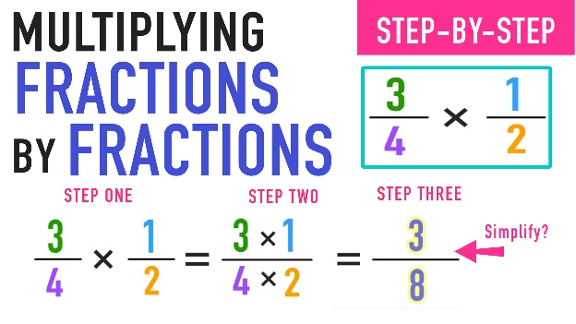
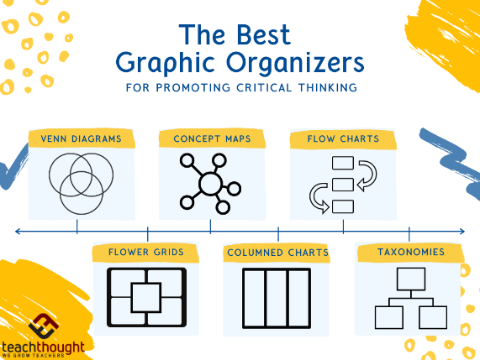

Practice – Activity Analysis
In this lesson, students are making observations of a desert to construct their own model. Review each of the activities below. As you read, underline strategies that provide options for comprehension and place a star (*) in places where you see additional opportunities for comprehension strategies. Then, complete the chart below the activity. We will do the first one together.
Activity One
Ask students to recall the features of the desert environment that they observed during their video tour of the Wonderland of Rocks. Explain to students that they will now explore another part of the Mojave Desert. Begin playing the Mara flyover video and explain to students that much of the Mojave Desert looks like the Wonderland of Rocks. Pause the video when the dense, green vegetation appears and wonder out loud why the environment looks different than other parts of the desert.* Resume the video for several more seconds and then pause near the end to display an image for students to refer to during the discussion. Ask students to respond to the following question: What is the relationship between this desert environment and the rest of the Mojave desert?*

Guideline |  | Additional Suggestions
Activate background knowledge
Highlight patterns, critical features, big ideas, and relationships
Guide information processing and visualization
Maximize transfer and generalization

Activity 2
The teacher will ask students what they remember about using their science logbooks and then review the process for recording notes in their logbooks. Then, students will read a description of each of the areas of the desert – Wonderland of Rocks and Mara. They will use the descriptions to take notes in an observation chart in their science logbooks and then use their logbooks to create a model of one of the two environments. *After creating models, they will work with a partner to discuss and add to the Venn diagram from Activity 1 to compare the environmental features depicted in their models. Finally, they will identify environmental factors in each environment that allow for plant growth.*
Guideline | Evidence from Lesson Plan | Additional Suggestions
Activate background knowledge
Highlight patterns, critical features, big ideas, and relationships
Guide information processing and visualization
Maximize transfer and generalization

