Student Guide – Answer Key

Lesson 8.09: Comprehension
Name:
Date:
Bellringer: A fourth-grade math teacher is introducing the concept of adding fractions with a common denominator. He wants to use multiple means of representation in his lesson to ensure all students can access the content.

What are some ways the teacher could incorporate multiple means of representation into the lesson?
The teacher could activate background knowledge by having students think about what they know about fractions with common denominators. The teacher could pre-teach vocabulary and symbols students will come across and reference “common denominator” in a student’s heritage language. The teacher could show a video or music video to help students review the concept of fractions with a common denominator. The teacher could use visuals and tactile objectives to model how to add fractions with a common denominator. The teacher could provide a graphic to help students remember the steps for adding fractions with a common denominator and provide a graphic organizer for student to record the steps.

Guideline – Comprehension
Multiple Means of Representation | Presenting information and content in different ways to support learning for all students.
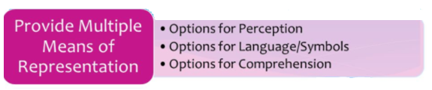

Comprehension | The teacher provides scaffolds and activities that cognitively engage students to help develop their ability to construct meaning and generate new understandings.

Video Viewing Guide:
- What are the two paths to learning according to the video?
Rehearsing and relating
- What is the difference between the two paths to learning?
Rehearsing is about repeating information over and over again until the brain decides it is important to remember. Relating is about making connections between prior learning and new learning.
- Why is one path to learning more effective than the other?
Relating helps learners sort and organize information into schema.

Comprehension
Guideline | Examples | Nonexamples
Activate background knowledge | - Use KWL charts or concepts maps  - Make cross-curricular connections | - Jumping into new content without connecting to prior learning
Highlight patterns, critical features, big ideas, and relationships | - Provide tips and tools for organizing information such as color coding, graphic organizers, and annotations  - Use multiple examples and nonexamples | - Students take notes on what they found interesting in a text  - The teacher does not provide explicit cues to help students attend to the most important content
Guide information processing and visualization | - Give explicit prompts for each step in a process  - Chunk information into smaller elements | - A teacher presents a problem and then asks students to solve  - A teacher walks students through solving a problem without pausing at after each step.
Maximize transfer and generalization | - Provide temples, graphic organizers, concept maps to support notetaking  - Provide opportunities to apply learning to new situations, such as scenario-based problems | - Students take notes on a blank sheet of notebook paper  - Students complete similar problems to support memorization of the steps

- Why is it important to provide options for comprehension?
Options for comprehension connect the “what” with the “why.”

Examples of strategies to support comprehension:
Strategy Image | Alignment to Comprehension Guideline | When to Use
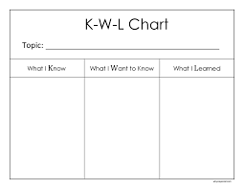 | KWL Chart – used to activate prior knowledge | Before beginning a new topic, at the beginning of a lesson to review the previous day’s lesson, at a transition from one topic to another related topic
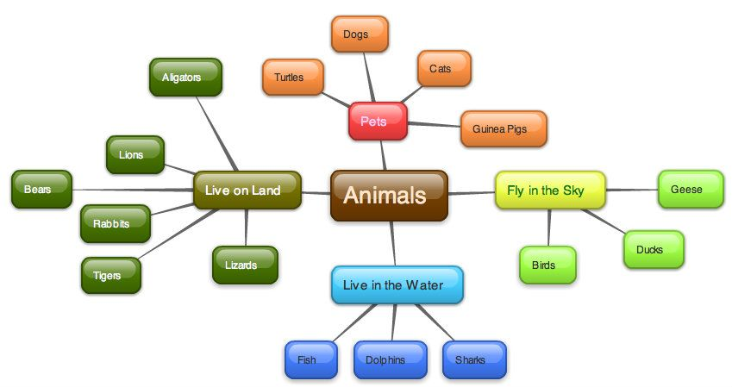 | Concept Map – to make connections between ideas and concepts | Before beginning a new lesson to see what students already know, during or at the end of a lesson to provide opportunities for students to process readings, discussions, activities, etc.
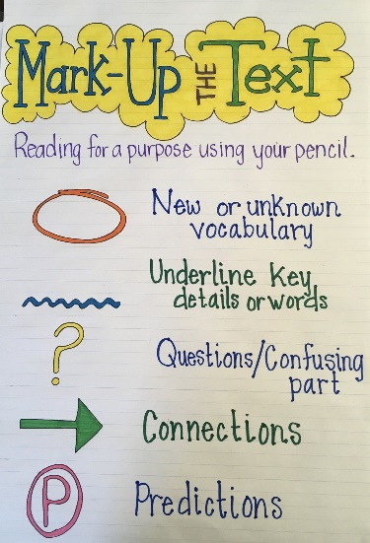 | Annotating Texts – helps students identify most important parts and consider their own prior knowledge | When students are reading texts to learn new content or to apply skills, when students are reading and providing peer feedback on texts written by their peers
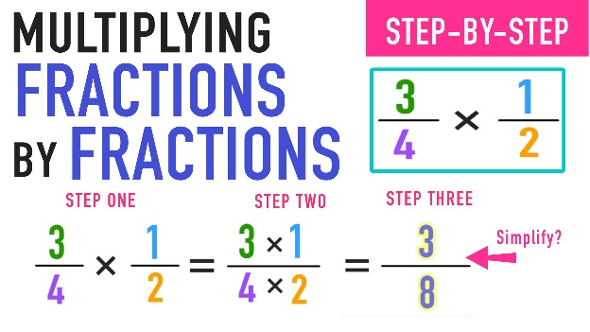 | Step by Step Directions – Breaks information into smaller pieces, provides process for visualization | When a new skill includes multiple steps, when an activity includes multiple steps
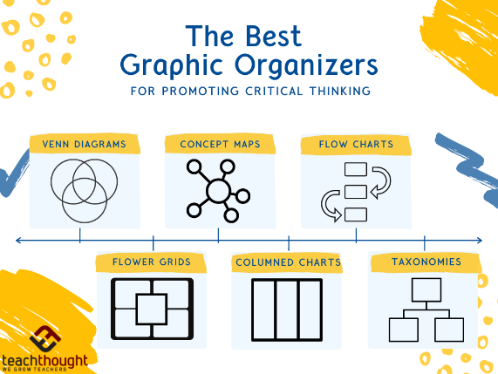 | Graphic Organizers – Helps highlight key features and relationships | During discussions, videos, readings to provide opportunities for students to record new information in a logical way

Practice – Activity Analysis
In this lesson, students are making observations of a desert to construct their own model. Review each of the activities below. As you read, underline strategies that provide options for comprehension and place a star (*) in places where you see additional opportunities for comprehension strategies. Then, complete the chart below the activity. We will do the first one together.
Activity One
Ask students to recall the features of the desert environment that they observed during their video tour of the Wonderland of Rocks. Explain to students that they will now explore another part of the Mojave Desert. Begin playing the Mara flyover video and explain to students that much of the Mojave Desert looks like the Wonderland of Rocks. Pause the video when the dense, green vegetation appears and wonder out loud why the environment looks different than other parts of the desert.* Resume the video for several more seconds and then pause near the end to display an image for students to refer to during the discussion. Ask students to respond to the following question: What is the relationship between this desert environment and the rest of the Mojave desert?*

Guideline |  | Additional Suggestions
Activate background knowledge | - The teacher asks students to recall the features of the desert environment that they learned in a previous lesson
Highlight patterns, critical features, big ideas, and relationships |  | - Provide a Venn diagram students can use to organize their thoughts about the similarities and differences
Guide information processing and visualization | - Pausing the video and wondering aloud about why the vegetation is different guides student thinking and helps them visualize the differences | - Break the discussion question into smaller parts and provide a student guide to guide students through the larger question one step at a time:  - What do you notice about this environment?  - How is this environment different than the rest of the desert?  - How is this environment similar to the rest of the desert?
Maximize transfer and generalization | - The teacher asks students to recall the features of the desert environment that they learned in a previous lesson (incorporate multiple opportunities for review) | - Provide a Venn diagram students can use to organize their thoughts about the similarities and differences

Activity 2
The teacher will ask students what they remember about using their science logbooks and then review the process for recording notes in their logbooks. Then, students will read a description of each of the areas of the desert – Wonderland of Rocks and Mara. They will use the descriptions to take notes in an observation chart in their science logbooks and then use their logbooks to create a model of one of the two environments. *After creating models, they will work with a partner to discuss and add to the Venn diagram from Activity 1 to compare the environmental features depicted in their models. Finally, they will identify environmental factors in each environment that allow for plant growth.*
Guideline | Evidence from Lesson Plan | Additional Suggestions
Activate background knowledge | - The teacher begins by activating prior knowledge about logbooks
Highlight patterns, critical features, big ideas, and relationships | - Includes a Venn diagram for comparing the two desert areas
Guide information processing and visualization |  | - Provide a visual step-by-step process for the activity (1. Read and record notes in your logbook, 2. Create a model, 3. Share and compare models with a partner)  - Provide a specific graphic organizer for the comparison discussion
Maximize transfer and generalization | - Includes a Venn diagram for comparing the two desert areas | - Provide a graphic organizer to support the discussion of environmental factors that allow for plant growth

