Exit Ticket

Lesson 8.10: Putting it All Together | Multiple Means of Representation
Name:
Date:
Examine the lesson plan provided below to evaluate its use of multiple means of representation. Complete the graphic organizer to record evidence and make suggestions for ways the teacher can include multiple means of representation through options for perception, language and symbols, and comprehension.

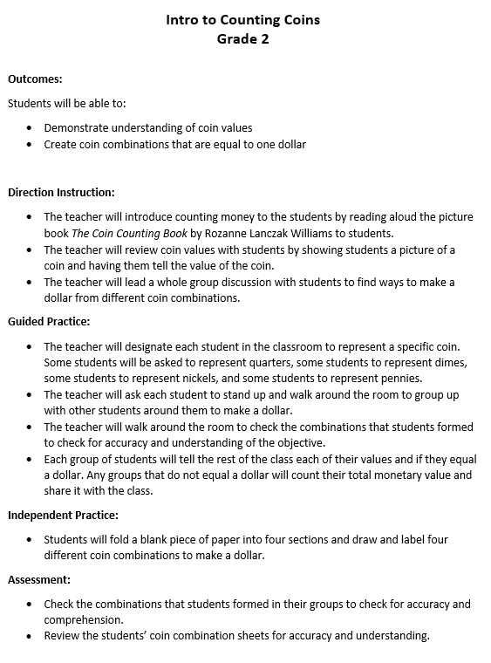
Activity | Evidence of Perception and Language & Symbols | Suggestions for improvement
Read Aloud – The Coin Counting Book
Teacher shows picture of coins and has student tell value of coin
Teacher discusses ways to make a dollar from different coin combinations
Students represent a specific coin and must group with other students to make a dollar.
Students draw and label four different coin combinations to make a dollar
Activate background knowledge
Highlight patterns, critical features, big ideas, and relationships
Guide information processing and visualization
Maximize transfer and generalization

