Exit Ticket - Answer Key

Lesson 8.10: Putting it All Together | Multiple Means of Representation
Name:
Date:
Examine the lesson plan provided below to evaluate its use of multiple means of representation. Complete the graphic organizer to record evidence and make suggestions for ways the teacher can include multiple means of representation through options for perception, language and symbols, and comprehension.

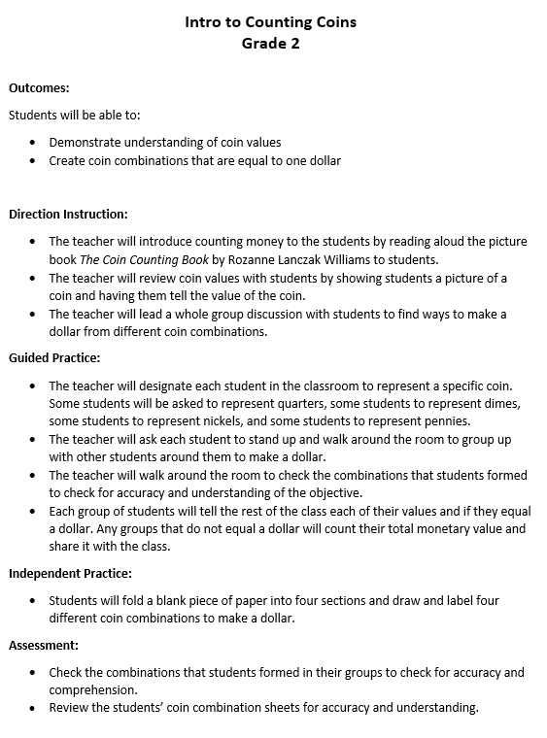
Activity | Evidence of Perception and Language & Symbols | Suggestions for improvement
Read Aloud – The Coin Counting Book | Students can visually see the book and her the words read verbally | - Provide eBook that allows students to customize the size of texts and graphics, colors, and layout, change the rate of speech or sound, and vary the pace and sequence of information
Teacher shows picture of coins and has student tell value of coin | Offer alternatives for auditory information | - Clarify vocabulary (values) and symbols while introducing the coins.  - Make connections in both English and a student’s heritage language  - Create a class poster with the coin, name of each coin, and value.  - Make connections to currency used in other countries  - Students could watch a video on coins and their values
Teacher discusses ways to make a dollar from different coin combinations |  | - Use the coin images presented earlier to visually create coin combinations to make a dollar while describing the process.  - Use digital tool to manipulate the coins  - Provide students with coins so they can make the different combinations with the teacher
Students represent a specific coin and must group with other students to make a dollar. |  | - Provide each student with an image of their coin to wear so others can visually see their value.  - Students verbally share information about their coin, such as the value.
Students draw and label four different coin combinations to make a dollar |  | - Use a digital tool to create coin combinations to make a dollar  - Use actual coins to create coin combinations  - Students create a video showing how they created different coin combinations to make a dollar
Activate background knowledge | The teacher shows different coins and ask students to share their values | - Ask students to think about where they’ve seen coins used and how they’ve been used.  - Have students share what they know about the different coin values
Highlight patterns, critical features, big ideas, and relationships |  | - Model examples and nonexamples of ways to make a dollar using different coin combinations  - Students create a flipbook or graphic organizer with information about each coin and examples/nonexamples of ways to make different coin combinations
Guide information processing and visualization |  | - Model ways to make different amounts using different coin combinations.  - Walk students step by step on how to make different amounts using different coin combinations
Maximize transfer and generalization |  | - Students create a flipbook with information about each coin and examples of ways to make different coin combinations  - Student groups use a graphic organizer to record the different ways they made a dollar  - Create a scenario where students must make a certain amount, such as paying for something at the grocery store. Students use different coin values to create that amount.

