Unit 8: Planning for Diverse Learners

Lesson 8.11: Multiple Means of Action & Expression | Options for Physical Action

Lesson at Glance
Warm-Up (5 mins)  - Bell Ringer | Instruction (12 mins)  - Intro to Multiple Means of Action and Expression (2)  - Intro to Physical Action (10) | Application (28 mins)  - Practice 1 – Scenario Analysis (5)  - Practice 2 – Alternative Tools (15)  - Debrief (3)  - Exit Ticket (5)

TEKS | 3 | The student explores the teaching and training profession. The student is expected to:  - summarize and apply pedagogical knowledge and skills needed by teaching and training professionals;
 | 7 | The student creates an effective learning environment. The student is expected to:  - describe and implement a safe and an effective learning environment that incorporates the principles of universal design;  - evaluate materials and equipment to determine age and grade level appropriateness and to meet the needs of diverse learners;
 | 10 | The student develops technology skills. The student is expected to:  - describe the role of technology in the instructional process;  - use technology applications appropriate for specific subject matter and student needs;
Objectives | - Define physical action.  - Describe and explain strategies to promote physical action in the classroom.  - Evaluate scenarios to determine effective use of physical action.  - Identify strategies for providing alternatives for physical action
Rationale/  Summary | Providing multiple means of physical actions gives students the opportunity to participate in learning tasks regardless of preference or disability. In this lesson students will be introduced to the guidelines for multiple means of action and expression, focusing on physical action. Students will learn about alternative ways for students to interact with instructional materials and their environment and examine two scenarios to evaluate their use of physical actions and identify tools that can be used to provide alternatives for physical action.
Formative Assessment and Exemplar Response | Students will return to the bellringer and consider alternative ways their teachers could provide options for physical action.  (See Exit Ticket – Answer Key for exemplar response)
Vocabulary | Multiple Means of Action & Expression |  | Offering options for ways students can interact with the instructional material, demonstrate their learning, and express what they know
Vocabulary | Assistive technology (AT) |  | Any form of device, technology, or equipment that helps students with disabilities participate, communicate, and learn.

Est Time | Instructional Activities (including formative assessments) | Materials
5 mins | Bellringer: Look at the images below and determine how each image relates to UDL.  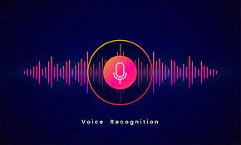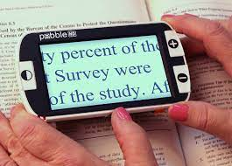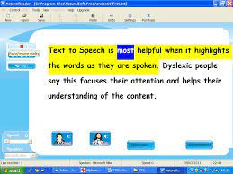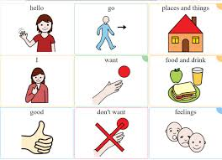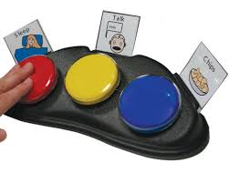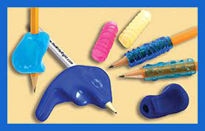 | Student Guide
2 mins | T: What are some of the ways teachers have had you interact with the materials and tools used to teach a concept?  S: Reponses will vary but could include videos, apps, tablets, manipulatives, PPTs, etc.  T: Are these ways ensuring access for all students?  S: No, some students may not be able to access the materials.
2 mins | Intro to Multiple Means of Action and Expression  T: As you may recall from our Jigsaw lesson at the beginning of the unit, multiple means of action and expression means offering options for ways students can interact with the instructional material, demonstrate their learning, and express what they know.  T: Let’s look at the three guidelines for multiple means of action and expression that we will learn about in our next few lessons. (Share via PPT while students record in student guide.)  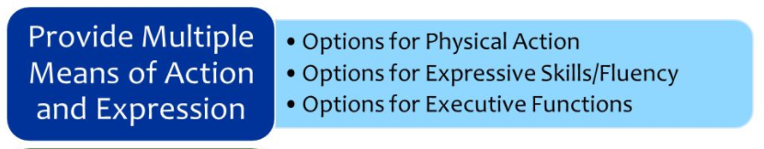  T: Today, we will focus on the first guideline: Options for physical action. | Student Guide  PPT
10 mins | Intro to Physical Action  T: What does physical action sound like it is referring to?  S: An action you do with your body.  T: Physical action refers to how students physically navigate and interact with their environment. Students vary in their abilities and preferences. Some learners have barriers to learning that are created by various sensory skills; therefore, it is important that teachers consider how they can reduce those barriers by providing materials and tools that are accessible to all learners.  T: Let’s look at a short video clip to learn more about physical action.  T: Think about the physical actions needed to complete the following tasks:  T: We can see that trying to interact with these common materials in the classroom would be a problem for some students. Teachers must provide options so that a student’s physical disabilities or motor skills do not hinder their ability to interact with the material.  T: Let’s see what physical action might look like in the classroom. (Share via PPT as students record notes in student guide.)  Adapted from CAST (2018). Universal Design for Learning Guidelines version 2.2. Retrieved from http://udlguidelines.cast.org  T: To open the door to learning for all students, it is important that a teacher provides accessible tools and devices. A significant number of learners with disabilities use assistive technologies on a regular basis for navigation, interaction, and composition. Assistive technology (AT) describes the device, equipment and software used to help people with disabilities learn and communicate more efficiently.  T: Here are a few other types of assistive technologies you might see in the classroom:  - Text to speech  - Voice recognition  - Magnifiers  - Large print materials  - Notetaking systems  T: Why is it important to model the use of assistive technologies and accessibility tools?  S: Students need to know how to use the tools for the technologies and tools to be beneficial to their learning. | Student Guide  PPT  Video Link: https://www.youtube.com/watch?v=XKob82_Mfpw
  Task | Physical Actions Needed
  Textbook | Lifting, turning the pages, sight
  Worksheet | Writing, writing an answer within a certain amount of space, turning the page, sight
  Computer | Using a mouse, clicking, pushing buttons, sight, typing
  Physical Actions
  Guideline | Examples | Nonexamples
  Provide alternative ways for students to interact with instructional materials and their environment. | - Provide flexibility with time, pacing, and range of motor action required to interact with instruction materials.  - Allow students to type an essay instead of writing it by hand.  - Provide multiple ways for students to respond, compose, or select material | - Require all students to interact with instructional material at the same pace and in the same way.  - Require all students to access content in a printed format
  Physical Actions
  Guideline | Examples | Nonexamples
  Provide access to and support with tools and assistive technologies | - Teach alternate keyboard commands for mouse control.  - Allow customized overlays for touch screens and keyboards.  - Model the use of assistive technologies and accessibility tools | - Require students with barriers to complete an easier assignment.  - Allow assistance technologies without modeling and support
5 mins | Practice 1: Scenario Analysis  T: Now let’s practice what you have just learned.  T: Consider the following scenario:  Mrs. D.’s students are learning about frogs and the life cycle of a frog. Students are working in groups to research and describe each stage of the frog’s life cycle. Each group has access to eBooks with the text-to-speech function, a touchscreen tablet, a laptop, and access to digital icons on their learning management system that link to specific kid-friendly websites and videos. Mrs. D. has asked students to record their learning in a graphic organizer using Google Docs. Before placing students in groups, Mrs. D. modeled how to use the voice typing function to help those who have difficulty typing and/or spelling.  T: In your student guide, notes some of the ways that Mrs. D. incorporated the guidelines for physical action in her activity.  S: (Write responses in student guide)  T: What were some of the ways Mrs. D. incorporated the guidelines for physical action?  S: Students had access to eBooks with text-to-speech functionality, touchscreen tablet where the font and size of objects could be made larger, a laptop for accessing content and recording notes in the graphic organizer where the font and size of objects could also be made larger, digital icons to easily access for research, she modeled and allowed access to voice typing for the graphic organizer. | Student Guide
15 mins | Practice 2 – Alternative Tools  T: Now, you are going to look at another scenario and determine how the teacher could provide alternatives to assist students with interacting with the material.  T: Before we look at the scenario, let’s explore a few tools that might be helpful in allowing students to interact with the material.  T: On your device, go to the settings menu and click on Ease of Access. Look at the options provided for vision, hearing, and interaction. Explore the following tools to see how they can be used to assist learners with interacting with the content.  T: (Provide 5 minutes for students to explore)  S: (Explore tools in settings for vision, hearing, and interaction)  T: Let’s look at the scenario.  Students in Ms. J.’s 4th grade class are learning about insects and about making claims and supporting their claims with evidence. In today’s lesson, students will work in lab groups to observe crickets, watch a video about crickets, and read a short text about crickets. Students will then make claims about crickets and support their claims with evidence from their lab observations and the texts they viewed using a graphic organizer.  T: You are going to work with a partner to determine at least three ways Ms. J. can provide alternative ways for students to interact with the instructional materials and provide access to tools and assistive technologies to make the material more accessible. Record your suggestions in the student guide.  S: (Complete practice 2 activity in student guide) | Student Guide  Windows Ease of Access Tools
  Ease of Access Options | How does it provide accessibility?
  Narrator | A screen reader describes what’s on your screen so you can use that information to navigate your device.
  Closed Captions | Display audio as text
  Talk instead of type (voice typing) | Use dictation to convert spoken words into text
  Mouse Keys (keyboard commands) | Use the numeric keypad to move the mouse pointer
2 mins | Debrief  T: What were some of the ways you suggested for Ms. J to provide alternatives for her students?  S: Responses will vary but could include accessing the text digitally to use the text to speech for reading the text about crickets, closed captions for videos, voice typing in a google doc to share evidence, using keyboard shortcuts in place of a mouse.  T: Before providing access to these different tools, what should Ms. J do?  S: She needs to model how to use the tools and provide support with the tools as students as using them.
5 mins | Exit Ticket  (Students complete the exit ticket.) | Exit Ticket

