Student Guide

Lesson 8.11: Multiple Means of Action & Expression | Options for Physical Action
Name:
Date:
Bellringer: Look at the images below and determine how each image relates to UDL.

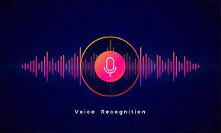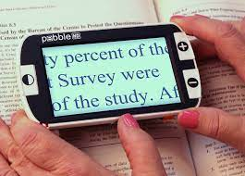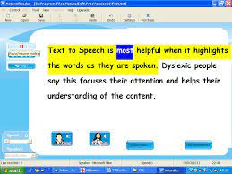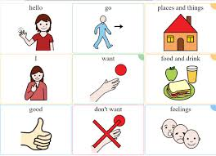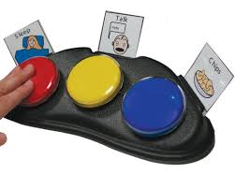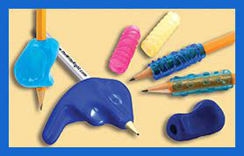

Intro to Multiple Means of Action and Expression

Multiple Means of Action & Expression

Multiple Means of Action & Expression Guidelines:

Intro to Physical Action
Physical Action
Guideline | Examples | Nonexamples
Provide alternative ways for students to interact with instructional materials and their environment.

Provide access to and support with tools and assistive technologies

Assistive technology (AT)

Other types of assistive technologies you might see in the classroom:

Practice 1: Scenario Analysis
Scenario- Mrs. D’s students are learning about frogs and the life cycle of a frog. Students are working in groups to research and describe each stage of the frog’s life cycle. Each group has access to eBooks with the text-to-speech function, a touchscreen tablet, a laptop, and access to digital icons on their learning management system that link to specific kid-friendly websites and videos. Mrs. D has asked students to record their learning in a graphic organizer using Google Docs. Before placing students in groups, Mrs. D modeled how to use the voice typing function to help those who have difficulty typing and/or spelling.
Notes some of the ways that Mrs. D incorporated the guidelines for physical action in her activity.

Practice 2: Scenario Analysis
On your device, go to the settings menu and click on Ease of Access. Look at the options provided for vision, hearing, and interaction. Explore the following tools to see how they can be used to assist learners with interacting with the content.

Ease of Access Options | How does it provide accessibility?
Narrator
Closed Captions
Talk instead of type (voice typing)
Mouse Keys (keyboard commands)

Read the following scenario.

Students in Ms. J’s 4th grade class are learning about insects and about making claims and supporting their claims with evidence. In today’s lesson, students will work in lab groups to observe crickets, watch a video about crickets, and read a short text about crickets. Students will then make claims about crickets and support their claims with evidence from their lab observations and the texts they viewed using a graphic organizer.

Work with a partner to determine at least three ways Ms. J can provide alternative ways for students to interact with the instructional materials and provide access to tools and assistive technologies to make the material more accessible.

