Student Guide – Answer Key

Lesson 8.11: Multiple Means of Action & Expression | Options for Physical Action
Name:
Date:

Bellringer: Look at the images below and determine how each image relates to UDL.

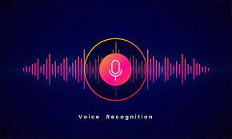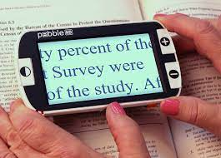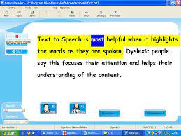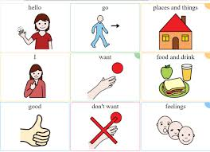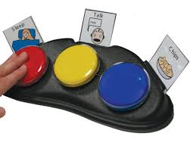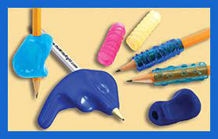
The voice recognition always students to say something and the computer will type it for them. The magnifier makes words on a page or screen larger for students to read more easily. The text-to-speech technology will read words to students. The picture choice board allows students to communicate their needs or choices through pictures. The light board allows students to use a push button to make choices. The pencil grip helps students write more easily. All these tools make learning and communicating more accessible for all students.
Intro to Multiple Means of Action and Expression

Multiple Means of Action & Expression | Offering options for ways students can interact with the instructional material, demonstrate their learning, and express what they know.
Multiple Means of Action & Expression Guidelines:
- Options for Physical Action
- Options for Expression & Communication
- Options for Executive Functions

Intro to Physical Action
Physical Action
Guideline | Examples | Nonexamples
Provide alternative ways for students to interact with instructional materials and their environment | - Provide flexibility with time, pacing, and range of motor action required to interact with instruction materials.  - Allow students to type an essay instead of writing it by hand.  - Provide multiple ways for students to respond, compose, or select material. | - Require all students to interact with instructional material at the same pace and in the same way.  - Require all students to access content in a printed format.
Provide access to and support with tools and assistive technologies | - Teach alternate keyboard commands for mouse control.  - Allow customized overlays for touch screens and keyboards.  - Model the use of assistive technologies and accessibility tools. | - Require students with barriers to complete an easier assignment.  - Allow assistance technologies without modeling and support.

Assistive technology (AT) | Any form of device, technology, or equipment that helps students with disabilities participate, communicate, and learn.

Other types of assistive technologies you might see in the classroom:
- Text to speech
- Voice recognition
- Magnifiers
- Large print materials
- Notetaking systems

Practice 1: Scenario Analysis
Scenario- Mrs. D’s students are learning about frogs and the life cycle of a frog. Students are working in groups to research and describe each stage of the frog’s life cycle. Each group has access to eBooks with the text-to-speech function, a touchscreen tablet, a laptop, and access to digital icons on their learning management system that link to specific kid-friendly websites and videos. Mrs. D has asked students to record their learning in a graphic organizer using Google Docs. Before placing students in groups, Mrs. D modeled how to use the voice typing function to help those who have difficulty typing and/or spelling.
Notes some of the ways that Mrs. D incorporated the guidelines for physical action in her activity.
- Students had access to eBooks with text-to-speech functionality.
- Touchscreen tablet where the font and size of objects could be made larger.
- A laptop for accessing content and recording notes in the graphic organizer where the font and size of objects could also be made larger.
- Digital icons to easily access for research.
- She modeled and allowed access to voice typing for the graphic organizer.

Practice 2: Scenario Analysis
On your device, go to the settings menu and click on Ease of Access. Look at the options provided for vision, hearing, and interaction. Explore the following tools to see how they can be used to assist learners with interacting with the content.

Ease of Access Options | How does it provide accessibility?
Narrator | A screen reader describes what’s on your screen so you can use that information to navigate your device.
Closed Captions | Display audio as text.
Talk instead of type (voice typing) | Use dictation to convert spoken words into text.
Mouse Keys (keyboard commands) | Use the numeric keypad to move the mouse pointer.

Read the following scenario.

Students in Ms. J’s 4th grade class are learning about insects and about making claims and supporting their claims with evidence. In today’s lesson, students will work in lab groups to observe crickets, watch a video about crickets, and read a short text about crickets. Students will then make claims about crickets and support their claims with evidence from their lab observations and the texts they viewed using a graphic organizer.
Work with a partner to determine at least three ways Ms. J can provide alternative ways for students to interact with the instructional materials and provide access to tools and assistive technologies to make the material more accessible.
Student responses will vary but may include:
- Closed captions for video.
- eBook of text to allow for text-to-speech.
- Digital graphic organizer to allow for voice typing.

