Unit 8: Planning for Diverse Learners

Lesson 8.01: Intro to Universal Design for Learning | Part I

Lesson at Glance
Warm-Up (5 mins)  - Bell Ringer | Instruction (30 mins)  - Intro to Universal Design for Learning (27 mins)  - Defining UDL (3 mins) | Application (10 mins)  - Debrief (5 mins)  - Exit Ticket (5 mins)

TEKS | 3 | The student explores the teaching and training profession. The student is expected to:  - summarize and apply pedagogical knowledge and skills needed by teaching and training professionals;
 | 7 | The student creates an effective learning environment. The student is expected to:  - describe and implement a safe and an effective learning environment that incorporates the principles of universal design;  - evaluate materials and equipment to determine age and grade level appropriateness and to meet the needs of diverse learners;
 | 10 | The student develops technology skills. The student is expected to:  - describe the role of technology in the instructional process;  - use technology applications appropriate for specific subject matter and student needs;
Objectives | • Define Universal Design for Learning and explain its purpose.
Rationale/  Summary | For years, teachers have been told to “teach to the middle,” meaning they develop instruction that targets the average students in the class. In this lesson, students will watch a TED Talk video titled “The Myth of Average” to explore why teaching to the middle or average is not the best approach to learning. Students will be introduced to Universal Design for Learning and consider how UDL can be used to support learning for all students.
Formative Assessment and Exemplar Response | Students will respond to the following multiple-choice questions:  - What is the impact of designing for the average?  - Which of the following are instructional practices can teachers use to provide a flexible learning environment?  - What does it mean to “design to the edges”?  See Exit Ticket Answer Key for exemplar response.
Vocabulary | Universal Design for Learning (UDL) |  | An educational framework to guide the development of flexible learning environments that can accommodate individual learning differences through engagement, representation, and expression. UDL minimizes barriers and maximizes learning for all students.

Est Time | Instructional Activities (including formative assessments) | Materials
4 mins | Bellringer: The coach of a high-school girls’ basketball team is buying shoes for the team. Since the average shoe size of a 16-year-old is a women’s 8.5, she buys everyone the same size. Provide three reasons why this isn’t a good idea. | Student Guide
1 min | T: Why isn’t this the best approach?  S: Because not everyone wears a women’s size 8.5 shoe. By putting all players in the same shoe size, they will likely not be able to play at the same skill level as they normally would. If the shoes are too big, it might cause a player to trip and get injured. If the shoe is too small, it wouldn’t fit the players foot, meaning they either wouldn’t be able to play at all or would get blisters from the shoe rubbing their foot.  T: How does this relate to student learning?  S: Students learn things in different ways. What works for one student may not work for another. | Student Guide
27 mins | Introduction to Universal Design for Learning  T: We are going to watch a TED Talk video titled - The Myth of Average. We will pause throughout the video to discuss key points. As you watch, complete the questions in your student guide to prepare for discussion.  S: (Watch video and complete questions in student guide.)  T: (Pause video at 1:49.) Turn to a partner and discuss the following question: How do you design one cockpit that can fit most individuals?  S: Student responses will vary.  T: (Pause video at 3:27). Why is designing for the average pilot wrong?  S: Because no two people are the exact same size on every dimension.  T: (Pause video at 8:25.) What does Todd mean by the quote: “When you design for the average, you design for no one.”  S: If you design a learning environment for the average student, you aren’t going to meet the needs of any of the students. Designing for the average hurts everyone because no two students are the same on every dimension.  T: (Pause video at 10:14.) What are two ways designing for the average destroys talent?  S:  - Designing for the average doesn’t appropriately challenge students who are gifted in certain areas.  - A perceived weakness may overshadow a talent. For example, a student may be skilled in reasoning through complex problems but struggles with reading. The student’s talent may be overlooked.  T: All students benefit from a learning environment that is designed to meet individual needs.  T: (Pause video at 11:46.) How can we use technology to design flexible learning environments?  S: Language translation, support for reading, vocabulary, pronounce a word or read a passage for you.  T: How can these support student learning?  S: It makes the learning accessible to more students.  T: Why might it be helpful to pre-teach academic vocabulary for students before engaging in a text?  S: It helps ensure that students have the background knowledge they need to understand and comprehend a text.  T: Let’s continue watching.  T: (Pause video at 14:40.) How did the use of technology help improve Billy’s performance?  S: He became the smartest kid in the class. Classmates went over to Billy to ask him questions about the assignment. He was able to show his talent for science, whereas before reading was a barrier to him showing his talent in science.  T: (Pause video at 16:00.) What does it mean to “ban the average” and instead, “design to the edges?” How can this impact student learning?  S: To ban the average means to no longer teach to the average. We should design to the edges by ensuring that the learning environment provides opportunities and supports for all students to thrive. This will lead to an increase in student performance and expand their talents in multiple areas.  T: What is the large-scale impact of designing for the average?  S: High dropout rate, low performance, lower the talent pool, less competitive in the job market.  T: Yes – this can have a huge impact on society as well because it limits the number of highly-skilled and qualified candidates that are available for the workforce. It also decreases our competitiveness with other countries. If companies can’t find the talent here, they will go somewhere else to find it, which hurts our economy. | Video:  The Myth of Average: Todd Rose at TEDx Sonoma County
3 mins | Defining UDL  T: (Share image below via PPT.) Instead of designing for the average, we should create a flexible learning environment where learning is accessible to all students. This is called Universal Design for Learning (UDL). UDL is an educational framework to guide the development of flexible learning environments that can accommodate individual learning differences through engagement, representation, and expression. It is an approach to curriculum that minimizes barriers and maximizes learning by ensuring that all learners can access and participate in meaningful, challenging learning opportunities.  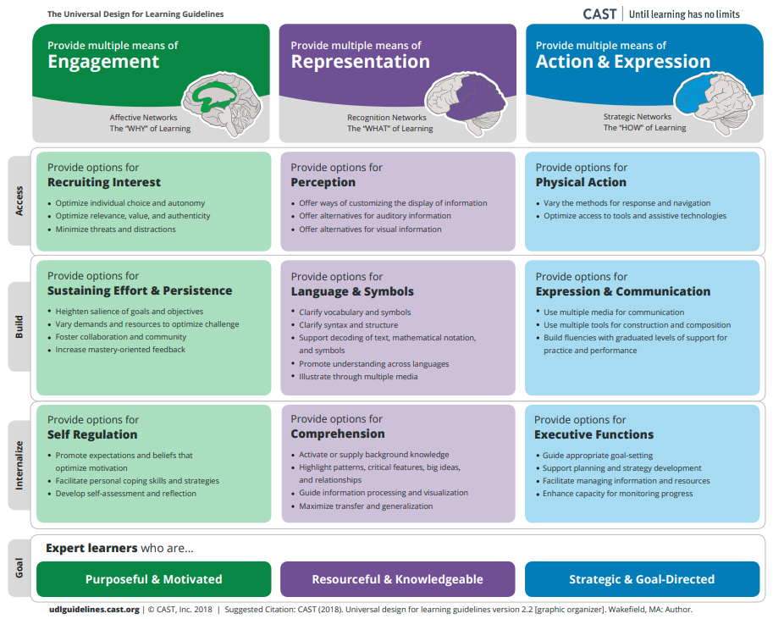  T: During this unit, we will dive into what UDL looks like in action.
5 mins | Debrief  T: Why shouldn’t teachers design for the average?  S: If a teacher designs for the average student, they aren’t going to meet the needs of any of their students.  T: How can a teacher ensure all students get what they need to achieve?  S: Teachers must ensure the learning environment provides opportunities and supports for all students to thrive, such as language translation, support for reading, vocabulary, etc. This will lead to an increase in student performance and expand their talents in multiple areas.  T: Throughout this unit, you will explore various strategies to support learning for all students.
5 mins | (Students complete the exit ticket.) | Exit Ticket

