Unit 9: Feedback

Lesson 9.02: Practice with Informal Feedback

Lesson at Glance
Warm-Up (4 mins)  - Bellringer (4) | Instruction (3 mins)  - Review Characteristics of Effective Feedback and Purpose of Informal/Verbal Feedback (3) | Application (38 mins)  - Practice-Informal, Verbal Feedback (33)  - Debrief (2)  - Exit Ticket (3)

TEKS | 4 | The student understands the learner and the learning process. The student is expected to:  - relate and implement principles and theories about the learning process to teaching and training situations;  - demonstrate and implement behaviors and skills that facilitate the learning process;
 | 14 | The student demonstrates the knowledge and skills needed to provide meaningful, specific, and timely feedback to students, families, and other school personnel on the growth of students in relation to classroom goals, while maintaining student confidentiality. The student is expected to:  - explain the role feedback plays in the learning process;  - demonstrate methods of providing feedback to students such as checklists, classroom processes, and written documentation;  - demonstrate methods of accepting and reflecting on feedback to determine plans for improvement of educational outcomes;
Objectives | - Practice delivering informal, verbal feedback.  - Analyze and evaluate informal, verbal feedback based on the characteristics of effective feedback
Rationale/  Summary | Feedback informs a student and/or teacher about the student’s performance relative to learning goals and outcomes. Creating opportunities for students to receive feedback that is meaningful, specific, and timely allows students to determine their learning strengths and utilize feedback to improve future learning and performance. Informal feedback provides instantaneous feedback to a student to allow for learning to move forward when students are practicing skills. In this lesson students will practice giving informal, verbal feedback through a role play scenario and examine how the feedback provided aligns to the characteristics for effective feedback.
Formative Assessment and Exemplar Response | - During class today you practiced providing informal, verbal feedback to your classmates. Reflect on your practice and identify the areas of strength that you exhibited and areas for you to improve upon for each characteristic of effective feedback.  - What was the hardest part of providing informal verbal feedback? Why?  - What did you learn by observing your group members that you can use to improve your own practice in providing informal, verbal feedback?  See Answer Key-Exit Ticket 9.2 for exemplar response.
  Characteristic of Effective Feedback | Your Strengths | Your Areas for Improvement
  Specific and Clear
  Focused on the Task
  Strengths and Improvements
  Timely and Actionable
Vocabulary | Informal Feedback |  | Feedback provided in the moment, not planned. This feedback is tailored to a situation as it arises.
Vocabulary | Verbal Feedback |  | Immediate and instantaneous feedback provided to a student verbally during instruction.
Vocabulary | Formative Feedback |  | Feedback that is provided during instruction and intended to move instruction or learning forward.

Est Time | Instructional Activities (including formative assessments) | Materials
2 mins | Bellringer  You are a teacher in a math class. Your students are working on grouping by fives to count to the total. Each student is asked to first draw a picture of the value, circle the groups of five and use those groups to count by five to get to the answer. You notice that once one of your students is forgetting to circle the groups of five in their drawing which is leading to the incorrect answer. What type of informal, verbal feedback might you give that student to get them back on track? Consider the characteristics of effective feedback we discussed in the previous lesson (specific and clear, focused on the task, strengths, and improvements and timely and actionable.) | Student Guide
2 mins | Bellringer Review  T: In the scenario, you were asked what feedback you might give a student who was struggling with a math concept. What did you say?  S: (answers will vary)  T: How does a statement like that fit the characteristics for effective feedback? (Ensure that students can explain how their responses meet the characteristics of effective feedback)  S: It is specific and tied to the skill. The student knows exactly what they need to do to improve. The feedback also highlights a strength before sharing an improvement.
3 mins | Review of Characteristics of Effective Feedback  T: We discussed in the previous lesson that feedback can take different forms depending on when it is delivered, how it is delivered, and the purpose for the feedback. Today we will practice giving informal verbal feedback.  T: Remember that regardless of the type of feedback given it all should align to the characteristics of effective feedback. What are the 4 characteristics of effective feedback that we have discussed?  S: Feedback should be specific and clear, focused on the task not the student, identify both strengths and areas for improvement, and be timely and actionable. | PPT  Student Guide
33 mins | Practice-Informal, Verbal Feedback  T: Today you are going to practice giving informal verbal feedback. First, we will get into groups of 3. (Arrange students into groups of 3.)  S: (Get into groups of three.)  T: To practice giving feedback we will role play three different scenarios. For each scenario, your group will have a member who will play the part of the teacher, a member who will play the part of the student and a member who will serve as the notetaker/observer/timekeeper. Throughout the practice, each member of the group will play each role once. S: (Determine group roles for the first scenario.)  T: I will provide task cards for each of the scenarios. There is a card for the role of the teacher and a card for the role of the student. Do not share what is on your card before the role play scenario. You will use the protocol below to role play the scenario. The observer/notetaker/timekeeper will be responsible for keeping the time during the protocol and recording notes on their student guide in the section labeled Practice-Informal, Verbal Feedback.  S: (Locate Practice-Informal, Verbal Feedback in student guides.)  T: Each round will last 10 minutes. (Check to make sure all groups have a way to keep time and review structure of each round.)  - 2 minutes: Teacher & student will read their task cards and prepare for the scenario.  - 4 minutes: Teacher and student will role play the scenario with the teacher providing informal, verbal feedback to the student on their task. The notetaker/observer will take notes about the feedback statements used by the teacher during the role play.  - 4 minutes: Notetaker will share the feedback statements observed and the group will complete the chart for each scenario assessing the feedback given against the characteristics for effective feedback.  T: At the conclusion of the first round of the protocol, you will exchange roles for the 2nd scenario and then again for the 3rd scenario. Each group member should have a chance to play all three group roles during the practice time. (Hand out the task cards for the first scenario.) There is a table of sentence prompts included on your student guide to support your practice in providing effective feedback as you role play your scenarios.  T: Any questions?  S: (Ask questions for clarification.)  T: At the completion of the first scenario, I will stop everyone and provide the task cards for the 2nd scenario. You may begin the first scenario now by reviewing the task cards for the role play. (Set timer for 10 minutes. Circulate to monitor and provide support to groups during practice.)  S: (Engage in role playing practice for scenario 1.)  T: We will now move to scenario 2. Determine who will play each role in this scenario.  S: (Determine group roles for scenario 2)  T: (Hand out task cards for scenario 2.) You may begin scenario 2 by reviewing your task cards. I will stop everyone in 10 minutes. (Set timer for 10 minutes. Circulate to monitor and provide feedback to groups during practice.)  S: (Engage in role playing practice for scenario 2.)  T: We will now move to scenario 3. Determine who will play each role in this scenario.  S: (Determine group roles for scenario 3.)  T: (Hand out task cards for scenario 3.) You may begin scenario 3 by reviewing your task cards. I will stop everyone in 10 minutes. (Set timer for 10 minutes. Circulate to monitor and provide support to groups during practice.)  S: (Engage in role playing practice for scenario 3.) | Student Guide  Role Play Task Cards
2 mins | Debrief  T: What did it feel like to provide informal, verbal feedback in these scenarios? Was it easy or hard for you and your group members? Comfortable or uncomfortable?  S: (Answers will vary.)  T: Which of the characteristics of effective feedback were the easiest to master?  S: (Answers will vary.)  T: Which of the characteristics of effective feedback were the toughest to master?  S: (Answers will vary.)  T: What is something that you observed or practiced today that you want to work on to improve in the future?  S: (Answers will vary.)
3 mins | S: (Complete the exit ticket.) | Exit Ticket

Role Play Task Cards
Scenario 1- Writing a Descriptive Paragraph (ELA)
Role: Teacher

You are working on a unit to help your students write more descriptive sentences. Prior to practicing you discussed how the 5 senses (taste, touch, sound, sight, and smell) can be used to include more details about an experience or situation. After instruction, you have asked each of the students to begin writing a short paragraph (2-3 sentences) that use all five senses to describe in detail an experience from their weekend. You are currently circulating to check on their progress. You are looking for basic grammar (appropriate punctuation, capitalization, sentence structure) as well as the use of words that describe using the five senses.

Scenario 1-Writing a Descriptive Paragraph (ELA)

Role: Student

Your teacher has just finished a lesson on writing descriptive sentences using your five senses. The teacher has now released you to work independently on writing a short paragraph (1-3 sentences) about your weekend using your five senses. You have started writing the paragraph and have included a couple of sentences that describe the sights, sounds and smell of a weekend experience but you are struggling to include taste and touch. You also have forgotten to capitalize the first letters of the sentence and have not used appropriate punctuation.
(Take this time to begin writing your sentences)

Scenario 2- Using Pictures to Visualize Money (Math)

Role: Teacher

You have just taught a lesson on coins and their denominations (pennies, nickels, dimes, and quarters). As a part of the “I can” statement for the day, students will need to show how they can use a drawing to show how coins can be used to count to a final amount of money. You have just called a student to the board to work an example problem. You have asked the student to draw out the coins that they would use to make $0.57. You are looking for the students to draw different sized circles for the different coins and label the value of each coin. Students should be able to show how to make the amount using coins two different ways and verbally say the coins name and value as they point to them to explain how they solved the problem.

Scenario 2- Using Pictures to Visualize Money (Math)

Role-Student

Your teacher has just taught a lesson on coins and their values (pennies, nickels, dimes, quarters). As a part of the lesson, the teacher has shown you how to draw a different size circle for each coin (quarters-largest, nickels-next largest, pennies-smaller, dimes-smallest) and to label the values on each coin when you draw them. Now that you know the value of each coin, the class is working on how to determine the coins to use to make a certain amount of money. Your teacher expects that you will show at least TWO different ways to make this amount of money. Your teacher invites you to try a problem in front of the class where you are showing how you can use different coins to make $0.57. In your first solution, you draw the different size circles and explain the value, but do not label the value of each coin. In your second solution you accidently use four dimes, one nickel and two pennies. You draw each coin, say the value, and label the value of each coin during this example.

Scenario 3-Labeling the Parts of a Plant (Science)

Role-Teacher

You are working on a unit about the different parts and functions of a plant. After a brief presentation about the parts of the plant, students have been asked to draw a picture of a plant and label the parts (root, stem, fruit, leaf, and flower). In addition to labeling the different parts of the plant, the students are to add descriptions for each part in their notes. Below is an example of a picture that might be drawn and the functions describing each part of the plant. You are circulating around the room as the students draw their pictures to make sure that all five parts are included and that there are descriptions of each part.

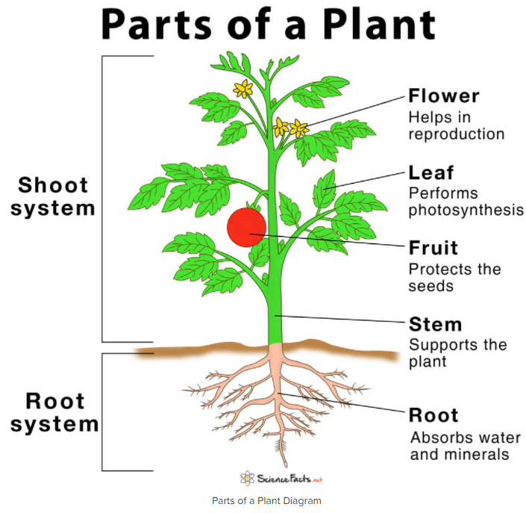

Scenario 3-Labeling the Parts of a Plant (Science)

Role-Student

Your teacher has just finished presenting information about the five parts of a plant (root, stem, flower, leaf, fruit) and their corresponding function. The teacher has now asked you to draw a picture in your lab notebook of a plant, label the five parts and write a brief description of the function of each part. As you draw your picture you incorrectly label the fruit and the flower and forget to write descriptions on several of the parts. Your teacher is circulating around the room as you are drawing to provide you feedback.

(Begin by creating a drawing. You can use the picture below to guide your work, but do not forget to mix up the fruit and flower labels and to exclude the descriptions of a couple of the parts.)

