Student Guide

Lesson 9.03: Practice-Formal, Written Feedback
Name:
Date:

Bellringer:
How does formal feedback differ from informal feedback? What are the benefits of formal written feedback over informal verbal feedback?

Model: Formal, Written Feedback
Scenario 1st Grade Narrative Writing
Description: The students were asked to write a narrative paragraph about an event from their weekend. Below are the success criteria shared with the students for the writing assignment.
Success Criteria:
Paragraph Structure | The paragraph should have at least 5 complete sentences. The paragraph should include an introduction sentence and a closing sentence.
Punctuation & Capitalization | Sentences should end with the appropriate punctuation. Proper nouns and the beginning words of sentences should be consistently capitalized.
Supporting Details | At least three supporting details are included in the paragraph.
Drawing | The drawing appropriately represents some of the details in the paragraph, adding details and interest.
Descriptive Title | The paragraph should include a descriptive title.

Student Work Sample (obtained from https://www.ode.state.or.us/wma/teachlearn/commoncore/ela-appendix-c.pdf):
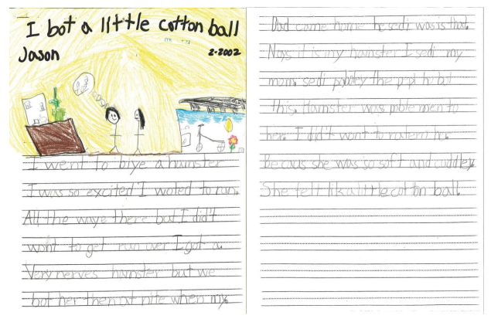
 | Examples of Effective Feedback Statements | Non-Examples
Strengths | - You included 5 complete sentences.  - You included at least three details.  - Your title is interesting and descriptive.  - Your drawing helps to visualize the event | - You wrote sentences.  - You included some details.  - Your title is good.  - You are a good drawer.
Areas of Improvement | - You could improve by using periods to end the sentence or thought.  - You could improve by capitalizing only proper nouns and the beginning of sentences.  - Be sure that all your sentences are complete with a subject and verb. | - You didn’t use appropriate punctuation.  - Use complete sentences.

Practice: Formal, Written Feedback
Scenario 1: 1st Grade Math Assessment
Description: The students have completed an end of unit assessment on using addition to solve word problems. Below are the success criteria for the assessment.
Success Criteria:
Correct Answer | The student should show the correct set up for each problem. The correct answer with the appropriate unit/label should be circled.  Problem 1: Correct Answer is 16 legs  Problem 2: Correct Answer is 25 pennies
Showed Work | The student should show work that represents how the answer was solved.
Drawing | The students should include a detailed and labeled drawing that shows an appropriate strategy used to solve the problem.
Student Work Sample (obtained from https://ci.appstate.edu/sites/default/files/grade1_unit8studentwork.pdf)
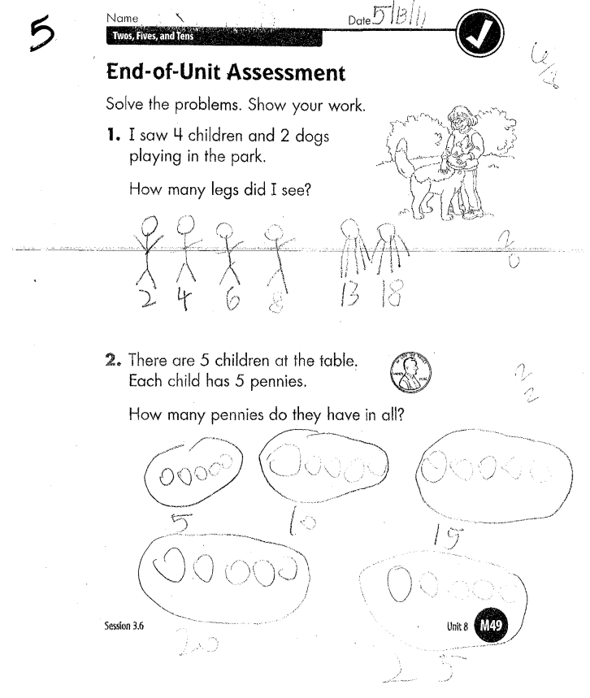

Feedback Statements:

Partner Discussion:
Characteristic of Effective Feedback | Strengths | Improvements
Specific and Clear
Focused on the Task
Strengths and Improvements
Timely and Actionable

Scenario 2: 6th grade Ancient Egypt Research
Description: At the end of each week students in a social studies class are asked to conduct research on a specific region of the world to learn more about the geographic features the influence on the neighboring civilizations. The students are given four questions to focus the research. Below are the success criteria for the assignment.
Success Criteria
Presentation | Organized appropriately using subheadings, information is accompanied by captioned pictures or subheadings, piece is visually appealing
Research Questions | Each research question is answered completely, and evidence of research is present
Vocabulary/Grammar | Writing is free of grammatical and spelling errors; historical terms are used accurately and effectively
Acknowledgement of Sources | At least three sources are acknowledged and listed with the date that the information was accessed

Student Work Sample (obtained from https://media.edufolios.org/uploads/sites/844/2018/05/Sample2.png):
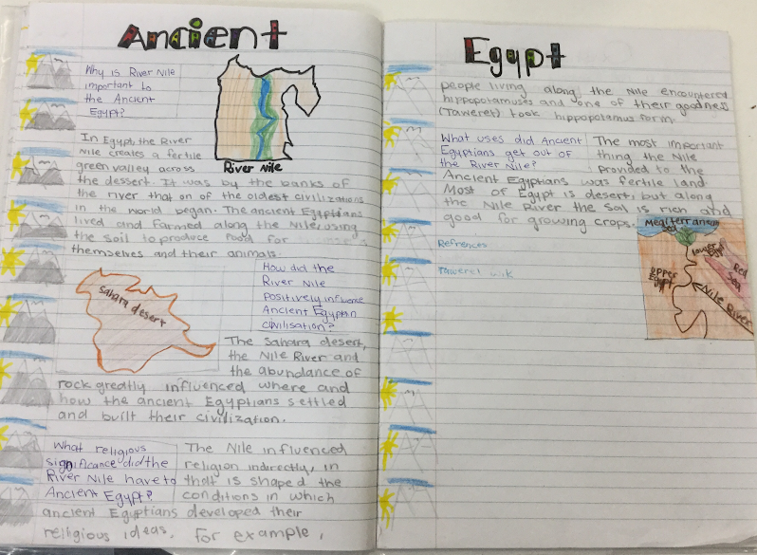

Feedback Statements:

Partner Discussion:
Characteristic of Effective Feedback | Strengths | Improvements
Specific and Clear
Focused on the Task
Strengths and Improvements
Timely and Actionable

