Student Guide
Lesson 1.06 Introducing the Professional Portfolio
Name:
Date:
Bellringer:
Reflect on how important it is to make a first impression. Share how your professional portfolio might help you to create a positive first impression.

Notes: Components of the Professional Portfolio
Professional Portfolio
Educational Philosophy
Work Samples
Resume

Resume Template
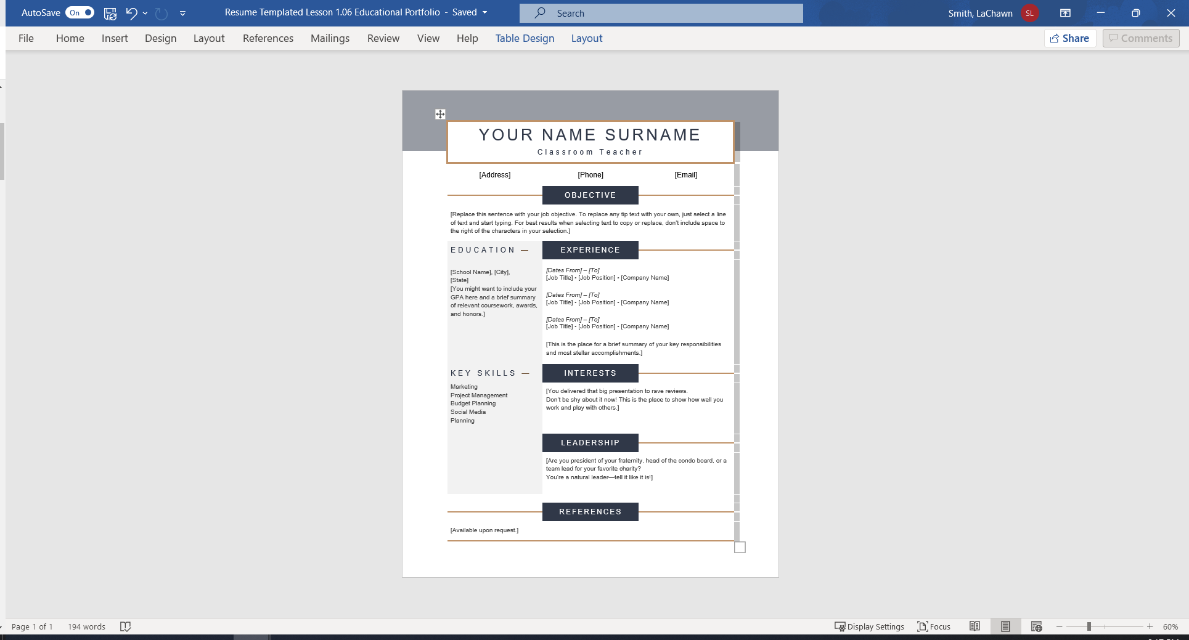
Word Resume Template. Word Resume Templates. (n.d.). Retrieved June 19, 2022, from https://templates.office.com/en-us/templates-for-Word

Professional Portfolio Development
Educational Portfolio
Component | Purpose | Definition | Required/Optional

