Student Guide—Answer Key
Lesson 1.06 Introducing the Professional Portfolio
Name:
Date:
Bellringer:
Reflect on how important it is to make a first impression. Share how your professional portfolio might help you to create a positive first impression.
Responses will vary but could include:
- It is important to make a good first impression because that help people form an opinion about whether you are a good teacher or not.
- People will be more willing to listen to what you have to share if you first form a good impression.
- The portfolio might create a positive impression by showing that you care about students. The portfolio could show that you are working to become a better teacher and to learn all that you can about teaching.

Notes: Components of the Professional Portfolio
Professional Portfolio | A collection of work and other documents that demonstrate effectiveness. They may be shared at a job interview and used to demonstrate professional growth.
Educational Philosophy | Teachers core beliefs about learning and teaching
Work Samples | Exhibits of teaching performance that provide direct evidence of a candidate’s ability to design and implement standards-based instruction, assess student learning, and reflect on the teaching and learning process
Resume | A formal document that a job applicant creates to itemize their qualifications for a position

Resume Template
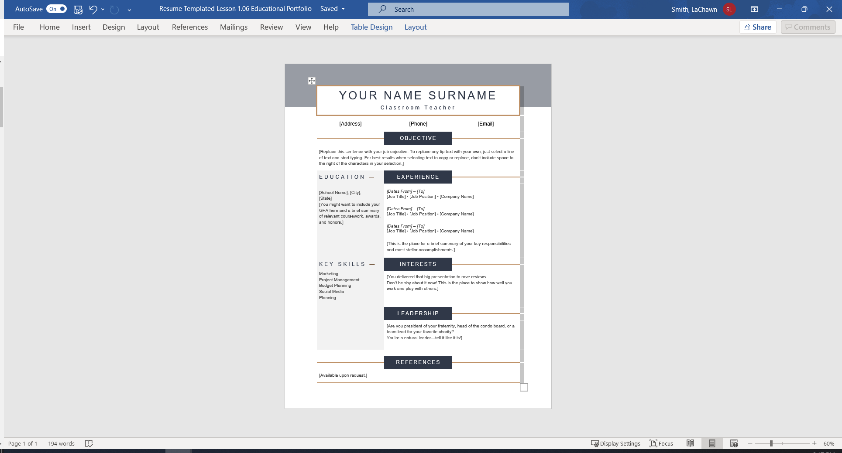
Word Resume Template. Word Resume Templates. (n.d.). Retrieved June 19, 2022, from https://templates.office.com/en-us/templates-for-Word

Professional Portfolio Development
Educational Portfolio
Component | Purpose | Definition | Required/Optional
Educational Philosophy | To share what I believe about teaching and how students learn. | Teachers’ core beliefs about learning and teaching | Required
Work Samples | To provide evidence of my work to become a teacher. | Exhibits of teaching performance that provide direct evidence of a candidate’s ability to design and implement standards-based instruction, assess student learning, and reflect on the teaching and learning process | Required
Resume | To show that I am qualified to be a teacher | A formal document that a job applicant creates to itemize their qualifications for a position | Required
Classroom Management Plan | To show what I believe is important in managing student behavior | Answers will vary. Example: A formal plan for how a teacher manages student behavior in a classroom. | Optional
Letter to Future Students | To show how I would connect with future students | Answers will vary. Example: A letter written to students which tells them information about their teacher. | Optional

