Student Guide

Lesson 2.02: What is Professionalism?
Name:
Date:
Bellringer: Reflect on your conduct, appearance, and communication at your E & T field site by responding to the following questions:
- How do you communicate/plan to communicate with your field site teacher?

- How do you communicate/plan to communicate with the students at your field site?

- How do you maintain professional conduct with your students and field site staff?

- What do you have to consider when planning your attire for your field site visit?

Review Four Key Areas of Teacher Professionalism

Key areas of teacher professionalism.

Scenario or Image | Professional or Not Unprofessional | Reasoning
A high school social studies teacher frequently gives students extra credit on assignments for wearing team gear from his favorite college sports team.
Mr. Jarrell is a middle school math teacher. He just gave his students an assignment, but they seem to really be struggling. He doesn’t seem to understand because he just went over the assignment. Mr. Jarrell gives a signal for the students to direct their attention back to the board. He asks students to share what part of the assignment they are struggling with the most and models a few problems on the board before having students continue with the assignment.

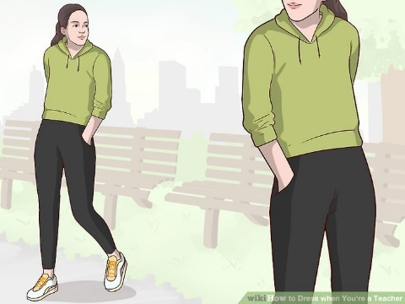
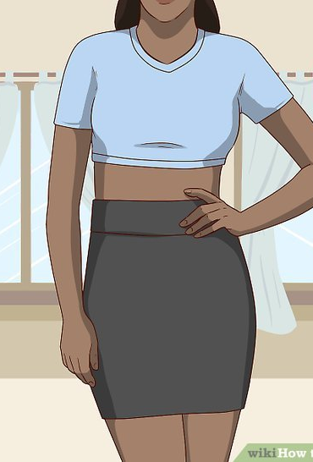
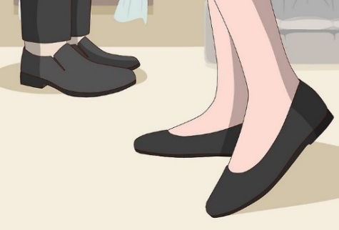
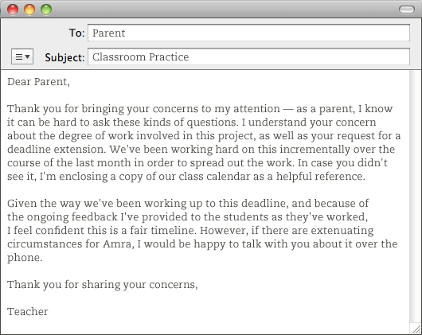
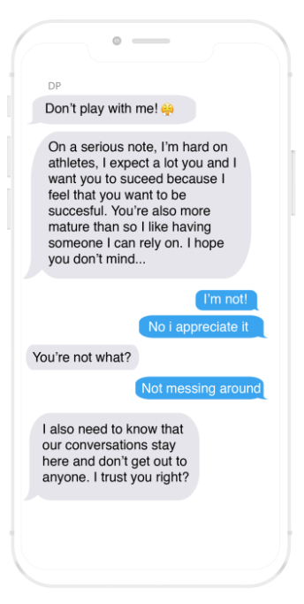

Practice – Field Site Scenarios
Read each scenario and plan for how you would respond if presented with the same situation based on your local district’s standards of conduct. Then, consider which district standard of conduct this scenario most closely aligns with.

Scenario | How I would respond | Standard of Conduct Alignment
You wake up late on the morning of your site visit and you don’t have time to iron the dress shirt and dress pants you had planned to wear. Your other professional attire is either dirty or wrinkled. What should you do?
One of your students asks for your personal cell phone number so they can share pictures of their project with you. You also notice that they tried to friend you on one of your personal social media accounts. What should you do?
One of your friends has a cousin in the class you are assigned to for your practicum. Your friend wants to know what her cousin scored on her last math test. How would you respond?
A parent sends you the following email accusing you of calling out his child in the middle of class and embarrassing him:
Dear _____,
Jason came home very upset yesterday. It really upset him when you told him to sit down and get back to work yesterday. He was really embarrassed. Don’t do that again in front of the other kids. Why would you want to humiliate a child by calling him out like that in front of everyone?
Sincerely,
Jason’s dad

How would you respond to this email?
A parent calls you on the last day of the grading period to see if there is anything her child can do to raise her grade. She wants to know if there is an extra credit assignment her child can complete to pass the class.
How would you respond?
You are in the teacher’s lounge working on a bulletin board when you overhear two teachers talking badly about the principal. As you are leaving the field site, the principal stops to talk to you and notices you are uneasy. What should you do?
You have learned many new instructional practices in this course that you want to try, but your mentor teacher is resistant and doesn’t want to make any changes to the way she’s typically done things. What should you do?

