Unit 2: The Professional Educator

Lesson 2.02: What is Professionalism?

Lesson at Glance
Warm-Up (7 mins)  - Bell Ringer (7) | Instruction (8 mins)  - Review Four Key Areas of Teacher Professionalism (8) | Application (30 mins)  - Practice – Field Site Scenarios (15)  - Debrief (10)  - Exit Ticket (5)

TEKS | 1 | The student demonstrates professional standards/employability skills as required by teaching and training profession business and industry. The student is expected to:  - demonstrate professionalism
 | 11 | The student understands the professional, ethical, and legal responsibilities in teaching and training. The student is expected to:  - develop teacher and trainer characteristics that promote professional and ethical conduct;  - analyze professional and ethical standards that apply to educators and trainers;
Objectives | - Describe professional and ethical behavior as essential responsibilities of an educator.  - Analyze and plan a professional and ethical response to common field site scenarios  - Explain the importance of professionalism at the E&T field site.
Rationale/  Summary | Professionalism as an educator is a key to a successful career. In this lesson, students will analyze scenarios to identify examples and nonexamples of practices in professional conduct, appearance, and communication and explain what the teacher could do differently to exhibit professionalism.
Formative Assessment and Exemplar Response | Students will respond to the following questions:  - Why is it important to demonstrate professional behavior at your E&T field site? How might unprofessional behavior impact your future as well as impact the students and teachers you are working with?  - Analyze the scenarios. Determine if the educator behaviors are professional (P) or not professional (NP) and explain the message the teacher is sending through their actions.  See Exit Ticket – Answer Key for exemplar response.
Vocabulary

Est Time | Instructional Activities (including formative assessments) | Materials
 | Lesson Preparation: Students will need access to the employee standards of conduct for your district during the scenario practice activity.
5 mins | Bellringer: Reflect on your conduct, appearance, and communication at your E & T field site by responding to the following questions:  - How do you communicate/plan to communicate with your field site teacher?  - How do you communicate/plan to communicate with the students at your field site?  - How do you maintain professional conduct with your students and field site staff?  - What do you have to consider when planning your attire for your field site visit? | Student Guide
2 mins | T: Get into groups of three. Share your reflections and describe how your conduct, appearance, and communication aligned to educator professionalism.  S: (Turn and talk.)  T: What trends did you notice in your groups?  S: Student responses will vary.
8 mins | Review Four Key Areas of Teacher Professionalism  T: What does it mean for a teacher to behave in a way that is professional and ethical?  S: (answers will vary but should reflect that Professionalism education means that teachers demonstrate integrity, honesty, and good moral character. Professionalism is being kind, being respectful, and using good manners. It is also about managing your emotions, keeping your private life private, and maintaining appropriate behavior with students.  T: What are the four key areas of teacher professionalism?  S:  - Interactions with students  - Workplace professional conduct  - Appearance  - Interactions with colleagues and the community  T: Let’s look at a couple scenarios to determine if the teacher’s behavior is professional or unprofessional.  T: (Share scenario via PPT.)  Scenario: A high school social studies teacher frequently gives students extra credit on assignments for wearing team gear from his favorite college sports team.  T: Is this conduct professional or unprofessional?  S: Unprofessional because he is showing favoritism to students who have team gear from his favorite college.  T: (Share next scenario via PPT.)  Scenario: Mr. Jarrell is a middle school math teacher. He just gave his students an assignment, but they seem to really be struggling. He doesn’t seem to understand because he just went over the assignment. Mr. Jarrell gives a signal for the students to direct their attention back to the board. He asks students to share what part of the assignment they are struggling with the most and models a few problems on the board before having students continue with the assignment.  T: Is this conduct professional or unprofessional?  S: Professional. Mr. Jarrell remained calm and modeled additional problems on the board instead of getting upset with the students for not understanding.  T: Another key area of teacher professionalism we discussed is appearance. What does it mean to have professional appearance? What does professional appearance communicate?  S: Attire that is both modest and practical. The way a teacher presents themselves communicates something about who they are and how they see themselves as professional educators. It also models for students what appropriate and professional appearance looks like.  T: Let’s look at a few images and I want you to tell me if the teacher’s appearance is professional or unprofessional.  T: (Share images via PPT.)    T: Is this teacher’s appearance professional?  S: Yes, he has on dress pants, a dress shirt, and a blazer.  T: (Share next image.)  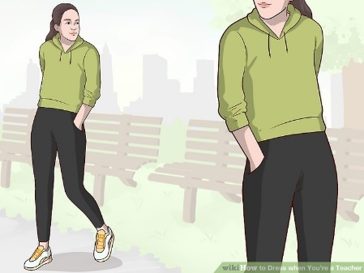  T: Is this teacher’s appearance professional?  S: No because she is wearing athletic clothing.  T: Would this attire be appropriate for a physical education teacher?  T: Yes  T: (Share next image.)  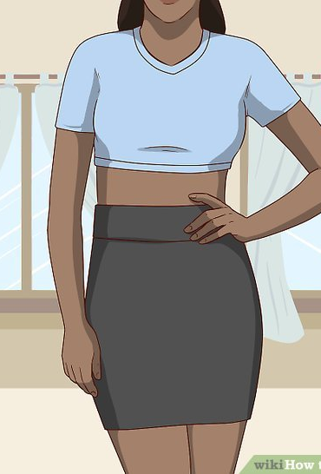  T: Is this teacher’s appearance professional?  S: No because she is wearing a short skirt and her stomach is showing.  T: (Share next image.)  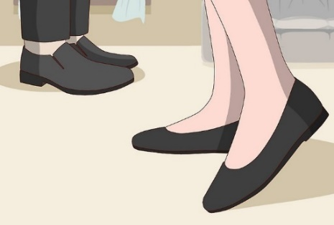  T: Are these appropriate shoes for a teacher?  S: Yes. They are dress shoes. The dress code typically doesn’t allow flip flops, sneakers, and house shoes  T: Are dress shoes the only shoes teachers are permitted to wear?  S: No. Administration can make exceptions.  T: Right - In many cases, administrators will have the discretion to make exceptions to appropriateness of attire as it relates to vocational courses, physical education, maintenance, medical necessities, field trips, and spirit days.  T: Let’s talk about communication. What is professional communication?  S: Professional communication means communicating openly and respectfully using appropriate language and tone. It means responding in a timely manner to communications from parents, students, staff members, etc. and choosing your words wisely.  T: Why is teacher professionalism so important?  S: Teachers play a key role in supporting students in achieving success. When you exhibit professionalism, it shows that you take your role seriously. Professionalism communicates to parents, students, colleagues, and administration that you can be trusted and helps them feel more confident in your abilities to guide student learning. Professionalism also models for students how they should represent themselves in their future careers.  T: Let’s look at a few images of different communications from teachers. I want you to tell me if you think the communication is professional or unprofessional.  T: (Share images via PPT.)  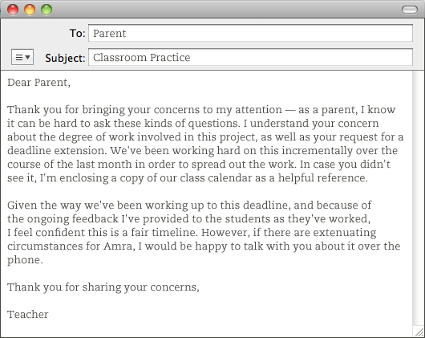  T: Is this communication professional or unprofessional and why?  S: Professional. The teacher thanks the parents for bringing up the concerns and express their understanding, but respectfully explains that they will not change their timeline. The teacher provides a copy of the timeline and offers to talk with the parents further by phone.  T: (Share next image.)  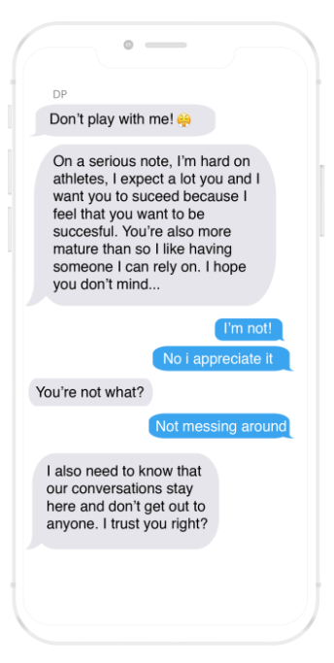  T: Is this communication between the student and teacher professional or unprofessional and why?  S: Unprofessional. The teacher is texting the student and asks the student not to share their conversation with anyone. This goes against the Code of Ethics. | Student Guide  Educators’ Code of Ethics  Source of Images  Image Source  Image Source
15  mins | Practice - Field Site Scenarios  T: You are going to examine scenarios that could likely occur or have occurred during your field experiences. Read each scenario and plan for how you would respond if presented with the same situation based on your local district’s standards of conduct. Then, consider which district standard of conduct this scenario most closely aligns with.  T: Let’s review a few together.  T: Read the following scenario and think about how you might respond in the situation.  T: (Share scenarios via PPT).  You wake up late on the morning of your site visit and you don’t have time to iron the dress shirt and dress pants you had planned to wear. Your other professional attire is either dirty or wrinkled. What should you do?  T: How would you respond?  S: I would call my mentor teacher at my field site and my teacher to let them know I will be a few minutes late. Then, I would take the few extra minutes to iron my clothes so I will be presentable.  T: What standard of conduct does this align with?  S: Student response will vary based on district standard of conduct.  T: Let’s look at another example.  One of your students asks for your personal cell phone number so they can share pictures of their project with you. You also notice that they tried to friend you on one of your personal social media accounts. What should you do?  T: Turn and talk with a partner about how you would respond in this situation.  S: (turn and talk with a partner).  T: How would you respond?  S: I would ask the student to send the pictures of their project to my school email account and would not accept their friend request on social media.  T: What standard of conduct does this align with?  S: Student response will vary based on district standards of conduct.  T: You are going to work with a partner to plan how you would respond to each scenario and determine which standard of conduct the scenario and your response most closely aligns with.  T: Are there any questions before you begin?  S: Students ask questions if needed.  T: Stand up, hands up, and pair up with a partner.  S: (Find a partner and complete scenarios). | PPT  Student Guide
10 mins | Debrief  T: How did you respond to the various scenarios? Were there any that were difficult for you to plan for how you would respond?  T: (Call on multiple students to share how they would respond to the different scenarios).  S: Student responses will vary based on scenario and experience but should clearly exhibit an understanding of professionalism and ethical behavior per their district’s standard of conduct.  T: How can your professionalism impact others?  S: Failing to act professionally sets a bad example for students and may lead to a loss of trust and respect by students, colleagues, and families. It sends a message to my students that I do not take their education seriously and communicates a lack of high expectations for all students. Failing to act professionally can also put others at risk of getting in trouble depending on the situation.
5 mins | (Students complete the exit ticket.) | Exit Ticket

