Student Guide – Answer Key

Lesson 2.02: What is Professionalism?
Name:
Date:
Bellringer: Reflect on your conduct, appearance, and communication at your E & T field site by responding to the following questions:
- How do you communicate/plan to communicate with your field site teacher?
Student responses will vary

- How do you communicate/plan to communicate with the students at your field site?
Student responses will vary

- How do you maintain professional conduct with your students and field site staff?
Student responses will vary

- What do you have to consider when planning your attire for your field site visit?
Student responses will vary

Review Four Key Areas of Teacher Professionalism

Key areas of teacher professionalism.
- Interactions with students
- Workplace professional conduct
- Appearance
- Interactions with colleagues and the community

Scenario or Image | Professional or Not Unprofessional | Reasoning
A high school social studies teacher frequently gives students extra credit on assignments for wearing team gear from his favorite college sports team. | Unprofessional | He is showing favoritism to students who have team gear from his favorite college.
Mr. Jarrell is a middle school math teacher. He just gave his students an assignment, but they seem to really be struggling. He doesn’t seem to understand because he just went over the assignment. Mr. Jarrell gives a signal for the students to direct their attention back to the board. He asks students to share what part of the assignment they are struggling with the most and models a few problems on the board before having students continue with the assignment. | Professional | Mr. Jarrell remained calm and modeled additional problems on the board instead of getting upset with the students for not understanding.
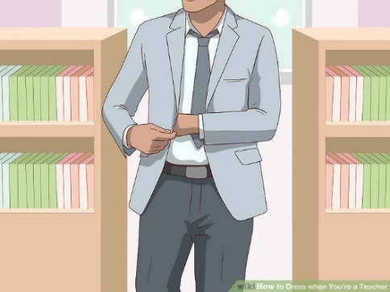 | Professional | He has on dress pants, a dress shirt, and a blazer, which follows the standard dress code.
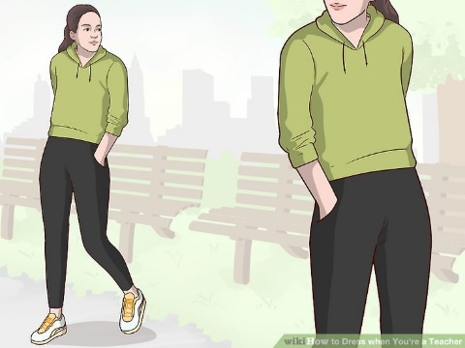 | Unprofessional unless you are a PE teacher | She is wearing athletic clothing. This would only be appropriate for a PE teacher.
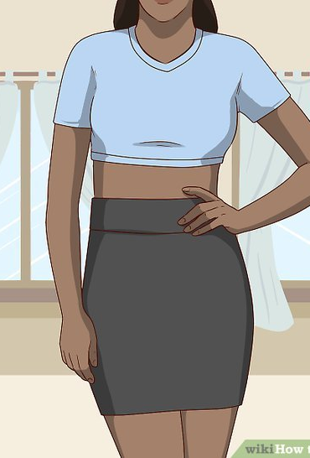 | Unprofessional | She is wearing a short skirt and her stomach is showing.
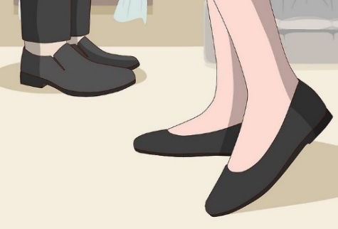 | Professional | They are dress shoes. The dress code typically doesn’t allow flip flops, sneakers, and house shoes. Administrators will have the discretion to make exceptions to appropriateness of attire as it relates to vocational courses, physical education, maintenance, medical necessities, field trips, and spirit days.
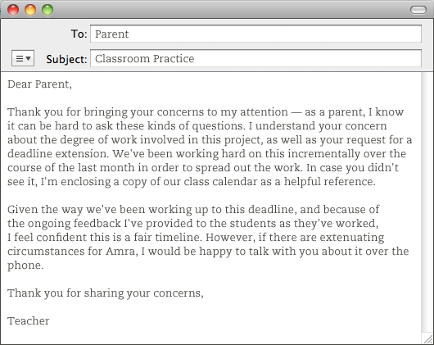 | Professional | The teacher thanks the parents for bringing up the concerns and express their understanding, but respectfully explains that they will not change their timeline. The teacher provides a copy of the timeline and offers to talk with the parents further by phone.
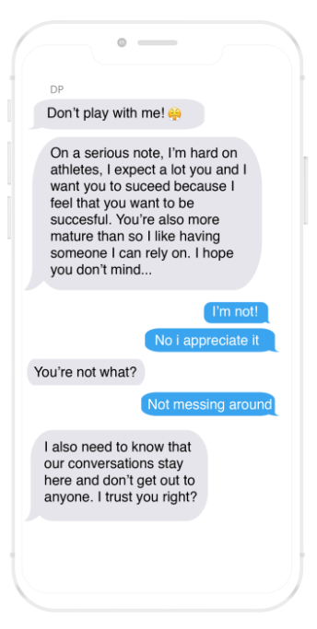 | Unprofessional | The teacher is texting the student and asks the student not to share their conversation with anyone. This goes against the code of ethics.

Practice – Field Site Scenarios
Read each scenario and plan for how you would respond if presented with the same situation based on your local district’s standards of conduct. Then, consider which district standard of conduct this scenario most closely aligns with.

Scenario | How I would respond | Standard of Conduct Alignment
You wake up late on the morning of your site visit and you don’t have time to iron the dress shirt and dress pants you had planned to wear. Your other professional attire is either dirty or wrinkled. What should you do? | I would call my mentor teacher at my field site and my teacher to let them know I will be a few minutes late. Then, I would take the few extra minutes to iron my clothes so I will be presentable. | Student response will vary based on district standards of conduct
One of your students asks for your personal cell phone number so they can share pictures of their project with you. You also notice that they tried to friend you on one of your personal social media accounts. What should you do? | I would ask the student to send the pictures of their project to my school email account and would not accept their friend request on social media. | Student response will vary based on district standards of conduct
One of your friends has a cousin in the class you are assigned to for your practicum. Your friend wants to know what her cousin scored on her last math test. How would you respond? | I would tell my friend that I’m not allowed to share information concerning students. Her cousin will have to tell her what she scored on the test. | Student response will vary based on district standards of conduct
A parent sends you the following email accusing you of calling out his child in the middle of class and embarrassing him:  Dear _____,  Jason came home very upset yesterday. It really upset him when you told him to sit down and get back to work yesterday. He was really embarrassed. Don’t do that again in front of the other kids. Why would you want to humiliate a child by calling him out like that in front of everyone?  Sincerely,  Jason’s dad  How would you respond to this email? | Student responses will vary but should be courteous, polite, and acknowledge the parent’s concern in an appropriate manner. | Student response will vary based on district standards of conduct
A parent calls you on the last day of the grading period to see if there is anything her child can do to raise her grade. She wants to know if there is an extra credit assignment her child can complete to pass the class.  How would you respond? | Student responses will vary but should be courteous, polite, and acknowledge the parent’s concern in an appropriate manner. | Student response will vary based on district standards of conduct
You are in the teacher’s lounge working on a bulletin board when you overhear two teachers talking badly about the principal. As you are leaving the field site, the principal stops to talk to you and notices you are uneasy. What should you do? | I would respect the privacy of the colleagues who made the comments, but I would share the concerns with the principal, so he is aware. | Student response will vary based on district standards of conduct
You have learned many new instructional practices in this course that you want to try, but your mentor teacher is resistant and doesn’t want to make any changes to the way she’s typically done things. What should you do? | I would ask to try some of the new strategies in a small group or in one lesson. I would ask the teacher to share some instructional strategies she has found to be effective. | Student response will vary based on district standards of conduct

