Exit Ticket - Answer Key

Lesson 3.01: Intro to RBIS for Reading Language Arts & the Simple View of Reading
Name:
Date:
Complete the following questions.
- Which of the following is an example of a research-based practice?
  - Students only reading books on their reading level.
  - Explicit and systematic phonics instruction.
  - Teaching phonics as it appears in a text.
  - Ignoring misread words.

- What are four research-based practices for RLA?
- Foundational Skills
- Knowledge Coherence
- Text Complexity
- Text-Based Responses

- Which graphic below correctly shows the Simple View of Reading?
  - 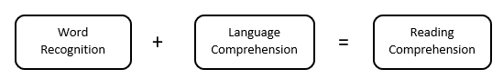
  - 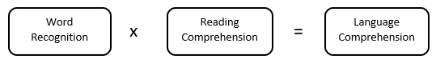
  - 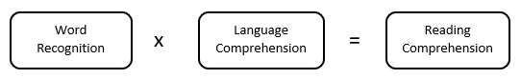
  - 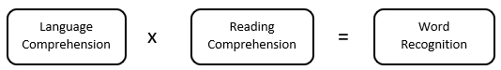

- Why is it important for a student to have strong language comprehension skills and word recognition skills?
Strong reading comprehension cannot occur unless both decoding skills and language comprehension abilities are strong.

