Unit 3: Research-Based Instructional Strategies (RBIS) for Reading Language Arts (RLA)

Lesson 3.01: Intro to RBIS for Reading Language Arts & the Simple View of Reading

Lesson at Glance
Warm-Up (5 mins)  - Bellringer (3 mins)  - Bellringer Review (2 mins) | Instruction (22 mins)  - Notes: Research-Based Instructional Strategies (2 mins)  - Notes: Strategies for Reading Language Arts (5 mins)  - Notes: Science of Reading & Structured Literacy (5 mins)  - Notes: The Simple View of Reading (10 mins) | Application (18 mins)  - Practice: Scenario Analysis (10 mins)  - Debrief (3 mins)  - Exit Ticket (5 mins)

TEKS | 6 | The student plans and uses effective instruction. The student is expected to:  - Apply principles and theories that impact instructional planning;  - Demonstrate competency in foundation and enrichment subject areas;  - Analyze the development of effective instructional strategies;
Objectives | - Describe the relationship between research-based practices and student achievement in reading and language arts.  - Use the simple view of reading to describe the relationship between decoding, language comprehension, and reading comprehension
Rationale/  Summary | There are clear, research-based best practices for instruction. Most certified elementary teachers in Texas must meet the Science of Teaching Reading standards. In this lesson, students will be introduced to Research-Based Instructional Strategies (RBIS) for Reading Language Arts and explore the relationship between decoding, language comprehension, and reading comprehension as shown in the simple view of reading.
Formative Assessment and Exemplar Response | Answer the following questions:  - Which of the following is an example of a research-based practice?  - What are four research-based practices for RLA?  - Which graphic below correctly shows the Simple View of Reading?  - Why is it important for a student to have strong language comprehension skills and word recognition skills?  See Exit Ticket Answer Key for exemplar responses.
Vocabulary | Research-Based Instructional Strategies |  | A set of practices supported by research that should be present in classrooms, regardless of instructional materials
Vocabulary | Foundational Skills |  | A set of skills a student must master to become a skilled reader
Vocabulary | Science of Reading |  | Settled science about how people learn to read
Vocabulary | Structured Literacy |  | Evidence-based practices for teaching foundational literacy skills
Vocabulary | Simple View of Reading |  | A formula demonstrating that to be a skilled reader, a learner must master two basic concepts: word recognition (decoding) and language compression (listening comprehension)
Vocabulary | Word Recognition (Decoding) |  | Ability to apply sound-symbol relationships to read words
Vocabulary | Language Comprehension |  | Ability to understand spoken words

Est Time | Instructional Activities (including formative assessments) | Materials
3 mins | Bellringer:  Complete the Anticipation Guide to self-assess your knowledge and understanding of foundational literacy skills. | Student Guide
2 mins | T: Turn and talk with a neighbor. Share your response for each statement and your reasoning. If you are in an even row, your partner is the person in front of you.  S: (Turn and talk.)  T: (Quickly review responses to Anticipation Guide.)  T: We will return to these questions later in the lesson to see if your thinking shifts based on new learning.
2 mins | Notes: Research-Based Instructional Strategies  T: Research-based instructional strategies are practices that were developed based on the best research available in the field of education and child psychology. They are a set of practices supported by research that should be present in classrooms, regardless of instructional materials. Today, we are going to call them RBIS.  S: (Students record definition in Student Guide.)  T: RBIS are…  - A set of research-based practices that highlights misconceptions common in the field.  - Topics that require conceptual or philosophical shifts in approach to instruction  - A set of practices that are supported by research and should be present in classrooms, regardless of instructional materials.  - A set of practices that relate directly to the design of instructional materials AND/OR the approach required to implement them well.  T: RBIS are NOT…  - Topics that are commonly agreed upon (e.g., materials should be aligned to the standards)  - Topics not related to curriculum and instructional materials (e.g., classroom management best practices)  T: Why should we use research-based practices?  S: We want to ensure that the instructional practices we are using are going to work.  T: Research tells us there are clear best practices in instruction. These practices improve students’ academic achievement and experience.  T: There are many research-based instructional practices. We are going to focus on some of the highest-leverage ones specific to reading language arts. | Student Guide
5 mins | Notes: Strategies for Reading Language Arts (RLA)  T: Let us look at content-specific practices for Reading Language Arts. We will look at each of these practices in more depth throughout this unit.  T: (Share via PPT as students record descriptions in Student Guide.)  Content-specific practices for Reading Language Arts:  - Foundational Skills: Explicit, systematic practice with literacy foundational skills  - Text Complexity: Regular practice with grade-level, complex text, and its academic language  - Knowledge Coherence: Building knowledge and vocabulary through text in all content areas.  - Text-Based Responses: Reading, writing, and speaking grounded in evidence from text, both literary and informational  T: Look at the following image.  T: (Share via PPT.). 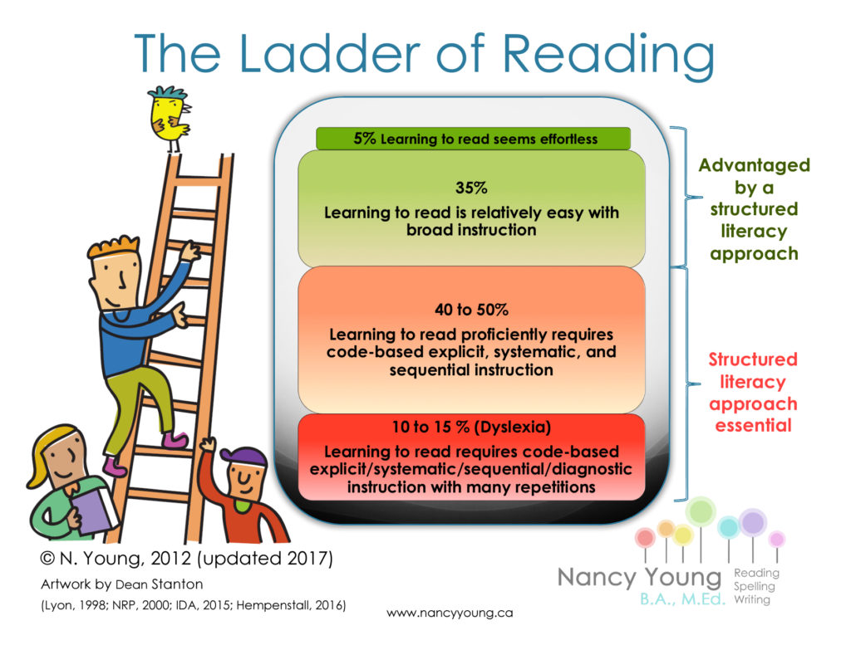  T: What stands out to you? What key points do you notice? Record your observations in your Student Guide.  T: (Provide time for students to record notes in Student Guide.)  T: What stands out to you about this image?  S: Responses will vary but should include:  - Reading is only effortless for about 5% of learners.  - Over 50 to 65% of learners require a structured literacy approach to learn how to read.  T: This image shows the importance of using research-based strategies to teach students how to read. All students benefit from explicit, systematic practice with literacy foundational skills.  T: Read the passage located under “Notes: Strategies for Reading Language Arts (RLA).” As you read, annotate the text. Then, write some ideas that stand out to you.  S: (Read and annotate passage.)  T: (Call on several volunteers to share their reactions to the passage.)  S: Responses will vary.  T: We know that learning to read is critical to a person’s success. We also know that there are scientifically based, effective ways to teach people to read. | PPT  Student Guide
5 mins | Notes: Science of Reading & Structured Literacy  Metacognitive Note: “The Science of Reading is a comprehensive body of research that encompasses years of scientific knowledge, spans across many languages, and shares the contributions of experts from relevant disciplines such as education, special education, literacy, psychology, neurology, and more. The Science of Reading has evolved from a wide span of research designs, experimental methods, participants, and statistical analyses. This conclusive, empirically supported research provides us with the information we need to gain a deeper understanding of how we learn to read, what skills are involved, how they work together, and which parts of the brain are responsible for reading development. From this research, we can identify an evidence-based best practice approach for teaching foundational literacy skills called Structured Literacy.” (IMSE Journal)  T: The science of reading is settled science about how people learn to read. The research-based approach for teaching foundational literacy skills is called structured literacy.  S: (Students record definitions in Student Guide).  T: Before we talk about a structured literacy approach, let us review your answers to the bellringer.  T: What was your response to the following prompt: Learning to read is a natural process?  S: False  T: False is the correct answer. Research supports the idea that learning to read is not a natural process. Reading is a learned skill.  T: What was your response to the following prompt: Instruction should be explicit, systematic, and sequential.  S: True  T: The correct answer is true. Research shows that the brain must learn and practice a discrete set of skills in an explicit and systematic way. Unfortunately, the science of reading has shown that many of the practices used over the years to teach reading were not based on scientific evidence.  T: What was your response to the next prompt - Students get better at reading by simply reading?  S: False  T: The correct answer is false. Again, the brain must learn and practice a discrete set of skills in an explicit and systematic way. Skilled reading does not just happen.  T: What was your response to the following prompt: Misread words should be ignored if they do not interfere with comprehension?  S: False  T: The correct answer is false. This is a common incorrect practice that has occurred for many years, but it only trains the brain to read words incorrectly and to ignore the individual sounds in words.  T: What was your response for the last prompt - Most reading difficulties can be prevented with a structured literacy approach?  S: True  T: The correct answer is true. The science of reading has proven that most reading difficulties can be prevented with a structured literacy approach. | Student Guide
10 mins | Notes: The Simple View of Reading  T: To learn how to read, people must master foundational skills. They are captured in the simple view of reading.  T: (Share via PPT as students record in Student Guide.)  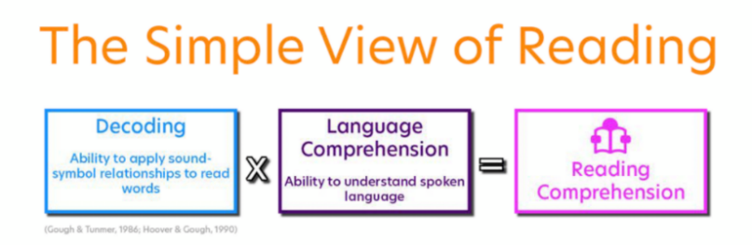  T: The goal for reading is comprehension. We want to be able to understand what we are reading. To have strong reading comprehension, a student must master two basic concepts: decoding and language comprehension.  T: Decoding is the ability to apply sound-symbol relationships to read words.  For example, to decode the word dog, I know that “d” says /d/, “o” says /ŏ/ or /ō/, and “g” says /g/ or /j/. Because I know the sound-symbol relationship and what sounds are used when, I can decode this word as “dog.”  T: (Display the text.)  T: Let us look at how decoding works. You have 20 seconds to read this text:  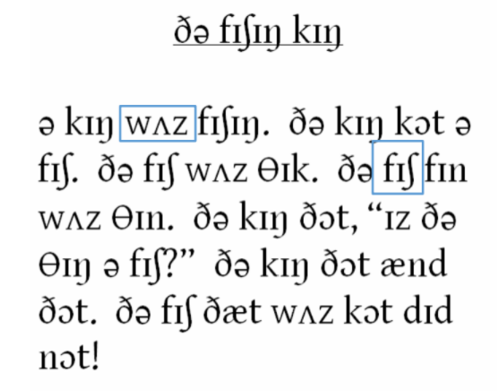  T: (Provide time for students to read.)  T: Who was able to read or understand the text?  T: (Wait for responses.)  T: How did you feel while trying to read this text? What made this difficult?  S: Frustrated. I do not know what any of the symbols/letters mean or say.  T: How did not being able to read the words impact your comprehension?  S: I could not read the words, so I have no idea what the passage is about.  T: Now, use the following code to help you decode the text.  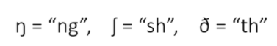  The Fishing King  A king was fishing. The king caught a fish. The fish was thick. The fish fin was thin. The king thought, “is the thing a fish?” The king thought and thought. The fish that was caught did not!  T: How did your ability to decode and comprehend this passage change once I broke down the code for you?  S: I was able to decode more of the words. Because I could now decode the words, I could understand that the passage was about a fishing king.  T: For students who are learning to read, letters may be unfamiliar symbols, like the symbols in this passage were unfamiliar to you. Students need to know how to recognize letters and their sounds.  T: To develop reading comprehension, a learner must also have language comprehension which is the ability to understand spoken words.  T: It is unlikely that a student will be able to understand what they read if they cannot understand the same idea when it is read to them. Let us look at an example. Read the sentence to yourself, then I will call on a volunteer to read it aloud.  T: (Call on a volunteer to read text.)  “Ke gob rih fotbe ug ruddt huff ruan filld uf fe dey.”  T: Was our volunteer able to decode the words?  S: Yes. They read the words aloud.  T: Even though we can decode the words, the sentence has no meaning because the words are nonsense or made-up.  T: Let us look at another example. I want you to tell me what the sentence is about.  “My dog was coated in gloppy muck from flailing in the mud.”  S: The dog is covered in thick mud from struggling or wriggling in the mud.  T: In reading this sentence, you used decoding and language comprehension to read and understand the meaning of the text. | PPT  Student Guide
10 mins | Practice: Scenario Analysis  T: Let us use the simple view of reading to help us determine if a student has strong reading comprehension. You can follow along in your student guide or the PPT.  T: Consider this scenario. Jamie often raises her hand to read aloud during class, and she performs well on oral reading fluency assessments because she reads accurately and at an appropriate rate. She can also decode unfamiliar words with ease. On the other hand, she rarely participates in class discussions and has difficulty answering questions about passages, stories, or books she reads on her own.  T: Do you think Jamie has strong or weak decoding skills? Record your answer in the chart in your student guide.  S: Strong because she can easily read unfamiliar words and does well on fluency assessments.  T: Do you think Jamie has strong or weak language comprehension skills? Record your answer in the chart in your student guide.  S: Weak because she rarely participates in discussion and has difficulty answering questions about the passages, stories, or books she reads on her own.  T: Does Jamie have strong or weak reading comprehension? Record your answer in the chart in your student guide.  S: Weak because her decoding and language comprehension skills are not strong.  T: Jamie appears to have a weakness in language comprehension which is hindering her ability to comprehend what she reads.  T: Now, you are going to work with a partner to analyze more scenarios to determine if the student has strong or weak decoding and language comprehension skills and whether that leads to strong or weak reading comprehension.  T: Locate the remaining scenarios in your student guide under Practice: Scenario Analysis. Read the remaining scenarios and determine if the student has strong or weak decoding and language comprehension skills and whether that leads to strong or weak reading comprehension. You will have 8 minutes to complete the activity. Are there any questions?  S: Students ask questions as needed.  T: You may begin.  S: (Complete practice activity.)
3 mins | Debrief  T: What did you notice about the impact decoding and language comprehension had on overall reading comprehension?  S: The student did not have strong reading comprehension unless both decoding skills and language comprehension skills were strong. If there was a weakness in even one area, the reading comprehension suffered.  T: What is the relationship between RBIS and student achievement in reading and language arts?  S: By using RBIS for reading language arts that focus on explicit and systematic teaching, regular practice with grade-level texts, vocabulary, and background knowledge, and reading comprehension through text-based responses, students are more likely to increase their understanding and mastery of skills. | Student Guide
5 mins | S: (Complete the Exit Ticket.) | Exit Ticket

