Student Guide – Answer Key

Lesson 3.01: Intro to RBIS for Reading Language Arts & the Simple View of Reading
Name:
Date:
Bellringer:
Complete the Anticipation Guide to self-assess your knowledge of foundational literacy skills.
 | True | False
Learning to read is a natural process.
Students learn to read by memorizing what common words look like.
Students get better at reading by simply reading.
Misread words should be ignored if they do not interfere with comprehension.
Most reading difficulties can be prevented with a structured literacy approach.

Notes: Research-Based Instructional Strategies

Research-Based Instructional Practices | A set of practices supported by research that should be present in classrooms, regardless of instructional materials.

Notes: Strategies for Reading Language Arts (RLA)

Content-specific practices for Reading Language Arts:
Foundational Skills | Text Complexity | Knowledge Coherence | Text-Based Responses
Explicit, systematic practice with literacy foundational skills | Regular practice with grade-level, complex text, and its academic language | Building knowledge and vocabulary through text in all content areas | Reading, writing, and speaking grounded in evidence from text, both literary and informational

Vocabulary
Foundational Skills | A set of skills a student must master to become a skilled reader.

Look at the following image. What stands out to you? What key points do you notice?
Responses will vary but should include:
- Reading is only effortless for about 5% of learners.
- Over 50 to 65% of learners require a structured literacy approach to learn how to read.
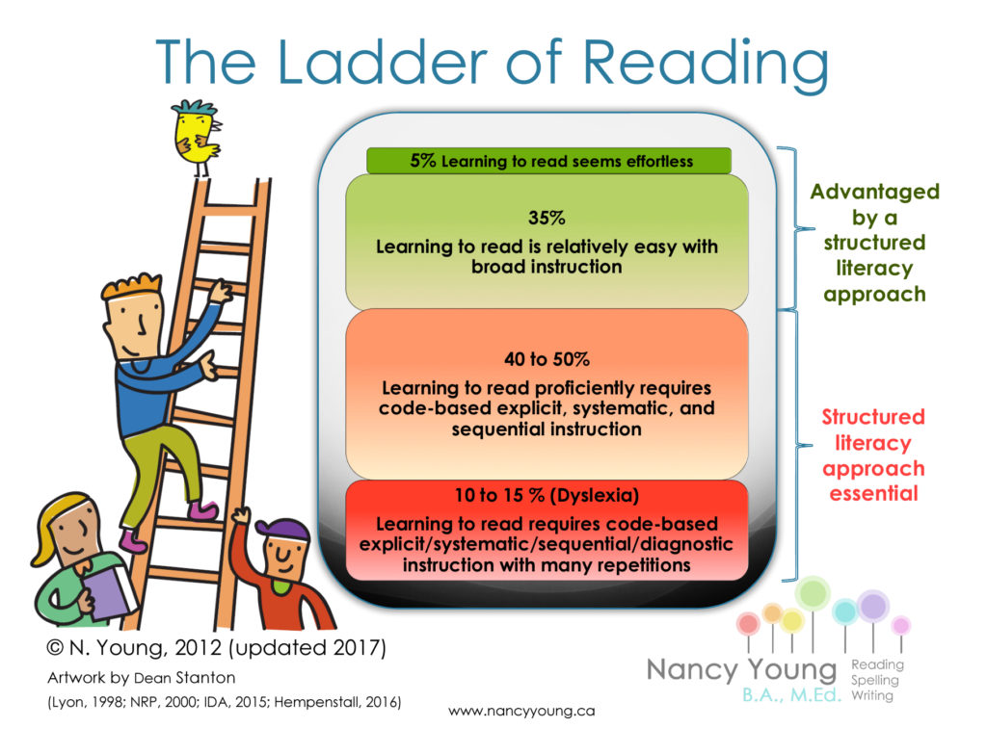
Read and annotate the following passage.

Research shows that reading on grade level by the end of 3rd grade is a predictor of future success. In a long-term study by the Annie E. Casey Foundation, researchers found that students who were not proficient in reading by the end of 3rd grade were four times more likely to drop out of high school than proficient readers. 3rd grade is an essential milestone year for early literacy; if students are not proficient readers by the time they enter the 4th grade, they will be unable to comprehend nearly half of the material they will be exposed to. For this reason, it is essential that teachers understand how reading skills are developed over time and are knowledgeable on research-based practices to support students in becoming skilled readers.

What were some key ideas that stood out to you from the passage?
Student responses will vary but may include:
- Over 50% of students need explicit, systematic, and sequential instruction.
- Learning to read is effortless to only 5% of students.

Intro to Science of Reading & Structured Literacy
Science of Reading | Settled science about how people learn to read.
Structured Literacy | Evidence-based practices for teaching foundational literacy skills.

Simple View of Reading
Reading Comprehension
Language Comprehension
Word Recognition
(Decoding)
X =

Simple View of Reading | A formula demonstrating that to be a skilled reader, a learner must master two basic concepts: word recognition (decoding) and language compression (listening comprehension).
Word Recognition (Decoding) | Ability to apply sound-symbol relationships to read words.
Language Comprehension | Ability to understand spoken words.

Practice – Scenario Analysis
Determine if the student has strong or weak decoding and language comprehension skills and whether that leads to strong or weak reading comprehension.
Scenario | Decoding | Language Comprehension | Reading Comprehension
Jamie often raises her hand to read aloud during class and she performs well on oral reading fluency assessments because she reads accurately and at an appropriate rate. She can also decode unfamiliar words with ease. On the other hand, she rarely participates in class discussions and has difficulty answering questions about passages, stories, or books she reads on her own. | Strong  Weak | Strong  Weak | Strong  Weak
Donte is a straight A student. He enjoys reading and discussing many subjects, such as social studies and biology. His least favorite subject is math even though he still performs well on his math assignments and assessments. Donte is the captain of his high school debate team and editor of the school newspaper. He is hoping to be valedictorian of his class one day and become the first in his family to go to college. | Strong  Weak | Strong  Weak | Strong  Weak
Jarrell is a very curious student and loves to learn about various topics. He eagerly listens to classroom instruction from the teacher, remembers details, and can make great connections across the content. He often dominates much of the class discussion because he is so eager to share what he knows. Although he loves to participate, Jarrell does not like to read aloud or read on his own. During written assignments, he often gets frustrated because of his spelling, and he cannot seem to get his thoughts down onto paper. | Strong  Weak | Strong  Weak | Strong  Weak
Mia is a senior and eager to graduate. She struggles to pass all her classes and finds studying, notetaking, and even talking about the content difficult. Mia is often seen as the class clown, especially when she is asked to do tasks in groups or in front of the whole class, such as reading aloud. Mia does not want to go to college, even though she was offered a soccer scholarship because she thinks school is too hard. She plans to live at home and work. | Strong  Weak | Strong  Weak | Strong  Weak

