Exit Ticket

Lesson 3.02: Systematic and Explicit Literacy Instruction
Name:
Date:
Examine the following lesson plan for evidence of explicit instruction and complete the chart that follows.
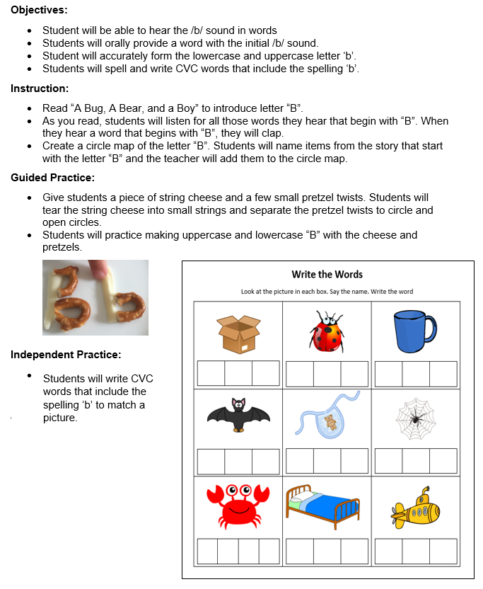

 | Criteria | Lesson Plan | Reasoning
Explicit | Clear, direct teaching | - Met  - Not Met
Explicit | Frequent checks for understanding | - Met  - Not Met
Explicit | Active participation | - Met  - Not Met
Systematic | Logically sequenced | - Met  - Not Met
Systematic | Builds on prior knowledge | - Met  - Not Met
Systematic | Proceeds in manageable steps | - Met  - Not Met

