Exit Ticket - Answer Key

Lesson 3.02: Systematic and Explicit Literacy Instruction
Name:
Date:
Examine the following lesson plan for evidence of explicit instruction and complete the chart that follows.

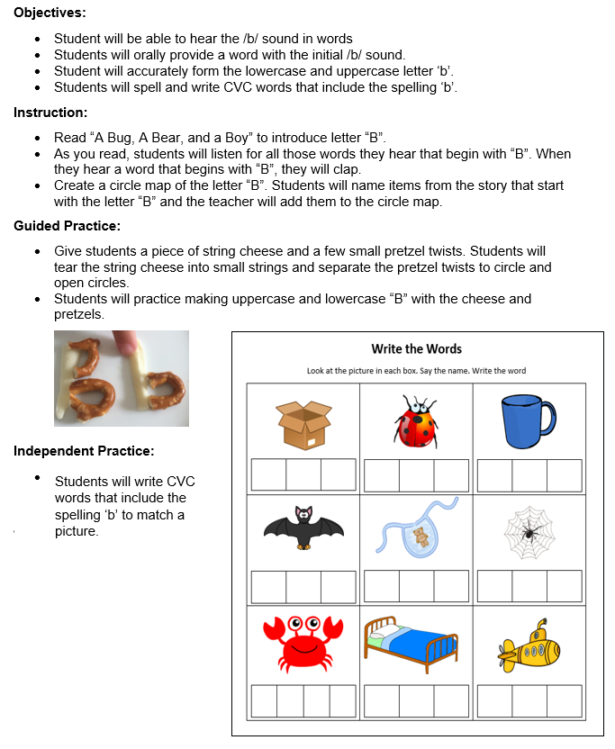

 | Criteria | Lesson Plan | Reasoning
Explicit | Clear, direct teaching | - Met  - Not Met | The teacher does not provide direct teaching on the objectives
Explicit | Frequent checks for understanding | - Met  - Not Met | There is no evidence of checks for understanding
Explicit | Active participation | - Met  - Not Met | Students have multiple opportunities to actively participate
Systematic | Logically sequenced | - Met  - Not Met | The lesson moves for students hearing and producing words with the /b/ sound to making the letter be with string cheese and pretzels to writing CVC words that state with /b/
Systematic | Builds on prior knowledge | - Met  - Not Met | No evidence that the lesson builds on students’ prior knowledge
Systematic | Proceeds in manageable steps | - Met  - Not Met | The teacher does not model any of the skills practiced in the lesson

