Unit 3: Research-Based Instructional Strategies (RBIS) for Reading Language Arts (RLA)

Lesson 3.02: Systematic and Explicit Literacy Instruction

Lesson at Glance
Warm-Up (5 mins)  - Bellringer | Instruction (12 mins)  - Notes: Systematic and Explicit Literacy Instruction | Application (28 mins)  - Practice 1: Scenario Analysis (5 mins)  - Practice 2: Lesson Analysis (15 mins)  - Debrief (3 mins)  - Exit Ticket (5 mins)

TEKS | 6 | The student plans and uses effective instruction. The student is expected to:  - Apply principles and theories that impact instructional planning;  - Develop instructional materials that align with the Texas Essential Knowledge and Skills;  - Demonstrate competency in foundation and enrichment subject areas;  - Analyze concepts for developing effective instructional strategies;  - Evaluate and analyze effectiveness of lessons plans and instructional strategies used in a lesson or series of lessons.
Objectives | - Define systematic and explicit literacy instruction.  - Explain the importance of systematic and explicit literacy instruction.  - Identify examples and nonexamples of systematic and explicit foundational literacy instruction
Rationale/  Summary | Research suggests that reading is only effortless for about 5% of learners. Over 50 to 65% of learners require a structured literacy approach to learn how to read. Studies show that students who receive systematic and explicit phonics instruction are better readers at the end of instruction than students who receive non-systematic or no phonics instruction. Instruction in foundational literacy should be systematic and explicit and include practice. Students need systematic and sequenced K-2 instruction and intervention, explicit and intentional daily instruction, and practice of specific skills in and out of text, including making meaning from what is read. In this lesson, students will learn the components of systematic and explicit literacy instruction, why it is important, and analyze lessons plans to identify examples and nonexamples of systematic and explicit instruction.
Formative Assessment and Exemplar Response | Examine the following lesson plan for evidence of explicit instruction and complete the chart that follows.  See Exit Ticket Answer Key for exemplar responses.
Vocabulary | Phonics |  | The study of the relationships between letters and the sounds they represent
Vocabulary | Systematic Phonics Instruction |  | Structured phonics instructional routines that provide step-by-step procedures and a scope and sequence of skills from less complex to more complex to allow students to build upon prior knowledge
Vocabulary | Explicit Phonics Instruction |  | Teacher directed phonics instruction that clearly explains and models each individual concept
Vocabulary | Incidental Phonics |  | Teacher directed instruction that does not follow a planned sequence of phonics concepts to guide instruction. Concepts and skills are taught as they appear in text.

Est Time | Instructional Activities (including formative assessments) | Materials
5 mins | Bellringer:  Look at the Ladder of Reading and the Simple View of Reading. How do these two things relate? | Student Guide
12 mins | Notes: Systematic and Explicit Literacy Instruction  T: In our previous lesson, we discussed key research-based instructional strategies that should be present in RLA classrooms.  - Foundational Skills: Explicit, systematic practice with literacy foundational skills  - Text Complexity: Regular practice with grade-level, complex text, and its academic language  - Knowledge Coherence: Building knowledge and vocabulary through text in all content areas.  - Text-Based Responses: Reading, writing, and speaking grounded in evidence from text, both literary and informational  T: (Share strategies via PPT.)  T: We also looked at the Ladder of Reading and the Simple View of Reading.  T: (Share image via PPT.)  T: For your bellringer, you thought about how these two are related. Can I have some volunteers share their thoughts?  S: The ladder of reading shows that reading is only effortless for about 5% of learners. Over 50 to 65% of learners require a structured literacy approach to learn how to read. The simple view of reading shows that, to have strong reading comprehension, a person must have strong decoding skills and strong language comprehension skills, which require explicit and systemic instruction.  T: Research tells us that almost 65% of learners require a structured approach to learning to read using evidence-based strategies.  T: Today, we are going to focus on strategies to support foundational reading skills.  T: Raise your hand if you have ever heard of the word phonics?  S: (Raise hands, if applicable.)  T: Who can tell me what phonics means?  S: Working with letters and letters sounds.  T: Phonics is the study of the relationships between letters and the sounds they represent. Phonics pertains to learning to read printed alphabetic symbols.  T: Instruction in foundational literacy, such as phonics instruction, should be systematic, explicit, and include practice.  T: What do you think of when you hear the word systematic?  S: There is a certain system or way of doing something.  T: Systematic phonics is structured instructional routines that provide step-by-step procedures and a scope and sequence of skills from less complex to more complex to allow students to build upon prior knowledge. Incidental phonics on the other hand, does not follow a planned sequence of phonics concepts to guide instruction. Concepts and skills are taught as they appear in text.  T: What do you remember about explicit instruction?  S: It involved direct instruction and modeling from the teacher.  T: Explicit phonics instruction is teacher-directed instruction that clearly explains and models each concept. Explicit instruction makes the code of the English language transparent for all students.  S: (Add definitions to Student Guide.)  T: During explicit instruction, students need opportunities to:  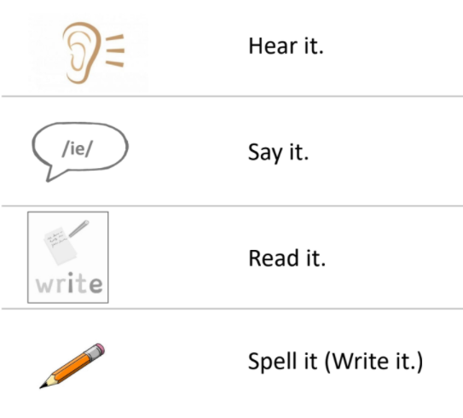  T: Students who received systematic and explicit phonics instruction were better readers at the end of instruction than students who received non-systematic or no phonics instruction (Ehri, 2006; Armbruster, Lehr, and Osborn, 2001).  T: Systematic and explicit instruction should include the following:  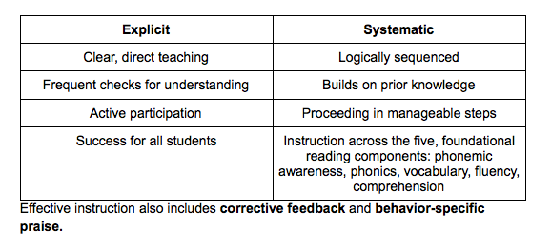  S: (Complete table in Student Guide.)  T: Let us look at how systematic and explicit phonics compares to incidental or non-systematic phonics. Look at the attributes for both systematic and incidental.  T: (Share content via PPT.)  S: (Complete table in Student Guide.)  T: What are some of the key differences you notice between systematic and explicit phonics vs incidental phonics?  S: With systematic and explicit instruction, students are directly taught key skills in isolation and through blending; skills are introduced in a logical order; and skills gradually increase in difficulty. With incidental instruction, skills are taught as they are encountered with no logical sequence or order to complexity.  T: Let us look at some examples and non-examples of systematic instruction.  T: The first characteristic of systematic instruction is that sound/spelling relationships are directly taught in isolation. What does isolation mean?  S: By itself.  T: Isolation means that students are taught the letter and its corresponding sound individually before being asked to read the pattern in a text. If I wanted you to learn the /oo/ sound, I would teach you what /oo/ looks like, and sounds like in isolation before having you read it in a word or sentence. I would have you practice saying the sound for /oo/ multiple times, have you practice listening for the sound in words, and practice writing “oo” for /oo/. Once you have learned that sound in isolation, then I would have you practice blending or putting the /oo/ sound together with other previously taught letter sounds to read words, such as “moon” or “spoon.”  T: With incidental phonics, while reading a book, the teacher might stop and ask students to say what they think “m-o-o-n” spells by looking at the picture in the book.  T: With incidental phonics, sounds and symbols would be introduced as they are encountered in a text. For example, if we were reading a book about space and came across the word “moon.” I would stop and tell you that the “oo” in this word says /oo/.  T: Another important characteristic of systematic phonics is that sound and spelling relationships or patterns are introduced in a logical order that increases difficulty. That means I would not teach you the sound for “oo” until I have first taught you the sound for “o” or other less difficult vowel combinations. Because incidental phonics addresses spelling patterns and sounds as they are encountered in text, there is no order to how spelling patterns or sounds are taught. Students could easily learn the /oo/ sound or other more difficult vowel patterns before they ever learn basic letter sounds, such as /o/. | PPT  Student Guide
  Systematic | Incidental
  Sound/spelling relationships are directly taught in isolation | Sound and spelling relationships are inferred from reading whole words
  Direct instruction and practice with blending previously taught sound/spelling patterns | Sound and spelling relationships are introduced as they are encountered in texts
  Sound/spelling relationships are introduced in a logical sequence and increase in difficulty | No logical sequence or progression of skills
5 mins | Practice 1: Scenario Analysis  T: Read each scenario and determine which scenario is more likely to lead students to a better understanding of the objective.  Objective for Both Scenarios:  Students will provide the corresponding sound when presented with the lowercase letter ‘k’ and write the spelling ‘k’ to represent /k/.  Scenario 1:  Explain that today, we will learn the sound /k/ and have students repeat the sound. Point to the alphabet card for Kk. Explain that the picture of the kite will help them remember the sound /k/ since the word kite begins with /k/. Write k on the board, point to the spelling, and say the letter name. Tell the student that the letter k stands for the sound /k/. Have students repeat the sound as you point to the spelling. Have students trace the letter k on their desks with one finger as they say /k/.  Scenario 2:  Explain that today, we will learn the sound /k/. Show a video to introduce the sound /k/. Hold up the alphabet card for Kk and ask students to repeat after you – K, Kite, /K/. Write the letter k on the board. Tell students this is letter k, and it makes the sound /k/. Ask students to turn and talk with a partner about other words they know that begin with the letter k. Students will go to their desks and make an alphabet wheel that has different words that start with /k/.  T: Which scenario is more likely to lead students to a better understanding of the objective?  S: Scenario 1 is more likely to lead students to a better understanding of the objective because students are practicing repeating the /k/ sound and tracing the letter ‘k’. In Scenario 2, the students are introduced to the letter ‘k’ for /k/, but they do not have the opportunity to practice repeating the sound or tracing the letter, which are the objectives for this lesson. Students talk with each other about words that begin with the letter ‘k’ and then create a wheel with words that begin with ‘k.’  T: What could the teacher in Scenario 2 have done differently?  S: Provided opportunities for the students to practice the /k/ sound and writing ‘k’ for /k/ opposed to just thinking of words that begin with /k/.
15 mins | Practice 2: Lesson Analysis  T: Review the materials in your Student Guide, excerpted from Amplify Texas Elementary Literacy program (First Grade, Unit 3 Skills, Lesson 12) for connections to RBIS 1: Foundational Skills.  T: Determine if the lesson plan provides systematic and explicit instruction and record evidence on your graphic organizer. | Student Guide
3 mins | Debrief  T: How were the materials systematic and explicit?  S: The teacher clearly and explicitly models the sound /oi/ and the spelling for the sound; the teacher checks for understanding as students trace ‘oi’ and make the sound; students have multiple opportunities to practice the sound /oi/ in isolation and in words. Students practice writing the spelling for /oi/ and read words with /oi/; the sequence of activities in the lesson are logically sequenced from just saying /oi/ to tracing the spelling for /oi/ then writing and reading words with /oi/; the teacher models the sound/spelling first then has students practice with guidance. Students then can practice the skill independently.  T: Why is it important to provide systematic and explicit instruction when teaching foundational reading skills?  S: According to the ladder of reading, over 50% to 65% of learners need a structured approach to learn how to read using evidence-based strategies. We have learned that systematic and explicit instruction provides clear, direct teaching that is logically sequenced, frequent checks for understanding, builds on prior knowledge, requires active participation, and proceeds in manageable steps.
5 mins | S: (Complete the Exit Ticket.) | Exit Ticket

