Student Guide

Lesson 3.02: Systematic and Explicit Literacy Instruction
Name:
Date:
Bellringer:
Look at the Ladder of Reading and the Simple View of Reading. How do these two things relate?

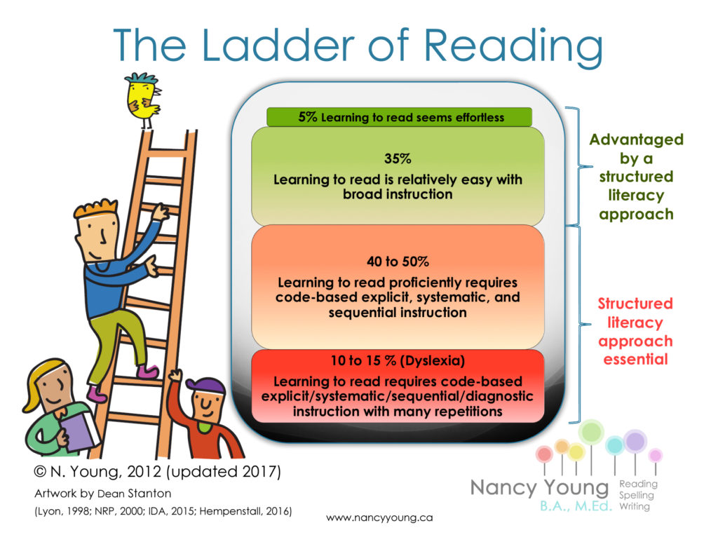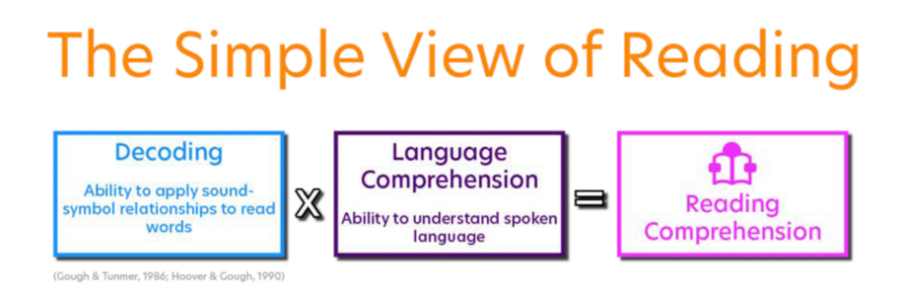

Notes: Systematic and Explicit Literacy Instruction
Phonics
Systematic Phonics Instruction
Explicit Phonics Instruction
Incidental Phonics

During explicit instruction, students need opportunities to:

Explicit | Systematic

Systematic | Example | Incidental | Example

Practice 1 – Scenario Analysis
Read each scenario and determine which scenario is more likely to lead students to a better understanding of the objective and why.

Objective for Both Scenarios:
Students will provide the corresponding sound when presented with the lowercase letter ‘k’ and write the spelling ‘k’ to represent /k/.

Scenario 1:
Explain that today, we will learn the sound /k/ and have students repeat the sound. Point to the alphabet card for Kk. Explain that the picture of the kite will help them remember the sound /k/ since the word kite begins with /k/. Write k on the board, point to the spelling, and say the letter name. Tell the student that the letter k stands for the sound /k/. Have students repeat the sound as you point to the spelling. Have students trace the letter k on their desks with one finger as they say /k/.

Scenario 2:
Explain that today, we will learn the sound /k/. Show a video to introduce the sound /k/. Hold up the alphabet card for Kk and ask students to repeat after you – K, Kite, /K/. Write the letter k on the board. Tell students this is letter k, and it makes the sound /k/. Ask students to turn and talk with a partner about other words they know that begin with the letter k. Students will go to their desks and make an alphabet wheel that has different words that start with /k/.

Practice 2: Lesson Analysis
Review the materials below, excerpted from Amplify Texas Elementary Literacy program (First Grade, Unit 3 Skills, Lesson 12) for connections to RBIS (Research Based Instructional Strategies) 1: Foundational Skills. How are the materials systematic and explicit? Record evidence in the graphic organizer.
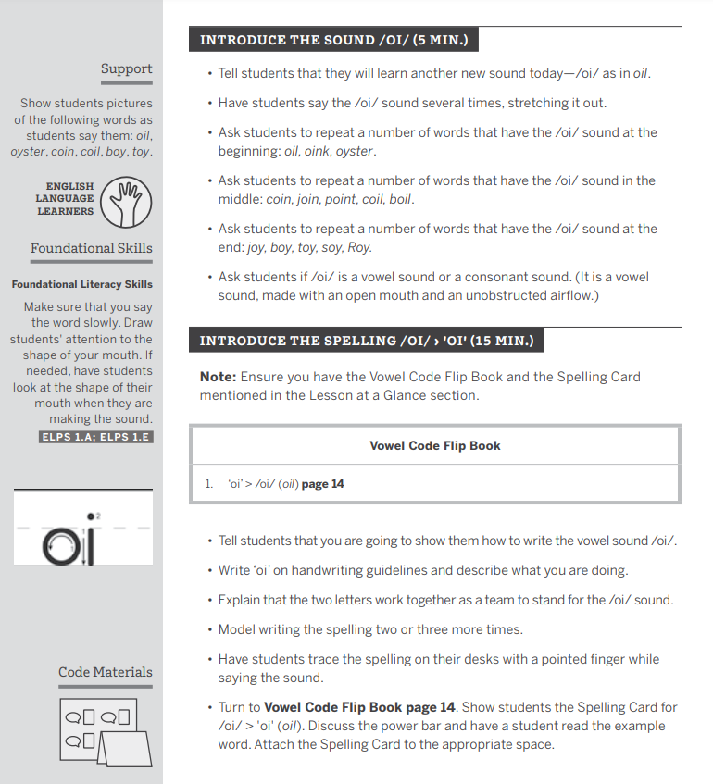
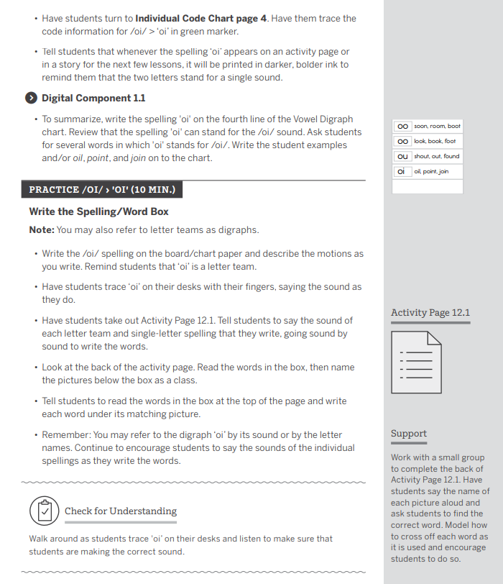

 | Criteria | Lesson Plan | Reasoning
Explicit | Clear, direct teaching | - Met  - Not Met
Explicit | Frequent checks for understanding | - Met  - Not Met
Explicit | Active participation | - Met  - Not Met
Systematic | Logically sequenced | - Met  - Not Met
Systematic | Builds on prior knowledge | - Met  - Not Met
Systematic | Proceeds in manageable steps | - Met  - Not Met

