Student Guide – Answer Key

Lesson 3.02: Systematic and Explicit Literacy Instruction
Name:
Date:
Bellringer:
Look at the Ladder of Reading and the Simple View of Reading. How do these two things relate?

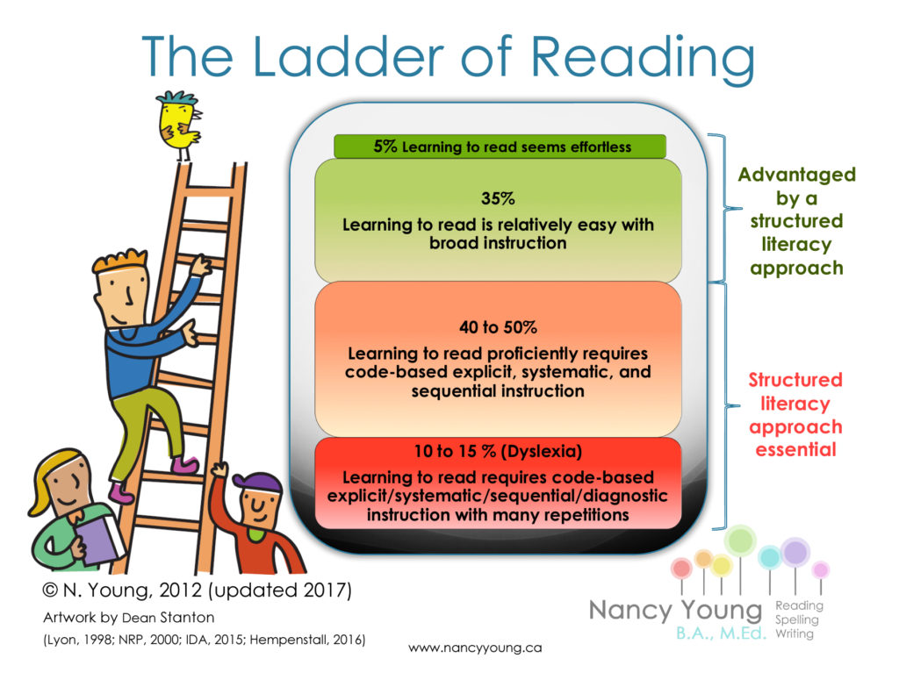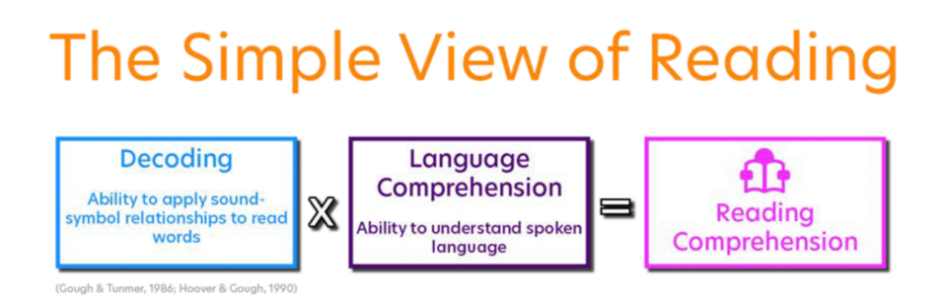
The ladder of reading shows that reading is only effortless for about 5% of learners. Over 50 to 65% of learners require a structured literacy approach to learn how to read. The simple view of reading shows that, to have strong reading comprehension, a person must have strong decoding skills and strong language comprehension skills. To gain these skills, learners need a structured approach to reading that includes the use of research-based strategies and explicit instruction.

Notes: Systematic and Explicit Literacy Instruction
Phonics | The study of the relationships between letters and the sounds they represent.
Systematic Phonics Instruction | Structured instructional routines that provide step-by-step procedures and a scope and sequence of skills from less complex to more complex to allow students to build upon prior knowledge.
Explicit Phonics Instruction | Teacher directed instruction that clearly explains and models each individual concept.
Incidental Phonics | Teacher directed instruction that does not follow a planned sequence of phonics concepts to guide instruction. Concepts and skills are taught as they appear in text.

During explicit instruction, students need opportunities to:
- Hear it.
- Say it.
- Read it.
- Spell it (write it).

Explicit | Systematic
Clear, direct teaching | Logically sequenced
Frequent checks for understanding | Builds on prior knowledge
Active participation | Proceeds in manageable steps

Systematic | Example | Incidental | Example
Sound/spelling relationships are directly taught in isolation. | Teach the sound for “oo” individually. Have students repeat the sound multiple times and practice writing the “oo” for the sound /oo/. | Sound and spelling relationships are inferred from reading whole words. | The teacher asks students to say what they think “m-o-o-n” spells by looking at the picture in the book.
Direct instruction and practice with blending previously taught sound/spelling patterns. | Once students have learned that “oo” says /oo/ they will practice blending that sound with other known sounds to make and read words. | Sound and spelling relationships are introduced as they are encountered in texts. | The teacher tells students that “oo” says /oo/ as they come across the word “moon” in a book.
Sound/spelling relationships are introduced in a logical sequence and increase in difficulty | Students would not learn the /oo/ sound until after they have mastered the /o/ sound and other more difficult vowel patterns. | No logical sequence or progression of skills | Sounds and patterns are taught as they are encountered in books. Students may learn /oo/ before they have learned other vowels and vowel patterns.

Practice 1 – Scenario Analysis
Read each scenario and determine which scenario is more likely to lead students to a better understanding of the objective and why.

Objective for Both Scenarios:
Students will provide the corresponding sound when presented with the lowercase letter ‘k’ and write the spelling ‘k’ to represent /k/.

Scenario 1:
Explain that today, we will learn the sound /k/ and have students repeat the sound. Point to the alphabet card for Kk. Explain that the picture of the kite will help them remember the sound /k/ since the word kite begins with /k/. Write k on the board, point to the spelling, and say the letter name. Tell the student that the letter k stands for the sound /k/. Have students repeat the sound as you point to the spelling. Have students trace the letter k on their desks with one finger as they say /k/.

Scenario 2:
Explain that today, we will learn the sound /k/. Show a video to introduce the sound /k/. Hold up the alphabet card for Kk and ask students to repeat after you – K, Kite, /K/. Write the letter k on the board. Tell students this is letter k, and it makes the sound /k/. Ask students to turn and talk with a partner about other words they know that begin with the letter k. Students will go to their desks and make an alphabet wheel that has different words that start with /k/.
Scenario 1 is more likely to lead students to a better understanding of the objective because students are practicing repeating the /k/ sound and tracing the letter ‘k’. In Scenario 2, the students are introduced to the letter ‘k’ for /k/, but they do not have the opportunity to practice repeating the sound or tracing the letter, which are the objectives for this lesson. Students talk with each other about words that begin with the letter ‘k’ and then create a wheel with words that begin with ‘k.’

Practice 2: Lesson Analysis
Review the materials below, excerpted from Amplify Texas Elementary Literacy program (First Grade, Unit 3 Skills, Lesson 12) for connections to RBIS (Research Based Instructional Strategies) 1: Foundational Skills. How are the materials systematic and explicit? Record evidence in the graphic organizer.
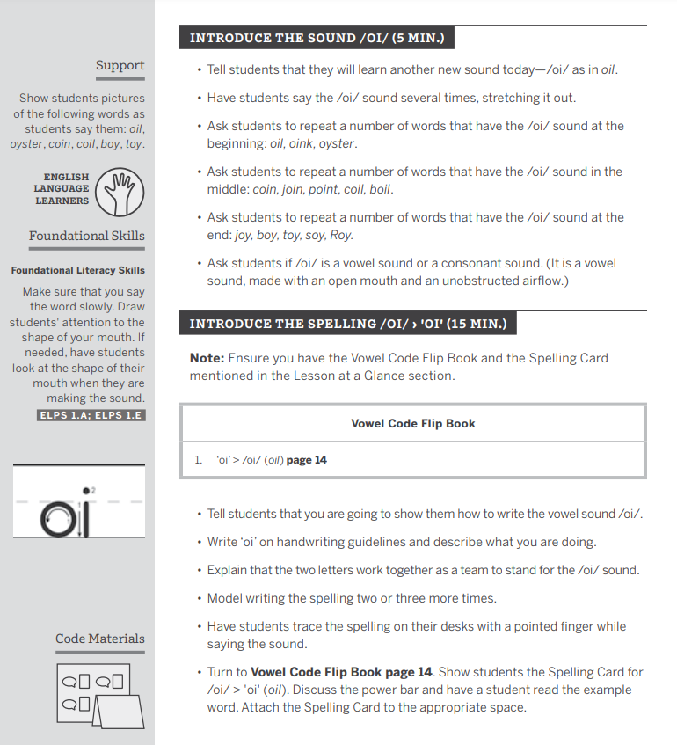
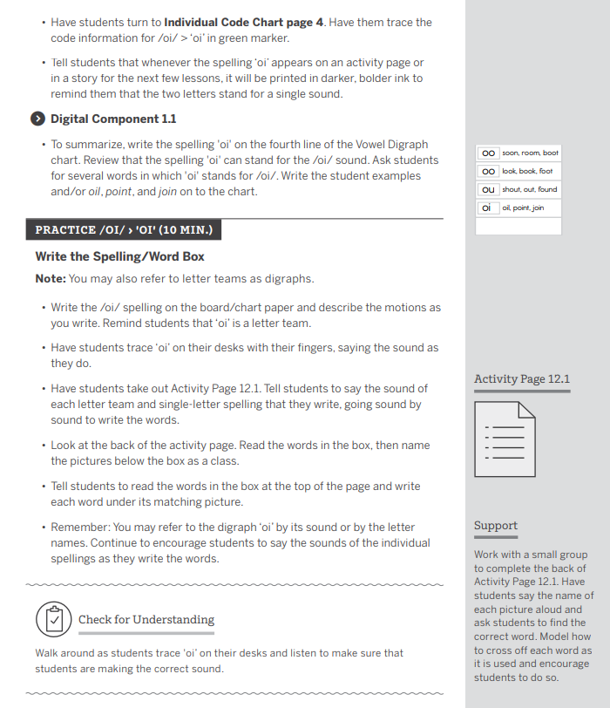

 | Criteria | Lesson Plan | Reasoning
Explicit | Clear, direct teaching | - Met  - Not Met | The teacher clearly and explicitly models the sound /oi/ and the spelling for the sound.
Explicit | Frequent checks for understanding | - Met  - Not Met | Teacher checks for understanding as students trace ‘oi’ and make the sound.
Explicit | Active participation | - Met  - Not Met | Students have multiple opportunities to practice the sound /oi/ in isolation and in words. Students practice writing the spelling for /oi/ and read words with /oi/.
Systematic | Logically sequenced | - Met  - Not Met | The sequence of activities in the lesson are logically sequenced from just saying /oi/ to tracing the spelling for /oi/ then writing and reading words with /oi/.
Systematic | Builds on prior knowledge | - Met  - Not Met | No evidence in the lesson.
Systematic | Proceeds in manageable steps | - Met  - Not Met | The teacher models the sound/spelling first then has students practice with guidance. Students then can practice the skill independently.

