Exit Ticket

Lesson 3.04: Practice in and Out of Text
Name:
Date:
Examine the following lesson plan and determine how students were asked to practice.
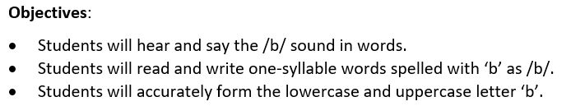
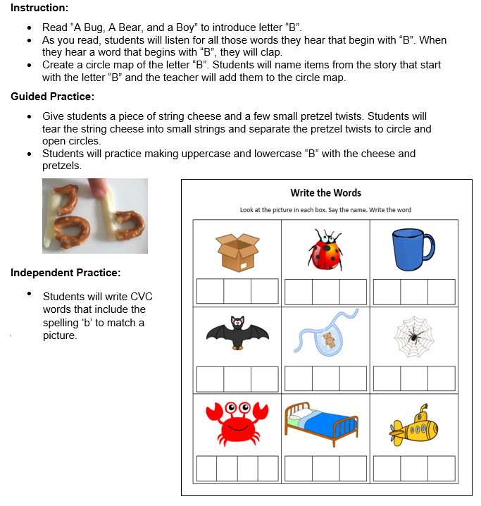

Practice Out of Text (Isolation) | Practice in Text

What are two ways that this practice activity does not provide opportunities for deliberate practice of skills in and out of context?

What impact might this have on students’ ability to master the objectives?

