Exit Ticket - Answer Key

Lesson 3.04: Practice in and Out of Text
Name:
Date:
Examine the following lesson plan and determine how students were asked to practice.
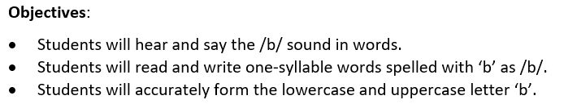
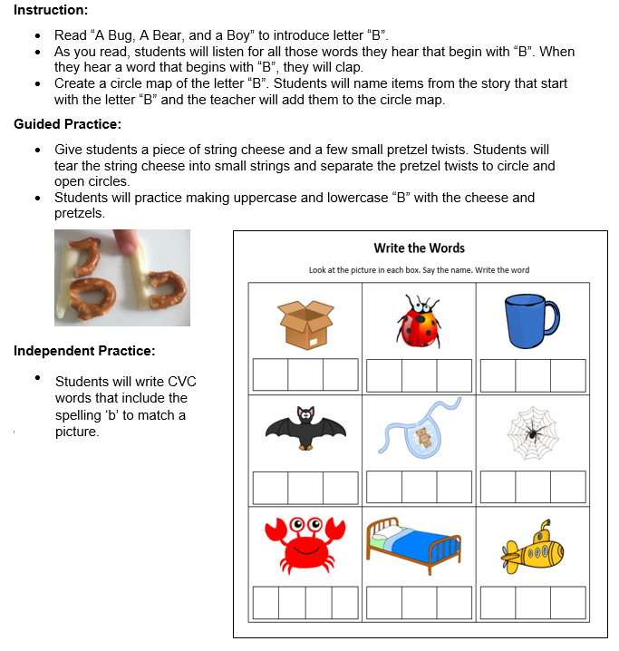

Practice Out of Text (Isolation) | Practice in Text
Students practice making the letter ‘b’ with string cheese and pretzels.
Students write CVC words with the spelling ‘b’ to match a picture.

What are two ways that this practice activity does not provide opportunities for deliberate practice of skills in and out of context?
Answers may include:
- Students did not have the opportunity to read words with the ‘b’ as /b/.
- Students did not have the opportunity to practice reading words with ‘b’ as /b/ in a text.
What impact might this have on students’ ability to master the objectives?
Students may meet the first objective to hear and say the /b/ sounds in words. Students did not participate in much deliberate practice in reading or writing words with the /b/ sounds. They only formed uppercase B with pretzels and cheese. Because of this, students may have difficulty mastering the second two objectives.

