Student Guide – Answer Key

Lesson 3.04: Practice in and Out of Text
Name:
Date:
Bellringer:
Complete the Anticipation Guide to review the criteria for deliberate practice.

Statement | Agree | Disagree | Reasoning
The practice should require the student to be authentic or perform the actual learning goal.
Practice does not need to be spaced over time.
Practice should be high-stakes and always count for a grade
Practice should be paired with timely feedback

Based on the anticipation guide, what are the criteria for deliberate practice that you explored in previous units?

Discussion: Introduction to Practice in and Out of Text
Deliberate Practice
Interactive
Modalities
Outside of Text
In Text
Decodable Text

Watch the video clip to see decodable words in isolation and in text. As you watch, record ways the students practice /ee/ both in isolation and in text.
Practice in Isolation | Practice in Text

Practice: Lesson Review
Review the materials excerpted from Grade 1, Unit 3, Lesson 12.
How does the lesson offer opportunities for practice in and out of text? Record evidence in the graphic organizer.
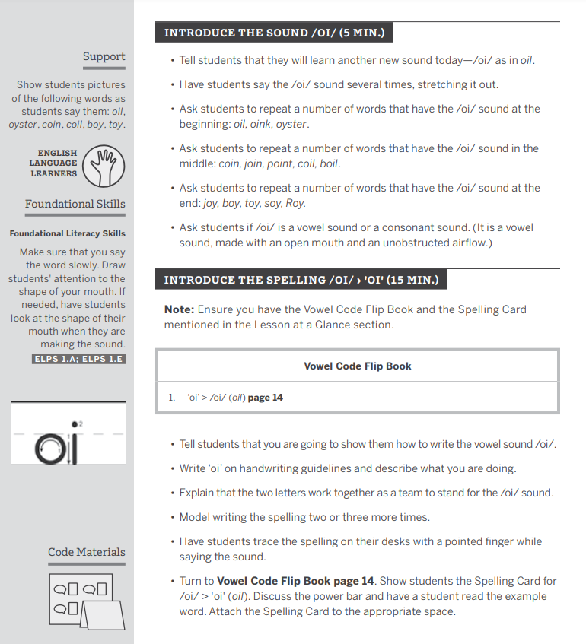
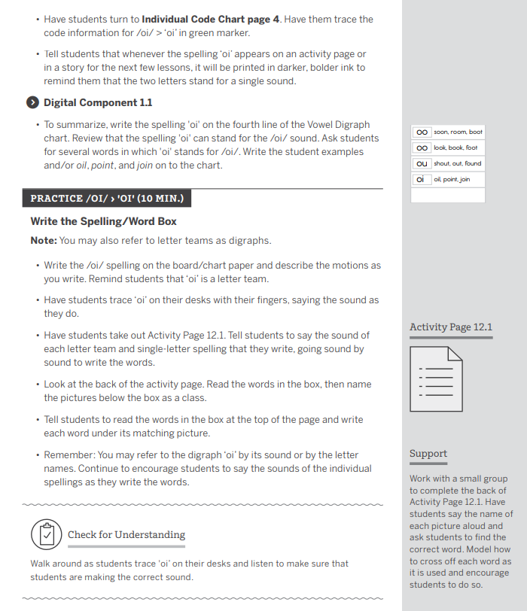
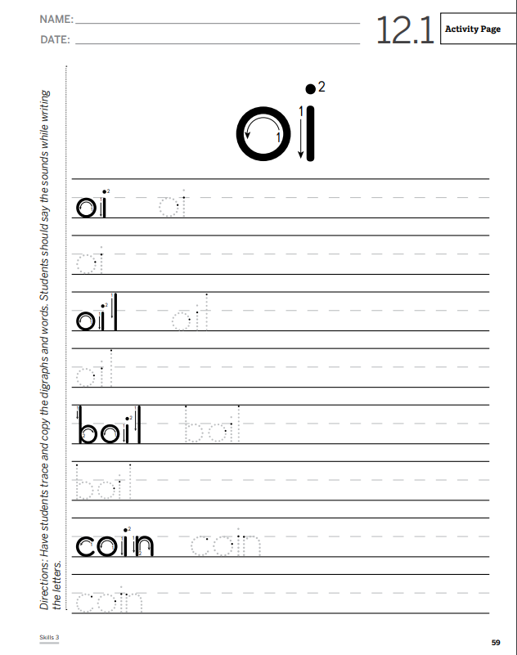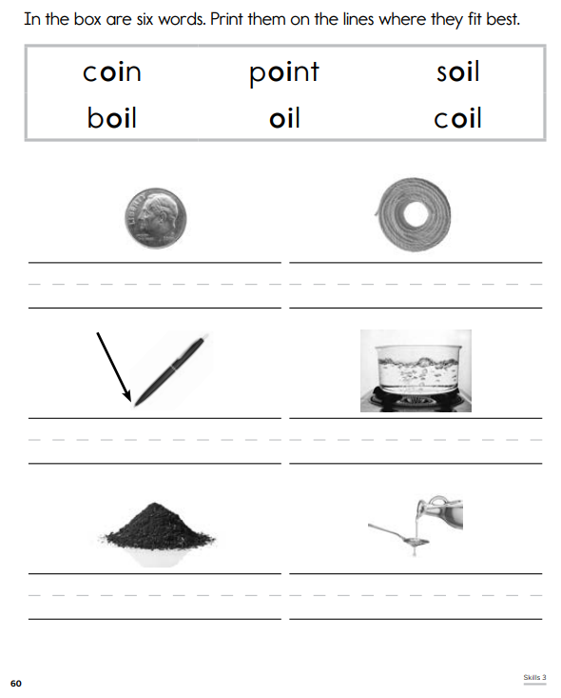

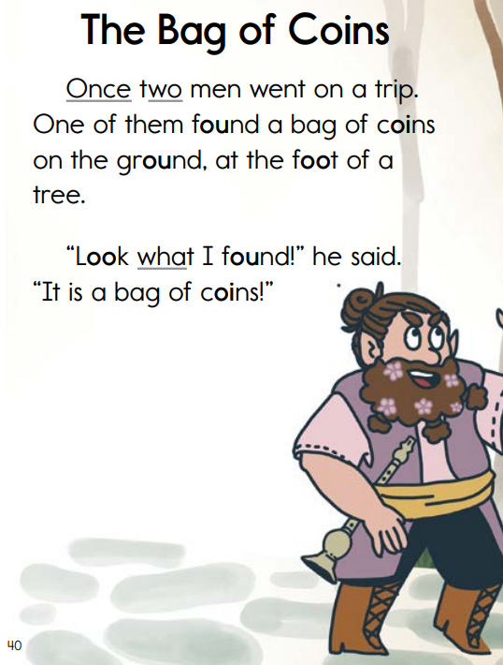
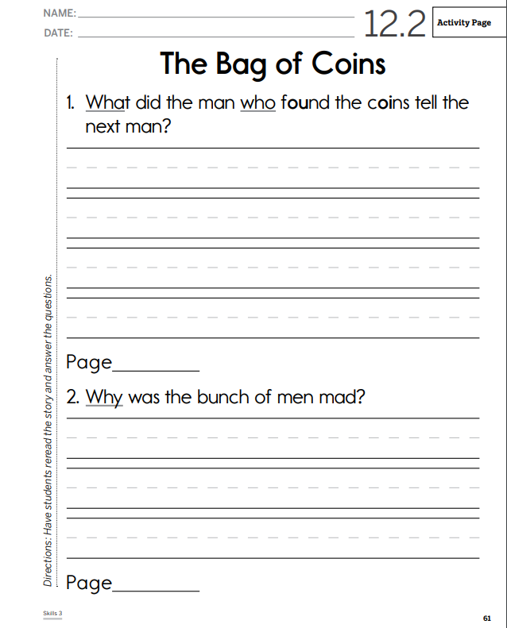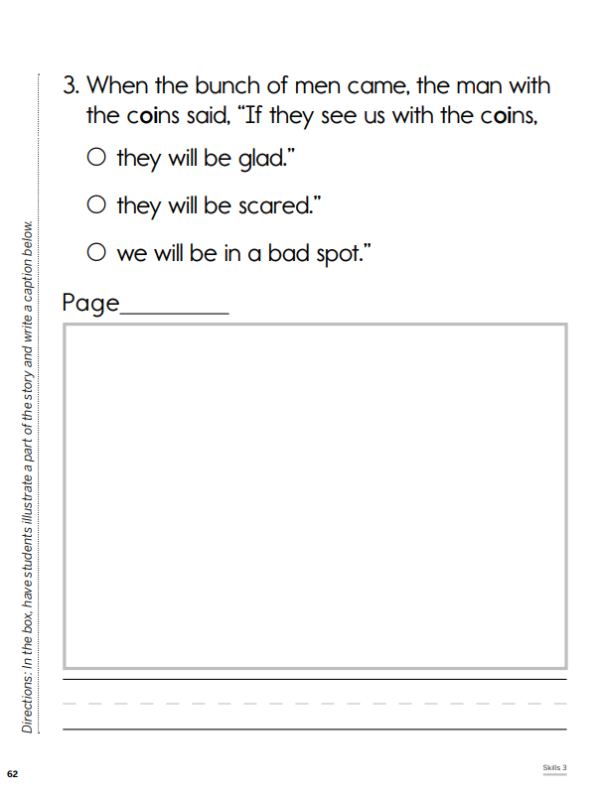

Practice Out of Text (Isolation) | Practice in Text

