Student Guide – Answer Key

Lesson 3.04: Practice in and Out of Text
Name:
Date:
Bellringer:
Complete the Anticipation Guide to review the criteria for deliberate practice.

Statement | Agree | Disagree | Reasoning
The practice should require the student to be authentic or perform the actual learning goal. |  |  | Students need to practice practicing the skill in an authentic way that addresses the learning goal.
Practice does not need to be spaced over time. |  |  | Knowledge or skills are made more lasting and permanent in your long-term memory when you practice them regularly over time. By regularly practicing, students pull ideas from their long term-memory into working memory and refresh and strengthen their understanding of that content.
Practice should be high-stakes and always count for a grade |  |  | The point of practice is to check your understanding before the stakes are high. Students should feel psychologically safe enough to practice free from fear of judgement, either by grading or other people.
Practice should be paired with timely feedback |  |  | It is important to receive timely feedback to ensure that the skills and content you are practicing are correct.

Based on the anticipation guide, what are the criteria for deliberate practice that you explored in previous units?
Practice that performs the learning goal (authentic), is spaced over time, is low-stakes and is paired with feedback for improvement.

Discussion: Introduction to Practice in and Out of Text
Deliberate Practice | Practice that performs the learning goal (authentic), is spaced over time, is low-stakes and is paired with feedback for improvement
Interactive | Learning that requires active student participation
Modalities | Different forms of sensory perception
Outside of Text | Analyze the letter-sound relationships and parts of a single word in isolation
In Text | Students take the sound they are practicing in isolation and read them within a text.
Decodable Text | A type of text that contains only the sound-letter relationships that have previously been taught

Watch the video clip to see decodable words in isolation and in text. As you watch, record ways the students practice /ee/ both in isolation and in text.
Practice in Isolation | Practice in Text
Practiced the sound /ee/ spelling ‘ee’ and ‘ea’  Practiced /ee/ in word meat and seed  Students underlined the ‘ee’ and ‘ea’ in words from a list  Practiced sounding out words from a list with /ee/, /e/ and /a/. | Students looked for words in the text “Up in the Trees” that had the ‘ee’ or ‘ea’ spelling and underlined them and read them.  Students read the book “Up in the Trees” to practice the /ee/ sound with ‘ee’ and ‘ea.’

Practice: Lesson Review
Review the materials excerpted from Grade 1, Unit 3, Lesson 12.
How does the lesson offer opportunities for practice in and out of text? Record evidence in the graphic organizer.
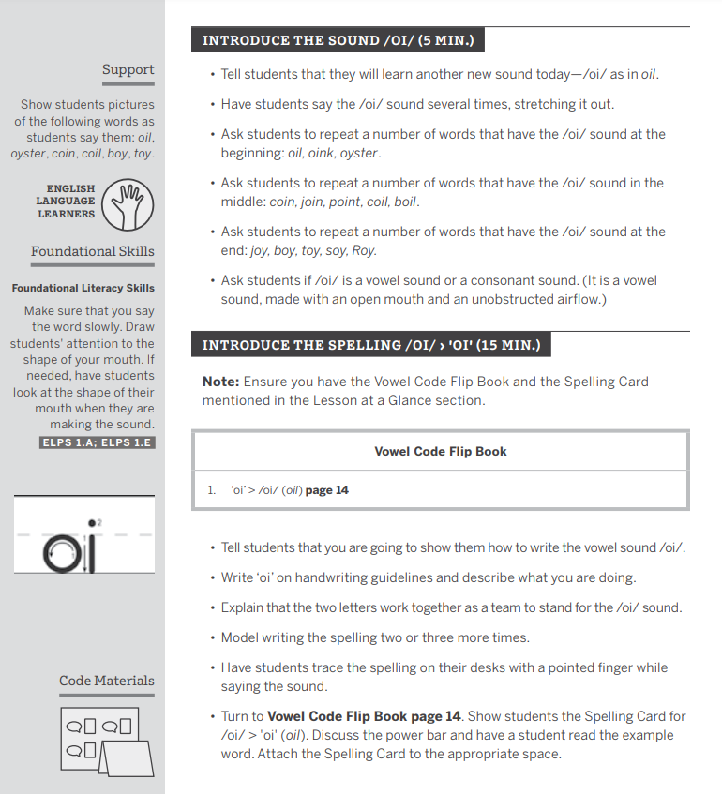
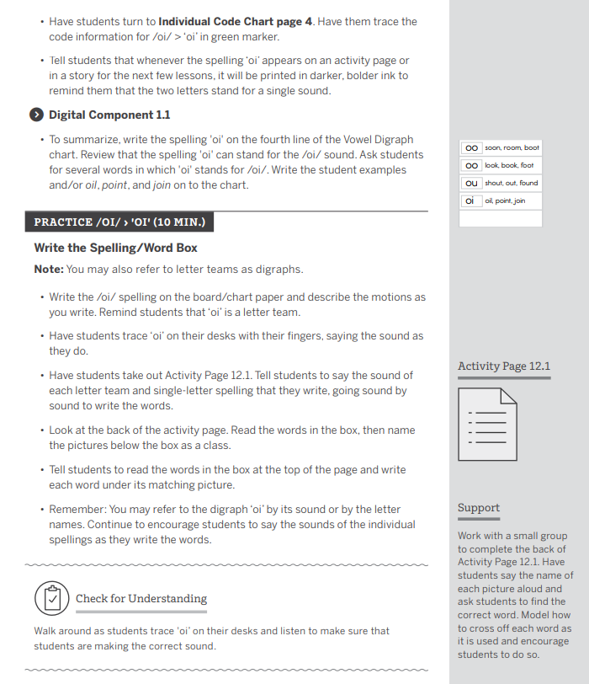
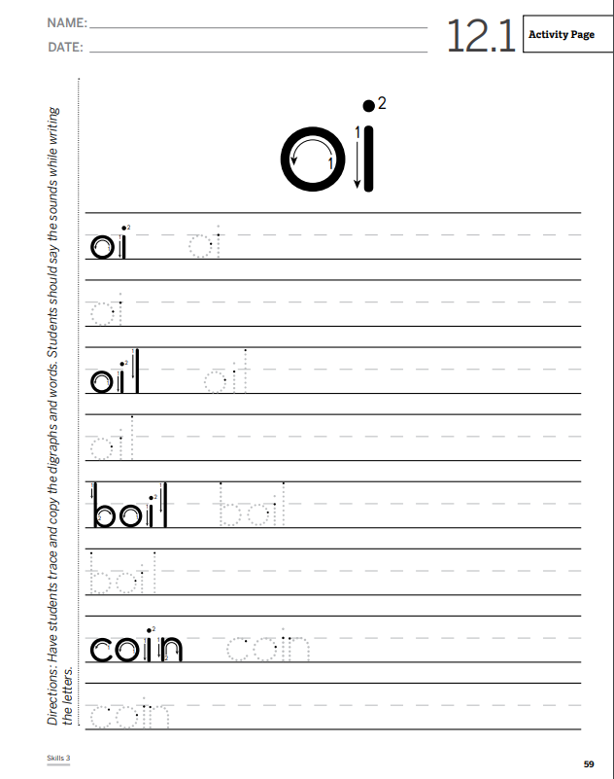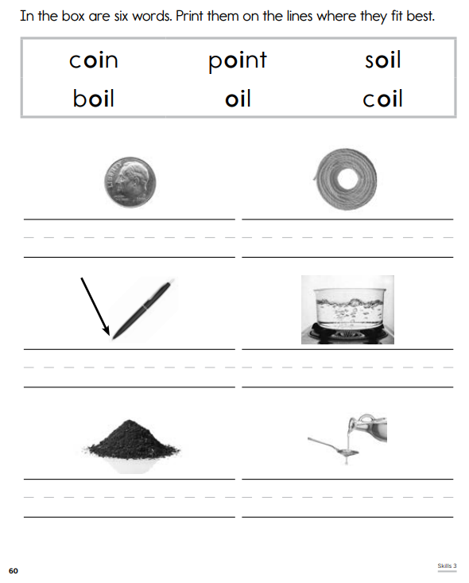

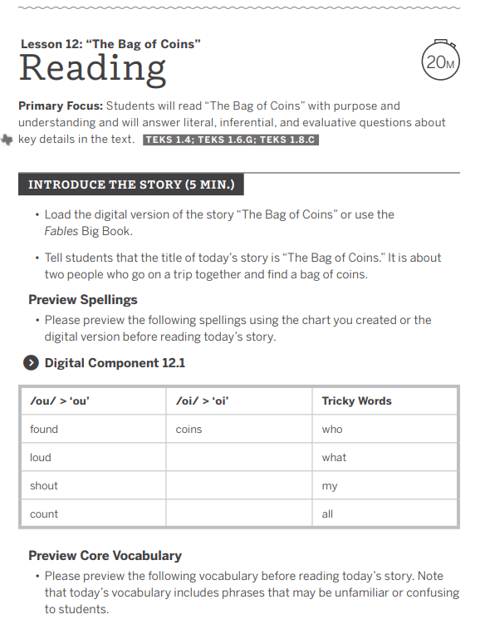
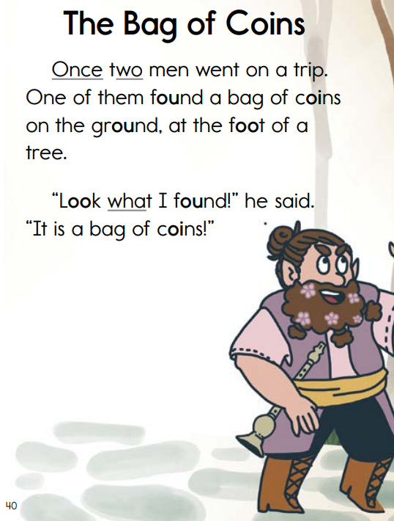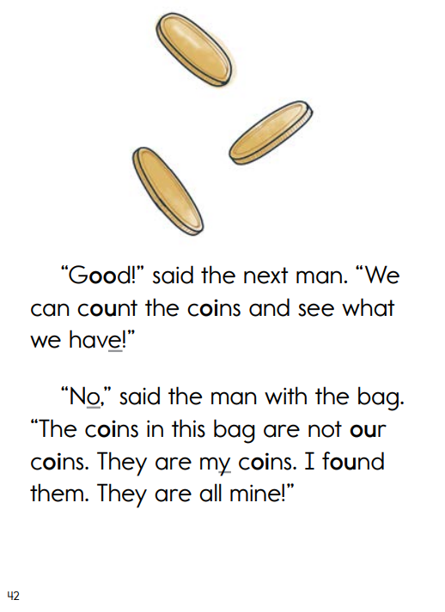
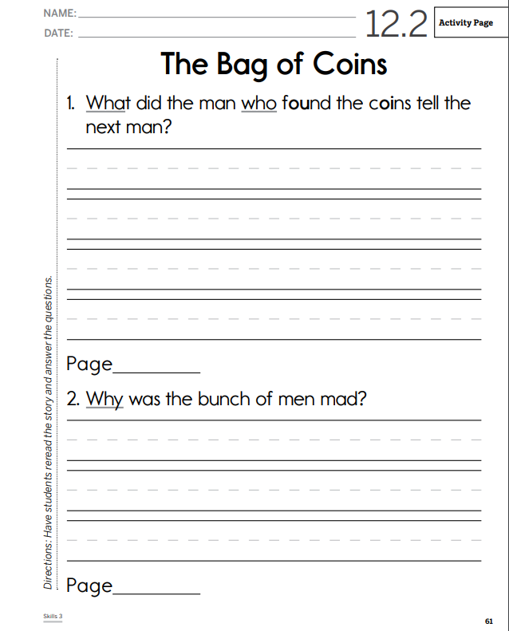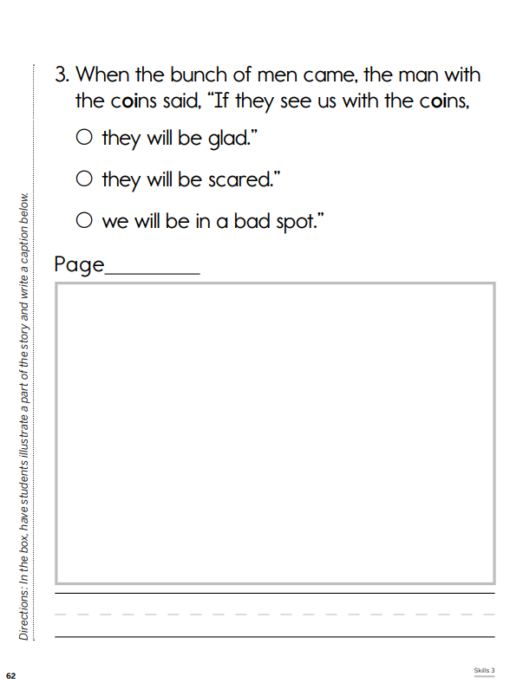

Practice Out of Text (Isolation) | Practice in Text
Students repeat the sound /oi/ several times and repeat words that have the /oi/ sound at the beginning, middle, and end.  Students practice writing the vowel sound /oi/ by tracing it with their finger on their desks. Students give words in which ‘oi’ stands for /oi/.  Students use Activity Page 12.1 to practice saying the sound of each letter team and single letter spelling that they write, going sound by sound to write the words. On the back, students read words and write each word under its matching picture. | Prior to reading, students review spellings in the text that practice previously taught skills – ‘ou’ and /ou/ and ‘oi’ as /oi/.  Students read the story “The Bag of Coins.”

Exit Ticket - Answer Key

Lesson 3.04: Practice in and Out of Text
Name:
Date:
Examine the following lesson plan and determine how students were asked to practice.

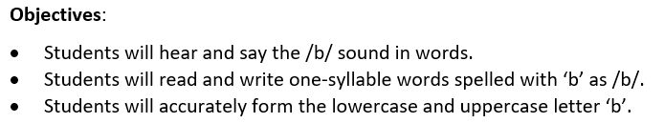
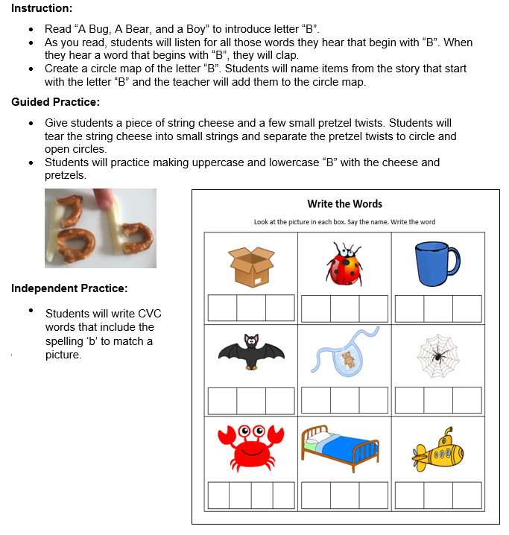

Practice Out of Text (Isolation) | Practice in Text
Students practice making the letter ‘b’ with string cheese and pretzels.
Students write CVC words with the spelling ‘b’ to match a picture.

What are two ways that this practice activity does not provide opportunities for deliberate practice of skills in and out of context?
Answers may include:
- Students did not have the opportunity to read words with the ‘b’ as /b/.
- Students did not have the opportunity to practice reading words with ‘b’ as /b/ in a text.
What impact might this have on students’ ability to master the objectives?
Students may meet the first objective to hear and say the /b/ sounds in words. Students did not participate in much deliberate practice in reading or writing words with the /b/ sounds. They only formed uppercase B with pretzels and cheese. Because of this, students may have difficulty mastering the second two objectives.

