Unit 3: Research-Based Instructional Strategies (RBIS) Reading Language Arts (RLA)

Lesson 3.05: Text Complexity

Lesson at Glance
Warm-Up (7 mins)  - Bellringer (5)  - Debrief (2) | Instruction (10 mins)  - Notes: Text Complexity (10) | Application (28 mins)  - Practice: Comparing Two Texts (10)  - Practice: 5th Grade Reading Assignments - Example and Non-Example (10)  - Debrief: (3)  - Exit Ticket (5)

TEKS | 6 | The student plans and uses effective instruction. The student is expected to:  - Apply principles and theories that impact instructional planning.  - Develop instructional materials that align with the Texas Essential Knowledge and Skills  - Demonstrate competency in foundation and enrichment subject areas.  - Analyze the development of effective instructional strategies.  - Evaluate and analyze effectiveness of lessons plans and instructional strategies used in a lesson or series of lessons
Objectives | - Define text complexity and academic language.  - Describe the role of text complexity in effective literacy instruction.  - Identify examples and nonexamples of complex text.
Rationale/  Summary | Students need regular practice with grade-level, complex texts, and associated academic language to work with new language, knowledge, and ways of thinking. In this lesson, students will define text complexity and learn what factors contribute to the complexity of a text. Students will look at examples and nonexamples of texts to determine if they are complex and how the text leads to effective literacy instruction.
Formative Assessment and Exemplar Response | Students will complete the following multiple-choice questions:  - How do you determine text complexity?  - Why does text complexity matter?  - What is the role of text complexity in effective literacy instruction?  See Exit Ticket Answer Key for exemplar responses.
Vocabulary | Text complexity |  | The level of difficulty in reading and understanding a text. The difficulty level is based on the text's readability, meaning or purpose levels, clarity and conventions of the language, knowledge demands, and structure.
Vocabulary | Academic Language |  | The specialized language, written and spoken, in classroom or other academic locations that helps students communicate and think about what they are learning.
Vocabulary | Implicit meaning |  | Something in a text is not stated outright or directly but is inferred.

Est Time | Instructional Activities (including formative assessments) | Materials
5 mins | Bellringer:  Explain if the following statement is true or false and why.  To help students practice reading “skills,” teachers should give struggling readers texts at their own reading level rather than reading grade level texts. | Student Guide
2 mins | Debrief:  T: Turn and talk to your partner to share your responses.  S: (Turn and talk.)  T: Was this statement true or false?  S: (student responses will likely vary).  T: The answer is false. A quote by Marilyn Jager Adams helps to explain why. Marilyn Jager Adams is a cognitive and developmental psychologist who has devoted her career to research and applied work in the area of cognition and education. She says, “Giving children easier texts when they’re weaker readers serves to deny them the very language and information they need to catch up and move on.” In other words, students need regular practice with grade-level, complex text, and its academic language. | Student Guide
10 mins | Notes: Text Complexity  T: Today we are going to consider text complexity and why it is important. Text complexity is the level of difficulty in reading and understanding a text. It is what makes a text challenging versus simple.  T: Complex texts provide students opportunities to work with new language, knowledge, and ways of thinking.  T: The level of difficulty is based on the following aspects:  - readability of the text  - levels of meaning or purpose in the text  - clarity and conventions of the language  - knowledge demands.  - structure of the text  S: (record notes in Student Guide.)  T: The readability of the text is determined by the length of words and sentences in the text and the frequency of unfamiliar words.  T: Let us look at an example.  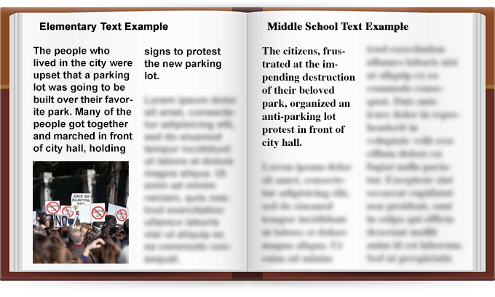  T: You can see that although both examples convey the same information, the elementary text uses words that are easier to understand and includes a photo. The middle school text uses more concise language and contains more multisyllabic and unfamiliar words.  T: The level of difficulty is also based on the levels of meaning or purpose in the text. This means that complex texts contain more implicit meaning where something in the text is not stated outright or directly but is inferred.  T: If we look back at the previous example, we can see that the author explicitly stated that the park is going to be replaced by a parking lot, whereas this fact is only implied in the middle school example.  T: Another factor impacting the level of complexity is the clarity and conventions of the language. Complex texts tend to use figurative language, ambiguity, or unfamiliar language, such as academic or domain specific vocabulary.  T: Look at the example.  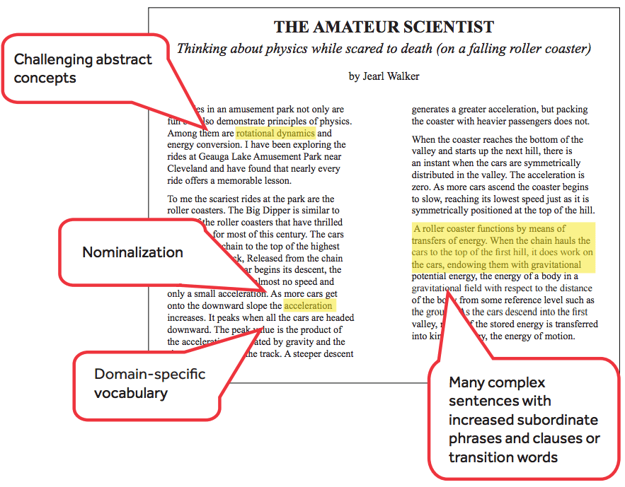  T: You can see that the author discusses more challenging concepts, uses more complex sentences, and includes domain-specific vocabulary which increases the complexity of the text.  T: The complexity of a text is determined by the knowledge demands required of the reader. Complex texts assume that the reader has life experience that will contribute to their understanding of the information in the text.  T: If we look back at our previous example, we can also see that the author assumes the reader has experience or at least some knowledge about roller coasters to help contribute to their understanding of the text.  T: Lastly, the complexity of a text is determined by the structure of the text. Text structure refers to how the text is organized regarding elements such as viewpoint, multiple characters, storylines, and complex details. Text that is organized chronologically tends to be easier to understand than those that use flashbacks or varied time and sequence. | Student Guide  PPT  Image #1 Source: https://iris.peabody.vanderbilt.edu/module/sec-rdng2/cresource/q1/p02/  Image #2 Source: https://www.generationready.com/white-papers/a-beginners-guide-to-text-complexity/
10 mins | Practice: Comparing Two Texts  T: Let us look at two different texts. Which text is more complex and appropriate for an 11th grade student and why?  S: (Students record response in student guide.)  T: Let us reread the two texts together. While we read, I am going to highlight some components of each text. Please follow along in your Student Guide or along with the PowerPoint.  S: (Follow along with Student Guide.)  T: (Project Lincoln Comparison Text on PowerPoint and read Text 1 aloud. Pause after reading the second sentence.) Please note how this sentence has a complex structure (identify one or more dependent clauses to an independent clause) and complex vocabulary. Additionally, in this sentence, it adds more ‘context’ to the text (identify the comparison of power.)  T: What does it mean that it is overall “sophisticated subject matter”?  S: It means that it is not just about one subject and talks about a lot of different things, implicit and explicit. It also uses figurative language.  T: (Project with PowerPoint.) Let us switch to Text 2. Can someone please read this text aloud?  S: (Read Text 2.)  T: Can someone think aloud for me about what they think the highlighted text and boxes mean? And why or why is it not complex?  S: Sad and gloomy is highlighted with the information that it paints a visual picture. I do have to rely on my knowledge of sad and gloomy to know what the feelings are. They also talk about his physical features and how he looks.  T: It also helps you visualize what is going on and is interesting language, but it is not complex. It talks about one subject and is mostly explicit in language.  T: Quickly respond to the reflection question.  S: (Respond to reflection question.)  T: (Project potential response with PowerPoint.) Please compare your response to the one on the board. Text 1 is more complex because it is about multiple subjects, and it also requires a person to think about what they are reading. It requires them to think beyond what is there. Text 2, on the other hand, does have some higher-level vocabulary but overall is only about one subject and vocabulary has one meaning.  T: Is there anything else to add?  S: (Make suggestions.) | Student Guide  PPT
10 mins | Practice: 5th Grade Reading Assignments - Example and Non-Example  T: In small groups you will read an example of complex text and a non-example. You will determine which text is complex and which is not. Using your device, please navigate to the link provided and look at both the text and the assignment.  T: (Divide students into small groups.)  T: In reviewing these two assignments, you will look at the text itself, and then the assignment itself – what activities are they doing? What questions are being answered? You do not need to read the entire text – you may skim it, but you do need to answer the three questions:  - Is this an example or non-example?  - Is this a grade-level text?  - Does this assignment and text demonstrate strong literacy instructional practices?  T: Are there any clarifying questions?  S: (Ask clarifying questions.)  T: You have approximately ten minutes. You may begin.  S: (Work with groups and discuss the text.)  T: (Circulate and monitor student progress. Redirect students if necessary to be on-task.)  T: You have five minutes. If you have not moved onto the next text, please do so now.  S: (Move to next text.)  T: You have a two-minute warning.  S: (Students complete tasks.) | Student Guide
3 mins | Debrief  T: For your debrief, you will meet with a group near yours. Quickly determine which group will explain Assignment 1 and Assignment 2.  S: (Assign selves Assignment 1 or Assignment 2.)  T: If you assigned your group to Assignment 1, quickly explain your rationale for the three questions to the other group. Once you have done this, the other group will explain if they have the same response and if they agree/disagree. You will then switch places. You may begin.  S: (Assignment 1 present.)  S: (Other group comment if they agree or disagree.)  T: Please switch, and Assignment 2 please present your three questions to the other group.  S: (Assignment 2 present.)  S: (Other group comment if they agree or disagree.)  T: Can one of the groups given Assignment 1 please present your questions and rationale.  S: This is the non-example. It is grade-level. It is not complex and is too simple a reading and assignment.  T: Classmates, do you agree?  S: Yes!  T: Can one of the groups given Assignment 2 please present your questions and rationale.  S: This is an example of a complex assignment. It is on grade-level. It uses complex sentence structure, complex vocabulary, and addresses various complex topics. It has explicit and implicit language.  T: Classmates, do you agree?  S: Yes.
5 mins | S: (Complete the Exit Ticket.) | Exit Ticket

