Student Guide – Answer Key

Lesson 3.05: Text Complexity
Name:
Date:
Bellringer:
Explain if the following statement is true or false and why.
To help students practice reading “skills,” teachers should give struggling readers texts at their own reading level rather than reading grade level texts.
The answer is false. Students need regular practice with grade-level, complex text, and its academic language to grow in their reading abilities.

Notes: Text Complexity
Vocabulary
Text complexity | The level of difficulty in reading and understanding a text. The level of difficulty is based on the readability of the text, the levels of meaning or purpose in the text, the clarity and conventions of the language, the knowledge demands, and the structure of the text.
Implicit meaning | Something in a text is not stated outright or directly but is inferred.
Academic Language | The specialized language, written and spoken, in classroom or other academic locations that helps students communicate and think about what they are learning.

The level of difficulty is based on the following aspects:
- readability of the text
- levels of meaning or purpose in the text
- clarity and conventions of the language
- knowledge demands.
- structure of the text.

Readability: determined by the length of words and sentences in the text and the frequency of unfamiliar words.
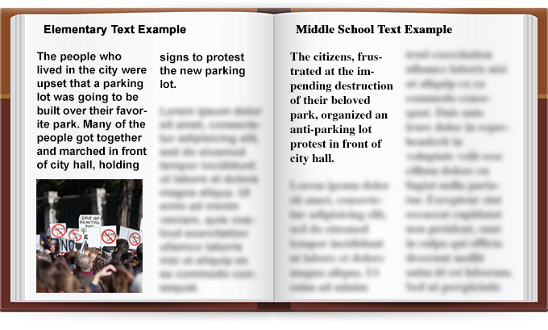
What do you notice about the two different examples?
Although both examples convey the same information, the elementary text uses words that are easier to understand and includes a photo. The middle school text uses more concise language and contains more multisyllabic and unfamiliar words.
Implicit meaning: something in the text is not stated outright or directly but is inferred.
What do you notice about the two different examples?
The author explicitly stated that the park is going to be replaced by a parking lot, whereas this fact is only implied in the middle school example.
Academic or domain specific vocabulary: figurative language, ambiguity, or unfamiliar language specific to the content.
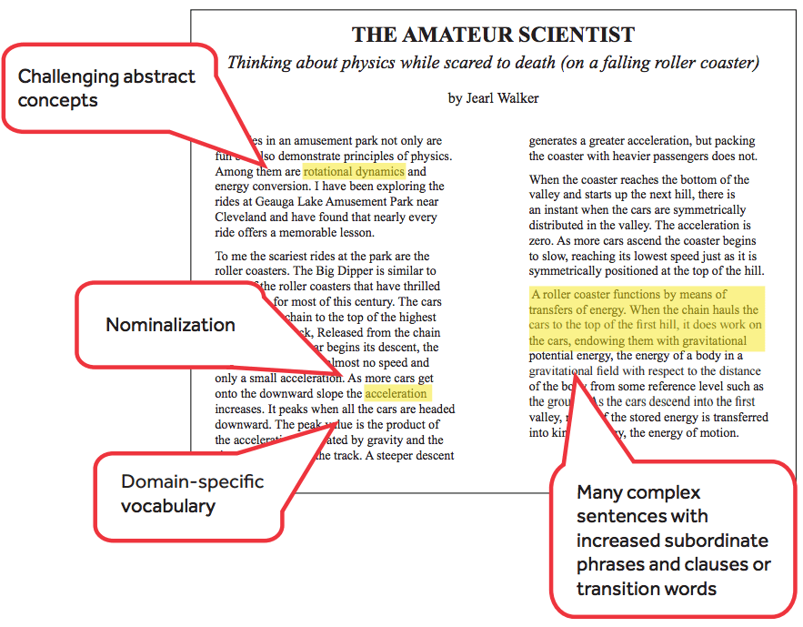
What do you notice about the example?
The author discusses more challenging concepts, uses more complex sentences, and includes domain-specific vocabulary which increases the complexity of the text.
Knowledge demands of the text: assume that the reader has life experience that will contribute to their understanding of the information in the text.
Where do you see evidence of this in the example?
The author assumes the reader has experience or at least some knowledge about roller coasters to help contribute to their understanding of the text.
Structure of the text: How the text is organized regarding elements such as viewpoint, multiple characters, storylines, and complex details. Texts that are organized chronologically tend to be easier to understand than those that use flashbacks or varied time and sequence.

Practice: Comparing Two Texts
Which text is more complex and appropriate for an 11th grade student and why?
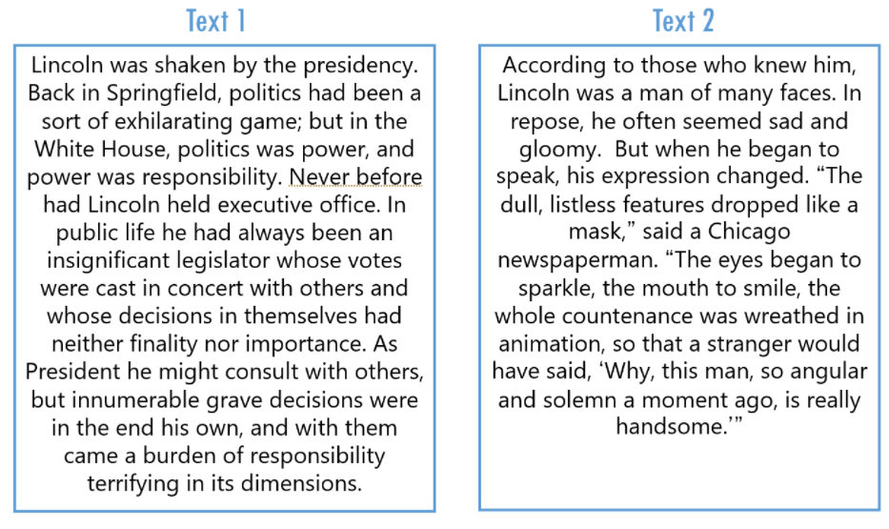
*Source: TEA (Texas Education Agency) – RBIS Session 2 – RLA Complexity and Knowledge Presentation
Responses may vary but may include:
Text 1 is more complex and appropriate for an 11th grader because it uses higher-level vocabulary and has more complex grammar.
Text 2 is not more complex but is appropriate for an 11th grader who might have a learning disability or a lower reading-level.
Based on the various aspects of the text, why is Text 1 more complex than Text 2?
Text 1 is more complex because it is about multiple subjects, and it also requires a person to think about what they are reading. It requires them to think beyond what is there. Text 2, on the other hand, does have some higher-level vocabulary but overall is only about one subject and vocabulary has one meaning.

Practice: 5th Grade Reading Assignments - Example and Non-Example
Directions: In small groups you will read an example of complex text and a non-example. You will determine which text is complex and which is not. Using your device, please navigate to the link provided and look at both the text and the assignment.
In reviewing these two assignments, you will look at the text itself, and then the assignment itself – what activities are they doing? What questions are being answered? You do not need to read the entire text – you may skim it, but you do need to answer the two questions:
- Is this a grade-level text?
- Does this assignment and text demonstrate strong literacy instructional practices?

Class Assignment #1 – Blocking Beethoven*
- Is this the Example or Non-Example?
Non-example.

- Is this a grade-level text?
Yes, this is a grade-level text. It uses appropriate language and complex vocabulary.

- Does this assignment and text demonstrate strong literacy instructional practices?
Responses will vary but should include some of the following points:
It does not demonstrate strong literacy instructional practices because a student is asked to read a story, answer multiple-choice questions, fill out a simple graphic organizer, and write short answers. The text itself is simple and does not use complex sentence structure. It focuses on one topic and does not use inferences. It is explicit language and is there to paint a picture.
*Source: Level U Reader: Blocking Beethoven. K5 Learning. (2020). Retrieved from https://www.k5learning.com/worksheets/reading-comprehension/level-u-childrens-story.pdf

Class Assignment #2 – Midsummer’s Night’s Dream
- Is this the Example or Non-Example?
Example
- Is this a grade-level text?

Yes, this is a grade-level text. It uses appropriate language and complex vocabulary.

- Does this assignment and text demonstrate strong literacy instructional practices?

Responses will vary but should include some of the following points:
This example or assignment is complex, both the writing and the assignment itself. The writing is complex because it uses complex sentence structures and builds on ideas. It builds on prior knowledge and has multiple pieces happening at once. It is not about one topic, but both paints a picture of mood and addresses complex topics. Additionally, the assignment itself requires Higher-Order-Thinking skills and helps the student apply knowledge and make assumptions.

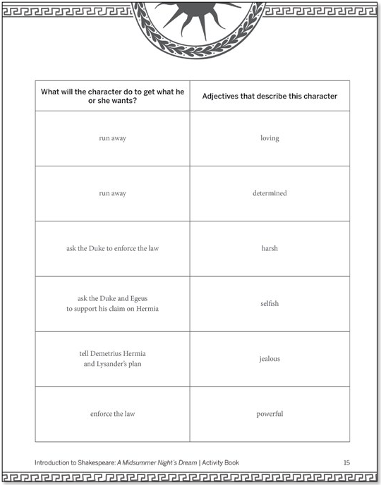
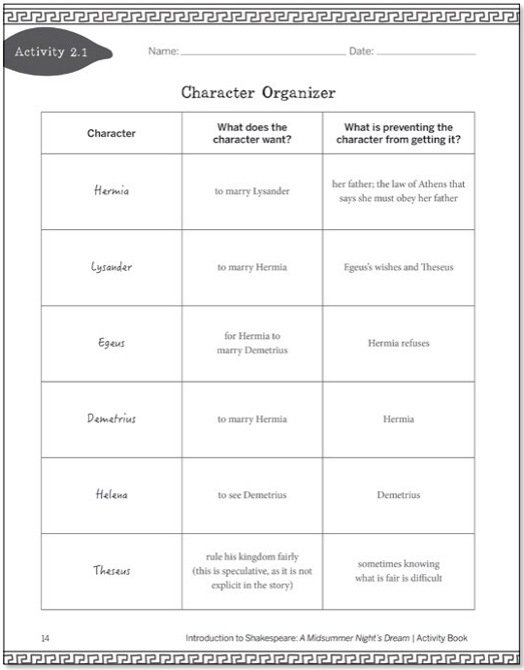
Assignment for Text
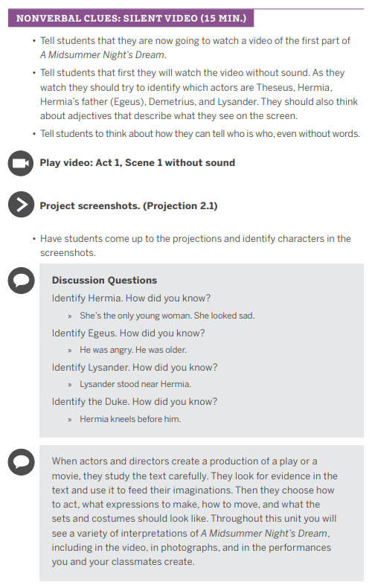
*Source: Introduction to Shakespeare: A Midsummer’s Night Dream| Activity Book

