Student Guide

Lesson 3.05: Text Complexity
Name:
Date:
Bellringer:
Explain if the following statement is true or false and why.
To help students practice reading “skills,” teachers should give struggling readers texts at their own reading level rather than reading grade level texts.

Notes: Text Complexity
Vocabulary
Text complexity
Implicit meaning
Academic Language

The level of difficulty is based on the following aspects:

Readability: determined by the length of words and sentences in the text and the frequency of unfamiliar words.
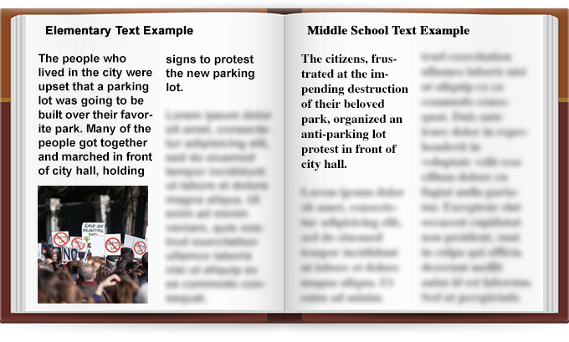
What do you notice about the two different examples?

Implicit meaning: something in the text is not stated outright or directly but is inferred.
What do you notice about the two different examples?

Academic or domain specific vocabulary: figurative language, ambiguity, or unfamiliar language specific to the content.
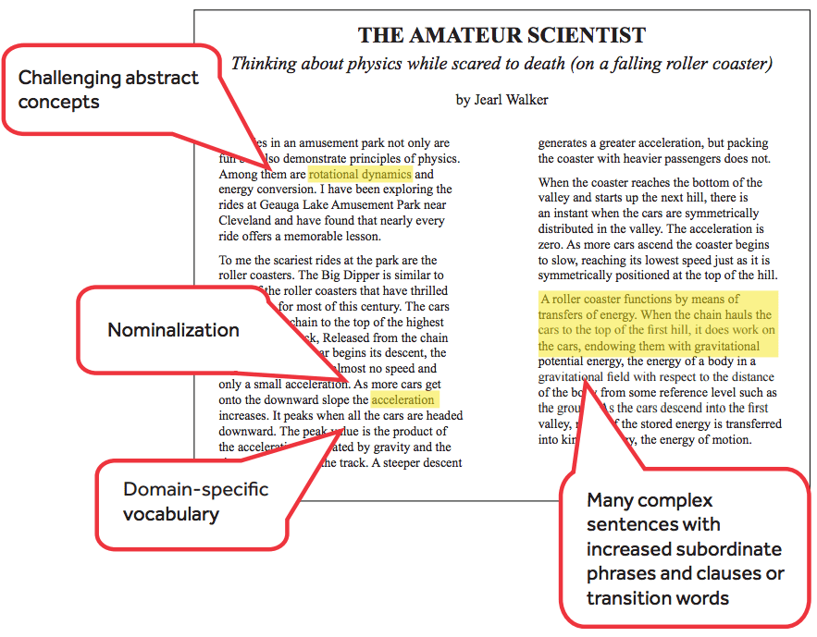
What do you notice about the example?

Knowledge demands of the text: assume that the reader has life experience that will contribute to their understanding of the information in the text.
Where do you see evidence of this in the example?

Structure of the text: How the text is organized regarding elements such as viewpoint, multiple characters, storylines, and complex details. Texts that are organized chronologically tend to be easier to understand than those that use flashbacks or varied time and sequence.

Practice: Comparing Two Texts
Which text is more complex and appropriate for an 11th grade student and why?
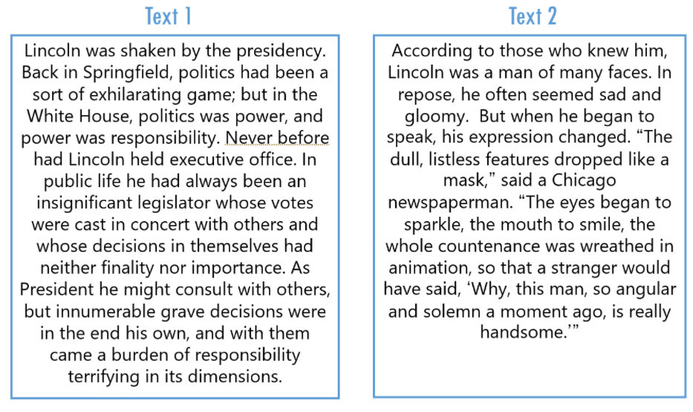
*Source: TEA – RBIS Session 2 – RLA Complexity and Knowledge Presentation

Based on the different aspects of the text, why is Text 1 more complex than Text 2?

Practice: 5th Grade Reading Assignments - Example and Non-Example
Directions: In small groups you will read an example of complex text and a non-example. You will determine which text is complex and which is not. Using your device, please navigate to the link provided and look at both the text and the assignment.
In reviewing these two assignments, you will look at the text itself, and then the assignment itself – what activities are they doing? What questions are being answered? You do not need to read the entire text – you may skim it, but you do need to answer the two questions:
- Is this a grade-level text?
- Does this assignment and text demonstrate strong literacy instructional practices?

Class Assignment #1 – Blocking Beethoven*
- Is this the Example or Non-Example?

- Is this a grade-level text?

- Does this assignment and text demonstrate strong literacy instructional practices?

*Source: Level U Reader: Blocking Beethoven. K5 Learning. (2020). Retrieved from
https://www.k5learning.com/worksheets/reading-comprehension/level-u-childrens-story.pdf

Class Assignment #2 – Midsummer’s Night’s Dream
- Is this the Example or Non-Example?

- Is this a grade-level text?

- Does this assignment and text demonstrate strong literacy instructional practices?

*Source: Introduction to Shakespeare: A Midsummer’s Night Dream| Activity Book

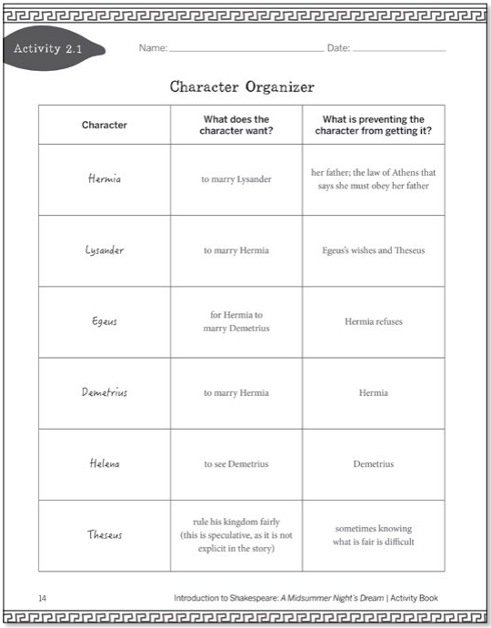
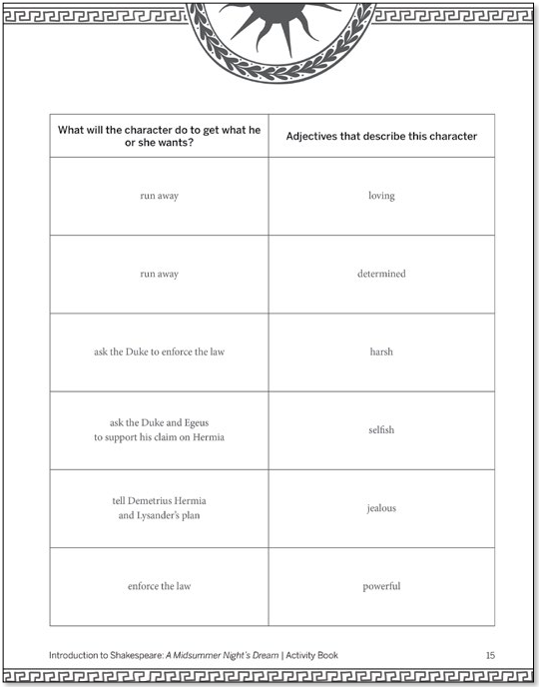
Assignment for Text
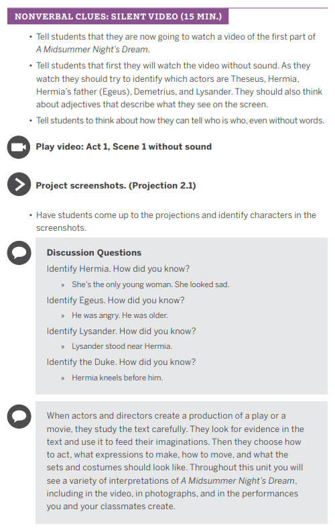

*Source: Introduction to Shakespeare: A Midsummer’s Night Dream| Activity Book

