Student Guide – Answer Key

Lesson 3.06: Complex Text in Tier 1 Instruction
Name:
Date:
Bellringer:
A 4th grade teacher is planning for their next unit from high-quality instructional curriculum, but they are concerned that the text complexity is too advanced for many of their students who are struggling readers. The teacher decides to find an alternative text on a lower reading level that they feel might be more appropriate and engaging for their students. How will this decision impact their students?
Responses will vary but may include:
Student responses may vary but could include that this will be beneficial for struggling readers because they might check out from a rigorous text. Using more engaging texts is better. The teacher meets students where they are, which is a good thing.
Notes: Complex Text
Vocabulary Word | Definition
Tier One Instruction | High-quality classroom-wide instruction and support for all students focused on essential grade-level skills and concepts.

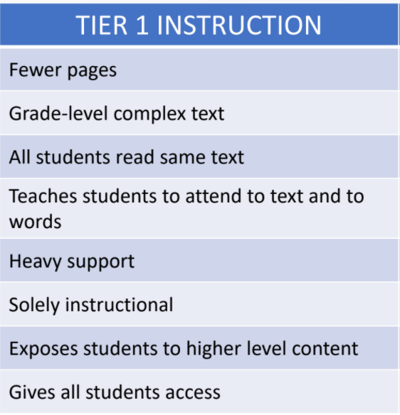
What do you notice about the criteria for complex texts in Tier 1 instruction?
Heavy support, instructional, exposes students to higher level content, all read the same text, gives all students access.

Tier 1 Instruction Source: TEA – RBIS Session 2 – RLA Complexity and Knowledge Presentation
Why should all students engage with complex texts? | All students should engage with complex texts because it helps the student grow their vocabulary, knowledge, and oral language skills. They can also develop the skills to access complex text independently.
How can all students engage in grade-level complex texts? | To access the grade-level complex texts, students need heavy support and scaffolding from the teacher.

Practice: The Impact on Vocabulary
A 5th grade teacher plans to have her students read an article about an owl that was stuck in the Rockefeller Center’s Christmas tree. Knowing she has students on various reading levels, she decides to use leveled texts. All her students will read and learn about the Rockefeller Christmas tree owl, but the texts will be modified to different reading levels. The students reading on grade level will receive the text on a 5th grade level. Students who are just below grade level will receive the text on a 4th grade level. Students who are significantly below grade level will read the text on a 3rd grade level.
5th grade text | 4th grade text | 3rd grade text
Source: 2020. Newsela. Tiny owl saved after getting stuck in Rockefeller Center's Christmas tree.

With a partner, review the texts at the three different levels. As you scan, take notes on what you notice about the text at each level. For example, how does the vocabulary change at each level? How does the language change at each level? How does that impact the meaning of the text?
Student responses will vary but may include the 3rd grade text was much shorter and did not have as many challenging vocabulary words as the grade level text. The sentences in the lower-level texts seemed easier. The 3rd grade text had easier words and did not’ provide a lot of challenging vocabulary. The sentences in the lower-level texts were basic. The story line was not as deep in the lower-texts and did not provide as much detail.

Vocabulary in each of the texts:
Well Below Level Text | Below Level Text | On Level Text
Raptor  Rescue  Spotted  Base  Hunting  Tucked  Carrier | Raptor  Surprised  Rescued  Sagging  Unwrapping  Prey  Needles  Creature  Squished  Surprised  Impressed  Preparing | Raptor  Undomesticated  Nonprofit  Rehabilitate  Iconic  Mocking  Bedraggled  Metaphor  Stowaway  Possibilities  Chaos  Relieved  Refuge  Fractures  Strive  Honored

How does vocabulary and language change at each level?
The on-grade level text included more challenging vocabulary words than the other texts. The only common word in the list is raptor.
What impact do you think this has on students’ vocabulary development and comprehension skills?
Students are not going to have the opportunity to increase their vocabulary or knowledge about the topic which is going to make it harder to understand the text. By only providing lower-level texts to struggling readers, a teacher limits the student’s access and exposure to rich vocabulary, language, and knowledge that will help build their comprehension skills. This makes it even more difficult for them to catch up and develop the skills necessary to access complex text independently.

Scaffolds and Support for Tier 1 Instruction
To help students access grade-level complex texts, teachers can:
- Pre-teach unfamiliar vocabulary and concepts.
- Provide necessary background knowledge.
- Use Text Sets (multiple texts on the same topic)
- Use graphic organizers.
- Read complex texts aloud to students.

Practice: Lesson Analysis
Look at a (Grade 4, Unit 9, Lesson 1) lesson plan to see how the lesson is structured to provide the necessary supports and scaffolds for all students. List the different ways the teacher can provide scaffolding and support to assist students in accessing the grade-level complex text.
Examples of Support
- Character Development Notes graphic organizer to record notes throughout the unit.
- Provide examples of texts written in the first-person point of view as a model or example for students
- Sentence frames to support their writing
- Pre-teaching vocabulary
- Activating background knowledge through think-pair-share
- Modeling
- Small groups

