Student Guide

Lesson 3.06: Complex Text in Tier 1 Instruction
Name:
Date:
Bellringer:
A 4th grade teacher is planning for their next unit from high-quality instructional curriculum, but they are concerned that the text complexity is too advanced for many of their students who are struggling readers. The teacher decides to find an alternative text on a lower reading level that they feel might be more appropriate and engaging for their students. How will this decision impact their students?

Notes: Complex Text
Vocabulary Word | Definition
Tier One Instruction

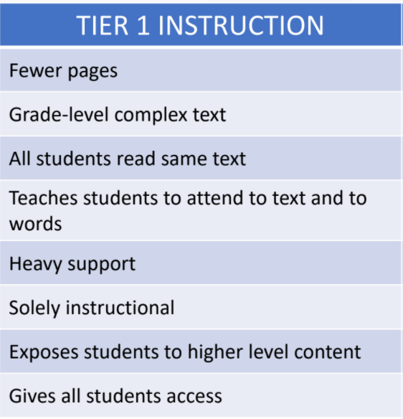
What do you notice about the criteria for complex texts in Tier 1 instruction?

Tier 1 Instruction Source: TEA – RBIS Session 2 – RLA Complexity and Knowledge Presentation
Why should all students engage with complex texts?
How can all students engage in grade-level complex texts?

Practice: The Impact on Vocabulary
A 5th grade teacher plans to have her students read an article about an owl that was stuck in the Rockefeller Center’s Christmas tree. Knowing she has students on various reading levels, she decides to use leveled texts. All her students will read and learn about the Rockefeller Christmas tree owl, but the texts will be modified to different reading levels. The students reading on grade level will receive the text on a 5th grade level. Students who are just below grade level will receive the text on a 4th grade level. Students who are significantly below grade level will read the text on a 3rd grade level.
5th grade text | 4th grade text | 3rd grade text
Source: 2020. Newsela. Tiny owl saved after getting stuck in Rockefeller Center's Christmas tree.

With a partner, review the texts at the three different levels. As you scan, take notes on what you notice about the text at each level. For example, how does the vocabulary change at each level? How does the language change at each level? How does that impact the meaning of the text?

Vocabulary in each of the texts:
Well Below Level Text | Below Level Text | On Level Text
Raptor  Rescue  Spotted  Base  Hunting  Tucked  Carrier | Raptor  Surprised  Rescued  Sagging  Unwrapping  Prey  Needles  Creature  Squished  Surprised  Impressed  Preparing | Raptor  Undomesticated  Nonprofit  Rehabilitate  Iconic  Mocking  Bedraggled  Metaphor  Stowaway  Possibilities  Chaos  Relieved  Refuge  Fractures  Strive  Honored

How does vocabulary and language change at each level?

What impact do you think this has on students’ vocabulary development and comprehension skills?

Scaffolds and Support for Tier 1 Instruction
To help students access grade-level complex texts, teachers can:

Practice: Lesson Analysis
Look at a (Grade 4, Unit 9, Lesson 1) lesson plan to see how the lesson is structured to provide the necessary supports and scaffolds for all students. List the different ways the teacher can provide scaffolding and support to assist students in accessing the grade-level complex text.
Examples of Support

