Unit 3: Research-Based Instructional Strategies (RBIS) Reading Language Arts (RLA)

Lesson 3.07: Background Knowledge and Reading Comprehension

Lesson at Glance
Warm-Up (7 mins)  - Bellringer (5 mins)  - Debrief (2 mins) | Instruction (15 mins)  - Notes: Background Knowledge (10 mins) | Application (23 mins)  - Practice: Grade 4 Curriculum Map (15 mins)  - Debrief: (3 mins)  - Exit Ticket (5 mins)

TEKS | 6 | The student plans and uses effective instruction. The student is expected to:  - Apply principles and theories that impact instructional planning.  - Develop instructional materials that align with the Texas Essential Knowledge and Skills  - Demonstrate competency in foundation and enrichment subject areas.  - Analyze the development of effective instructional strategies.  - Evaluate and analyze effectiveness of lessons plans and instructional strategies used in a lesson or series of lessons
Objectives | - Describe the role of background knowledge in reading comprehension.  - Define and identify examples of a skills-based vs knowledge-based approach to reading.  - Compare a skills-based approach to a knowledge-based approach in various content and the affect each approach has on building background knowledge and vocabulary
Rationale/  Summary | Background knowledge is an essential component to reading comprehension because it helps a reader make sense of new ideas and experiences. Knowledge helps readers free up working memory by chunking information. Knowledge also helps build vocabulary. In this lesson, students will describe the role of background knowledge in reading comprehension and look at a grade 4 curriculum map to determine how each unit over the course of the year is structured to build background knowledge and vocabulary.
Formative Assessment and Exemplar Response | Students will respond to the following questions:  - Read the following descriptions for two different 2nd grade lessons that focus on non-fiction text. Determine which is an example of a skill-based approach and which is an example of a knowledge-building approach.  - Which approach is more likely to build students’ knowledge and vocabulary? Why?  - How have you seen background knowledge incorporated in your own internship experience?  See Exit Ticket Answer Key for exemplar responses.
Vocabulary | Background Knowledge |  | The knowledge and skills you have based on life experiences and previous learning that is stored in the memory and acquired over time.
Vocabulary | Skills-based Approach |  | Students engage in a whole-group mini-lesson that targets a reading skill such as finding the main idea or making an inference. The teacher will instruct on this skill over the course of a few days using a variety of texts on different topics.
Vocabulary | Knowledge-based Approach |  | Students read multiple texts on the same topic to build content-rich knowledge and vocabulary of history, geography, science, literature, etc.

Est Time | Instructional Activities (including formative assessments) | Materials
5 mins | Bellringer:  Read the excerpt and write a 2-3 sentence summary of what you think the excerpt is about.  “Over the past 30 years, the number of gears on road bikes has steadily increased. Current group sets now provide 22 gears through the combination of two chainrings and 11 sprockets. The range of sizes for the chainrings and sprockets has also grown in that time, too, providing riders plenty of scope to fine-tune the gearing on their bikes.  With such a generous number of gears on offer, it is tempting to think that there would not be much point to tinkering with them, but the human engine demands it. After all, there is a finite amount of power on offer and the efficiency of the system depends upon maintaining a consistent cadence (~80rpm), regardless of any change in the terrain or riding conditions.  Every road cyclist understands that the size of the chainrings and sprockets dictate the gearing of the bike, however there is more to the concept than simply the number of teeth involved. What is most important is the ratio and the way that the sprockets multiply the effort made with the chainring.” | Student Guide  PPT  Source:  https://cyclingtips.com/2017/11/understanding-bicycle-gear-ratios-why-they-matter/
2 mins | Debrief:  T: What do you think this excerpt was about?  S: Something about bikes and gears on the bike.  T: What was challenging about trying to comprehend this text?  S: I do not know what group sets, chainrings, sprockets, cadence, etc. mean. I do not know much about cycling. | Student Guide
15 mins | Notes: Background Knowledge  T: The passage I gave you to read during the bellringer was difficult to comprehend because you all had little background knowledge about the topic. Let us look at another passage. Find the section titled “Notes: Background Knowledge” in your Student Guide. Take a few minutes to read the short excerpt.  S: (Read excerpt.)  T: What was this article about?  S: The importance of consistency in the ingredients and the process when making a pizza.  T: Why was this article easier to comprehend?  S: Because we all know about pizza.  T: Right – the second passage was easier to comprehend because you have some background knowledge about the subject. Background knowledge is the knowledge and skills you have based on life experiences and previous learning that is stored in the memory and acquired over time.  S: (record notes in Student Guide.)  T: Background knowledge can help students:  - Make connections to new information.  - Make sense of new ideas and experiences  - Better understand new information  - Store and retrieve new information.  - Free up working memory by chunking information.  - Build vocabulary.  T: How big of a role does knowledge and vocabulary really play in comprehension? Let us say I am going to give a reading assessment about baseball. Who do you think will do the best on it?  - Students with a high reading ability and knowledge of baseball.  - Students with high reading ability and low knowledge of baseball.  - Students with low reading ability but a high knowledge of baseball.  - Students with low reading ability and low knowledge of baseball.  Rank your predictions from who will score the highest to who will score the lowest.  Let us see how you did! This was an actual study that was conducted to determine the role of background knowledge.  T: (Share via PPT.)  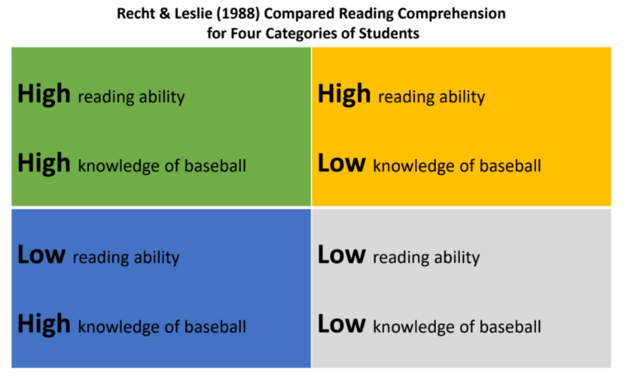  T: The green quadrant represents students who have high reading ability and deep knowledge of baseball. The yellow quadrant represents students who have high reading ability but little knowledge about baseball. The blue quadrant represents students who have low reading ability but have a high level of knowledge about baseball. The gray quadrant represents students who have a low reading ability and know little about baseball. Let us look at the results of the study.  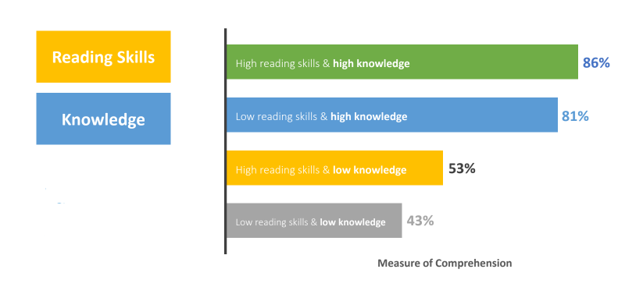  T: What do you notice? Were your predictions correct?  S: The students who had low reading skills, but a high knowledge of baseball scored almost as well as the students who had a high reading ability and high level of knowledge of baseball. The students who had a high reading ability, but little knowledge of baseball scored lower than the students who were lower-level readers with high knowledge of baseball.  T: Right – The researchers found that knowledge of the topic had a much bigger impact on comprehension than generalized reading ability did. Background knowledge is an essential component to reading comprehension because it helps a reader make sense of new ideas and experiences. Knowledge helps readers free up working memory by chunking information. Knowledge also helps build vocabulary.  T: Studies have also shown that reading or listening to a series of text on the same topic can yield as much as four times the vocabulary growth (Landauer and Dumais, 1997). Why do you think reading a series of texts on the same topic promotes vocabulary growth?  S: It allows students to hear the information and vocabulary multiple times.  T: Take a minute and write one sentence about why background knowledge is important. (After one minute, call on students to share responses.)  T: Building background knowledge is important to helping students understand what they read. An approach to lesson planning that builds background knowledge is called a knowledge-based approach.  With a knowledge-based approach, students:  - Read multiple texts on the same topic.  - Engage with other sources (audio, video, discussion) about the same topic.  - Build content knowledge and vocabulary.  This supports their ability to comprehend what they read.  T: Turn and talk to a partner. Partner 1 explains what a knowledge-based approach is, partner 2 explains how it helps build background knowledge.  S: (Turn and talk.)  T: (Call on students to share their explanations)  T: Unlike a knowledge-based approach, a skills-based approach teaches reading skills in isolation. This would be like practicing how to shoot a basketball, but never playing a game with a team.  This is a practice that is used frequently in standardized test preparation. Think about lessons in which students read several short, unrelated passages, and are asked to find the main idea or make an inference.  Because of the focus on skills, texts and topics are unrelated. Students do not build the necessary background knowledge to aid comprehension.  T: What examples of skills-based learning have you experienced or observed?  S: (Answers will vary)  T: Let us Look at two different scope and sequences for 3rd grade to see the difference between a skills-based approach and a knowledge-based approach.  T: (share via PPT.)  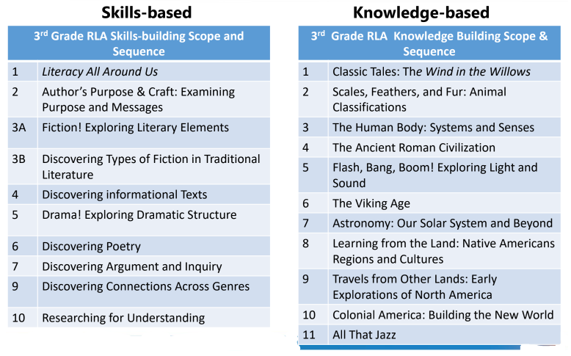  T: What do you notice about the two different approaches?  S: The skills-based list focuses on various comprehension skills like genres, fiction, author’s purpose whereas the knowledge-based list focuses on topics or themes.  T: Right - often, units focused on skills or genres lead to teaching around disjointed text passages that miss opportunities for knowledge and vocabulary building. Shifting focus from skill to topic can build background knowledge and engagement. By engaging in units that focus on sequences of high-quality texts on a single topic, students can build knowledge and vocabulary around important topics while also learning key comprehension skills.  T: Knowledge building should also happen strategically across grades, so students build on what they have already learned. Let us look at an example.  T: (Share via PPT.) If you look at the graphic, you can see that American History is a topic that students’ study across grade levels from kindergarten all the way to 5th grade.  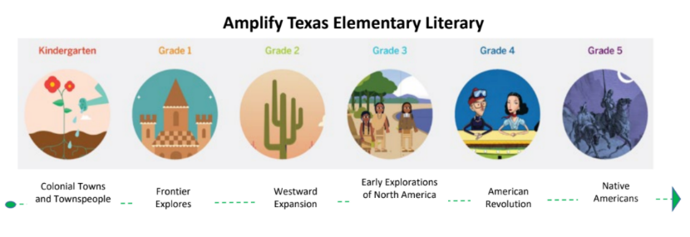 | Student Guide  PPT  Source: https://www.bakemag.com/articles/14937-the-power-of-pizza  Source: Recht, D. & Leslie, L. “Effect of Prior Knowledge on Good and Poor Readers Memory of Text.” (1998) Journal of Educational Psychology
15 mins | Practice: Grade 4 Curriculum Map  T: We are going to look at a Grade 4 Curriculum Map to see how the units are structured to build student knowledge and vocabulary while also learning about key comprehension skills.  T: (Provide students with a copy of the Grade 4 Curriculum Map.)  T: Let us look at the first unit, Unit 1: Personal Narratives: My Story, My Voice. Quietly read the summary of the unit.  S: (read summary for unit 1.)  T: What is this unit about? Record your response in the chart in your Student Guide.  S: The genre of personal narratives.  T: How is the unit structured to build background knowledge and vocabulary about personal narratives? Record your response in the chart in your Student Guide.  S: Students read five personal narratives and identify the elements of the genre. They use the elements of the genre to write their own personal narratives.  T: In this unit, students learn all about the genre personal narrative, while also building their skills around literary devices, such as similes and metaphors, dialogue, point of view, etc. and cause and effect.  T: Now, you are going to collaborate with a partner to examine two other units to determine what the topic/theme of each unit is and how each unit is structured to build knowledge and vocabulary. You will record your responses in the chart in your Student Guide. After you have had time to analyze your assigned units, you will share with the group what you found.  T: Are there any questions?  S: (ask questions as needed.)  T: You will have 10 minutes with your partner. You may begin.  T: (After 10 minutes.) Stop. Now you will each share out with the group. As each group presents, please take notes in your Student Guide for the corresponding unit.  S: (Groups share out while students take notes in Student Guide.) | Student Guide  PPT  Grade 4 Curriculum Map
3 mins | Debrief  T: What did you notice about each of the units?  S: All the texts the students engaged with during each unit were centered around a particular topic.  T: How does this approach support knowledge building and vocabulary development?  S: By reading multiple texts on the same topic, students have multiple opportunities to engage with the content and build their knowledge around the topic opposed to just using the book to practice comprehension skill. Students have multiple opportunities to be exposed to the new vocabulary, which will help store it into long-term memory.
5 mins | S: (Complete the Exit Ticket.) | Exit Ticket

