Student Guide – Answer Key

Lesson 3.07: Background Knowledge and Reading Comprehension
Name:
Date:
Bellringer:
Read the excerpt and write a 2-3 sentence summary of what you think the excerpt is about.
“Over the past 30 years, the number of gears on road bikes has steadily increased. Current group sets now provide 22 gears through the combination of two chainrings and 11 sprockets. The range of sizes for the chainrings and sprockets has also grown in that time, too, providing riders plenty of scope to fine-tune the gearing on their bikes.
With such a generous number of gears on offer, it is tempting to think that there would not be much point to tinkering with them, but the human engine demands it. After all, there is a finite amount of power on offer and the efficiency of the system depends upon maintaining a consistent cadence (~80rpm), regardless of any change in the terrain or riding conditions.
Every road cyclist understands that the size of the chainrings and sprockets dictate the gearing of the bike, however there is more to the concept than simply the number of teeth involved. What is most important is the ratio and the way that the sprockets multiply the effort made with the chainring.”
Source: https://cyclingtips.com/2017/11/understanding-bicycle-gear-ratios-why-they-matter/
Responses will vary but may include:
Student responses may vary but could include the passage is about bikes and gears on the bike. The passage is about how chainrings and sprockets impact the gearing system on a bike.
Note: students will likely have difficulty developing a summary, which is the point.
Notes: Background Knowledge
“Paul Bright, senior innovation manager for AB Mauri North America, points out that to make a great pizza, it is quite simple: consistency.
“Once pizza makers determine the formulation and process to produce their version of a great pie, the next step is to ensure that the process is followed the same way every time,” Bright says. “Any changes to ingredients – like flour – or to process times and temperatures can increase the chances of inconsistently baked pizzas on a week in and week out basis.”
So, the question looms: For pizza makers, what steps are the foundation of making great pizza?
Consistency in process is the key. Dough is a living product, at least until 140 degrees when the yeast dies during the baking process. Time and temperature standards must be in place and adhered to when mixing, processing, and storing dough for later use. Fermentation equals flavor and shortcuts taken during the processing will simply produce substandard pizza crusts,” points out Dave Krishock, bakery technical support manager for Grain Craft.”
Source: https://www.bakemag.com/articles/14937-the-power-of-pizza
What was this article about?
The importance of consistency in the ingredients and the process when making a pizza.
Why was this article easier to comprehend?
Because we all know about pizza, dough, crust, ovens, etc. We all know about the process involved with making a pizza and have all likely baked a pizza.
Vocabulary Word | Definition
Background Knowledge | The knowledge and skills you have based on life experiences and previous learning that is stored in the memory and acquired over time.

Background knowledge can help students:
- Make connections to new information.
- Make sense of new ideas and experiences
- Better understand new information
- Store and retrieve new information.
- Free up working memory by chunking information.
- Build vocabulary.
How big of a role does knowledge and vocabulary really play in comprehension? Let us say I am going to give a reading assessment about baseball. Who do you think will do the best on it?
- Students with a high reading ability and knowledge of baseball.
- Students with high reading ability and low knowledge of baseball.
- Students with low reading ability but a high knowledge of baseball.
- Students with low reading ability and low knowledge of baseball.

Rank your predictions from who will score the highest to who will score the lowest.

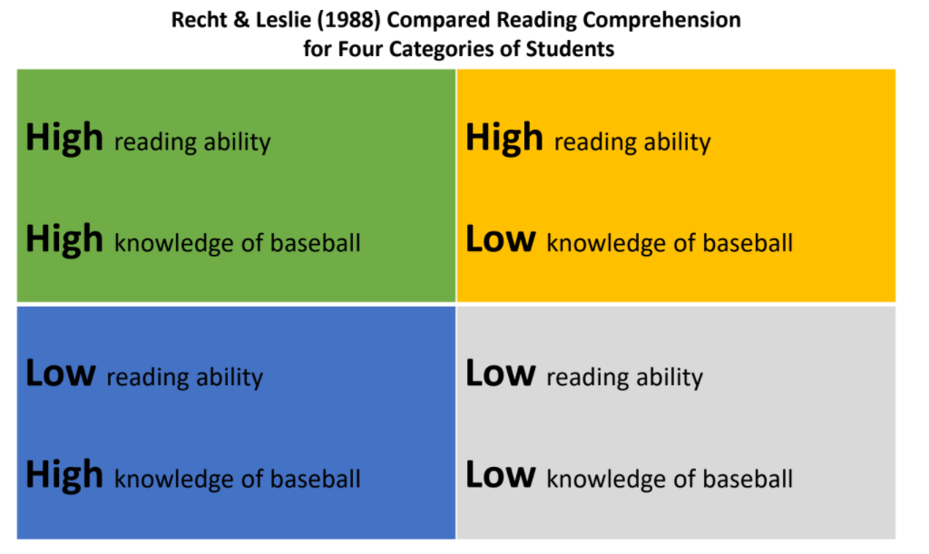
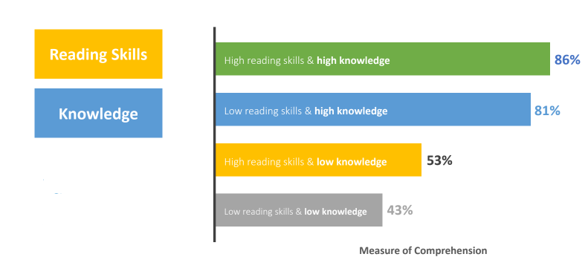
What do you notice?
The students who had low reading skills, but a high knowledge of baseball scored almost as well as the students who had a high reading ability and high level of knowledge of baseball. The students who had a high reading ability, but little knowledge of baseball scored lower than the students who were lower-level readers with high knowledge of baseball.
Why is background knowledge important?
Building background knowledge is important in helping students understand what they read.

Knowledge-based | Skills-based
Students read multiple texts on the same topic to build content-rich knowledge and vocabulary of history, geography, science, literature, etc. | Students engage in a whole-group mini-lesson that targets a reading skill such as finding the main idea or making an inference. The teacher will instruct on this skill over the course of a few days using a variety of texts on different topics.
With a knowledge-based approach, students:  - Read multiple texts on the same topic.  - Engage with other sources (audio, video, discussion) about the same topic.  - Build content knowledge and vocabulary.  This supports their ability to comprehend what they read. | A skills-based approach teaches reading skills in isolation. This would be like practicing how to shoot a basketball, but never playing a game with a team.  This is a practice that is used frequently in standardized test preparation. Think about lessons in which students read several short, unrelated passages, and are asked to find the main idea or make an inference.  Because of the focus on skills, texts and topics are unrelated. Students do not build the necessary background knowledge to aid comprehension.
What examples of knowledge-based learning have you experienced or observed?  Student responses will vary | What examples of skills-based learning have you experienced or observed?  Student responses will vary.

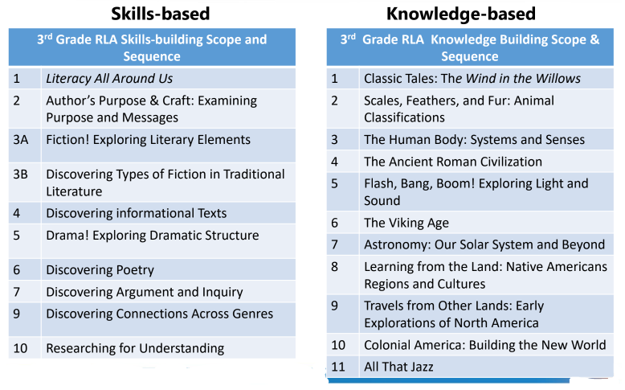
What do you notice about the two different approaches?
The skills-based list focuses on various comprehension skills like genres, fiction, author’s purpose whereas the knowledge-based list focuses on topics or themes.

Practice: Grade 4 Curriclum Map
Look at the Grade 4 Curriculum Map to see how the units are structured to build student knowledge and vocabulary while also learning about key comprehension skills.
Unit | Topic/Theme of Unit | How does the unit build student knowledge and vocabulary? | What key comprehension skills are addressed in this unit?
1 | Personal Narratives | Students read five personal narratives and identify the elements of the genre. They use the elements of the genre to write their own personal narratives. | Students learn about the genre, literary devices, such as similes and metaphors, dialogue, point of view, etc. and cause and effect.
2 | Inventors, inventions, and the process of creation | Students participate in close reads of informational texts about inventors, inventions, and the process of creation, which help them analyze objects and situations in the world around them and ultimately become inventors themselves. | Students learn research skills, speaking and listening skills, finding evidence, opinion, informational, and narrative writing, and how to adjust their style of writing for the audience.
3 | Contemporary Fiction | Students use excerpts from The House on Mango Street as an anchor text. Throughout this unit, students read closely and analyze the text, then practice using literary elements they have explored in each vignette from the Reader. | Narrative literature and writing, details, dialogue, and action, theme, contrasting character perception, multi-chapter narrative by planning, drafting, and revising.
4 | American Revolution | Students review the stages of the writing process, enact and record key information from vignettes corresponding to the causes of the American Revolution. | Write a five-paragraph compare essay, subject-verb agreement with both regular and irregular verbs, prefixes and suffixes when added to root words
5 | Fiction Genre | Students focus on character development, setting, plot, and literary devices while reading an abridged version of Robert Louis Stevenson’s popular adventure story, Treasure Island. | Identify and use modal auxiliary verbs, relative pronouns, and coordinating conjunctions, trace development of character, setting, plot, and literary devices in a longer work of fiction, develop an adventure story using an introduction, problem, or conflict, rising action, turning point or climax, and a resolution.
6 | Poetry | The poems in this unit represent a wide variety of time periods, from Kshemendra’s 12th century treatise on the responsibilities of poets to the work of living writers such as Harryette Mullen. | Read text with the purpose of identifying details and evidence, figurative language, poetic devices including rhyme, repetition, alliteration, meter, and tone, extended metaphors in text, Write original poems with colorful language and poetic devices.
7 | Geology | This unit focuses on the composition of the earth and the forces that change its surface. Students learn about the theory of plate tectonics and how it explains the presence of volcanoes, mountains, underwater trenches, ridges, and other geological features. Students will also study geological processes like rock formation, weathering, and erosion to understand how the earth changes over time and why it looks the way it does. | How to reference bolded words in the glossary not directly addressed in lessons, examine, and explain similes, draft an informational pamphlet, write a wiki entry, and create a descriptive paragraph, use literary devices including alliteration, personification, and simile.
8 | Energy | Students will sequentially construct a timeline of energy development starting in the 19th century with the discovery of oil in Texas. They will build an understanding of the myriad energy sources available today, including fossil fuels and renewable fuels. Students will generate research questions about energy and conduct research using primary and secondary sources. | Identify central ideas and key details in the text, identify cause/effect and problem/solution relationships in the text, make and defend a claim using textual evidence, make inferences in texts and draw conclusions, identify, and gather primary and secondary source information, draft, revise, and publish an argumentative essay
9 | Novel Study: Hello, Universe | This novel study will help students improve their reading abilities and their enjoyment of authentic texts and will also encourage them to appreciate other people’s perspectives and experiences. Throughout the unit, students will analyze the relationships among the characters in the story and reflect on their own relationships with family and friends. Students will use a variety of graphic organizers to synthesize and analyze character and plot development. | Establish a purpose for reading a novel, analyze character relationships and interactions, generate questions before, during and after reading to deepen understanding, identify and understand the elements of plot, prepare and present information using appropriate media.

