Student Guide

Lesson 3.07: Background Knowledge and Reading Comprehension
Name:
Date:
Bellringer:
Read the excerpt and write a 2-3 sentence summary of what you think the excerpt is about.
“Over the past 30 years, the number of gears on road bikes has steadily increased. Current group sets now provide 22 gears through the combination of two chainrings and 11 sprockets. The range of sizes for the chainrings and sprockets has also grown in that time, too, providing riders plenty of scope to fine-tune the gearing on their bikes.
With such a generous number of gears on offer, it is tempting to think that there would not be much point to tinkering with them, but the human engine demands it. After all, there is a finite amount of power on offer and the efficiency of the system depends upon maintaining a consistent cadence (~80rpm), regardless of any change in the terrain or riding conditions.
Every road cyclist understands that the size of the chainrings and sprockets dictate the gearing of the bike, however there is more to the concept than simply the number of teeth involved. What is most important is the ratio and the way that the sprockets multiply the effort made with the chainring.”
Source: https://cyclingtips.com/2017/11/understanding-bicycle-gear-ratios-why-they-matter/

Notes: Background Knowledge
“Paul Bright, senior innovation manager for AB Mauri North America, points out that to make a great pizza, it is quite simple: consistency.
“Once pizza makers determine the formulation and process to produce their version of a great pie, the next step is to ensure that the process is followed the same way every time,” Bright says. “Any changes to ingredients – like flour – or to process times and temperatures can increase the chances of inconsistently baked pizzas on a week in and week out basis.”
So, the question looms: For pizza makers, what steps are the foundation of making great pizza?
Consistency in process is the key. Dough is a living product, at least until 140 degrees when the yeast dies during the baking process. Time and temperature standards must be in place and adhered to when mixing, processing, and storing dough for later use. Fermentation equals flavor and shortcuts taken during the processing will simply produce substandard pizza crusts,” points out Dave Krishock, bakery technical support manager for Grain Craft.”
Source: https://www.bakemag.com/articles/14937-the-power-of-pizza
What was this article about?

Why was this article easier to comprehend?

Vocabulary Word | Definition
Background Knowledge

Background knowledge can help students:

How big of a role does knowledge and vocabulary really play in comprehension? I am going to give a reading assessment about baseball. Who do you think will do the best on it?
- Students with a high reading ability and knowledge of baseball.
- Students with high reading ability and low knowledge of baseball.
- Students with low reading ability but a high knowledge of baseball.
- Students with low reading ability and low knowledge of baseball.

Rank your predictions from who will score the highest to who will score the lowest.

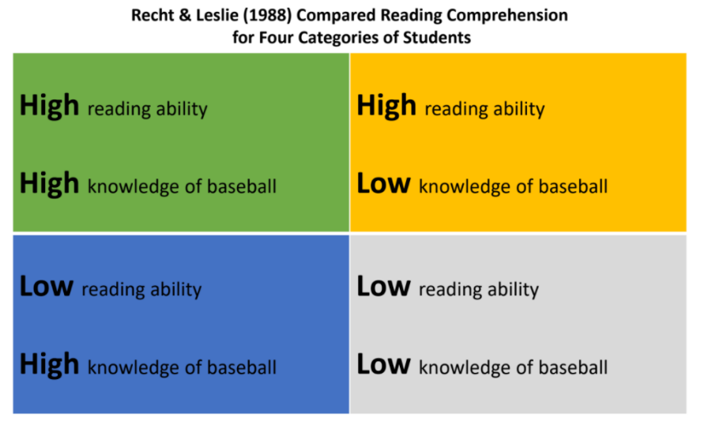
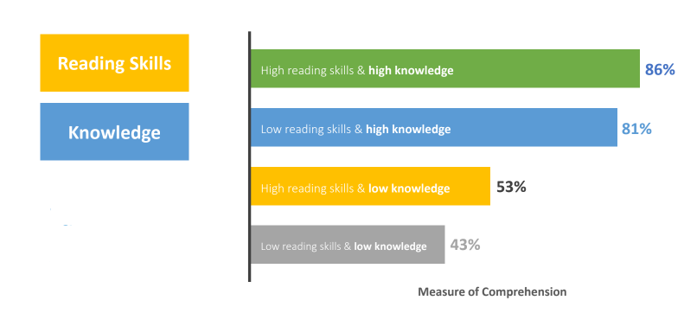
What do you notice?

Why is background knowledge important?

Knowledge-based | Skills-based
With a knowledge-based approach, students: | A skills-based approach, students:
What examples of knowledge-based learning have you experienced or observed? | What examples of skills-based learning have you experienced or observed?

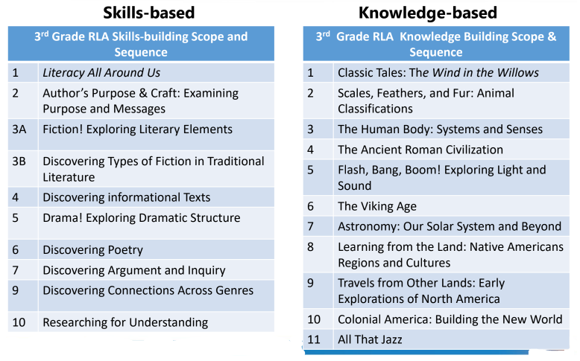
What do you notice about the two different approaches?

Practice: Grade 4 Curriclum Map
Look at the Grade 4 Curriculum Map to see how the units are structured to build student knowledge and vocabulary while also learning about key comprehension skills.
Unit | Topic/Theme of Unit | How does the unit build student knowledge and vocabulary? | What key comprehension skills are addressed in this unit?
1
2
3
4
5
6
7
8
9

