Student Guide

Lesson 3.11: Assessment Data
Name:
Date:
Bellringer:
Match the type of assessment with its correct definition and when it is used.
Diagnostic  Formative  Summative  Interim | Assessment used at the end of a learning sequence to determine to what extent students met the learning objectives; evaluative.  Assessment used at different checkpoints throughout the year to measure student understanding of a broader span of student expectations and learning targets to monitor progress, predict summative performance, and identify students for intervention.  Assessments are used to determine student progress while learning is still happening (during a learning sequence) and to inform the next steps in a learning progression.  Assessments are used to collect information about a student’s strengths and weaknesses in a particular skill area and are usually given at the beginning of a new unit.

Notes: Assessment Data
Assessment Type | Explanation | Most Common Item Type | Example
Cold Assessments
Warm Assessments
Hot Assessments

Practice: Card Sort
Analyze the assessment cards to determine if each assessment is cold, warm, or hot.
Card # | Assessment Type
1 (PAST Assessment)
2 (Check for Understanding)
3 (Word Reading in Isolation)
4 (Domain Assessment)
9 (5th Formative Assessment)
5 (Story Reading Assessment)
6 (STAAR Assessment)
7 (Exit Ticket)
8 (CKLA End of Year Assessment)
9 (Formative Assessment)
10 (Core Knowledge Diagnostics)
11 (Formative Assessment Letter Check)

Notes: Assessment Data, Part 2
Assessment Type | To Support Students: | Common Pitfalls
Cold Assessments
Warm/Hot Assessments

Practice: Lesson Analysis
Read the excerpt from An Amazing Apprentice and read the excerpt of a student work sample to determine what we can learn from student responses to the text.
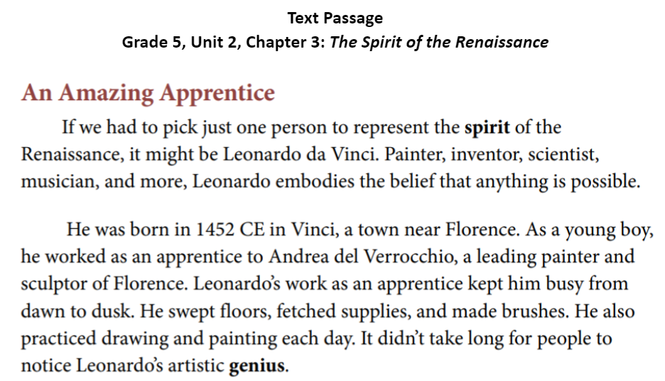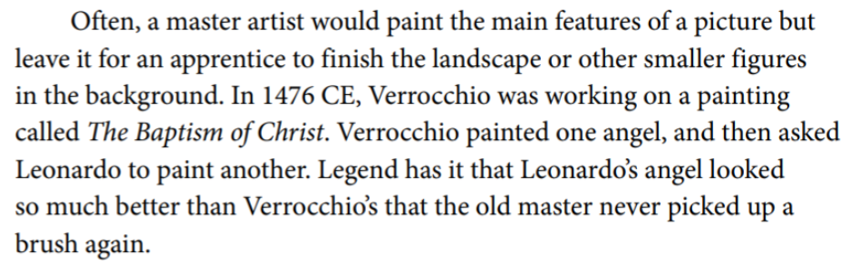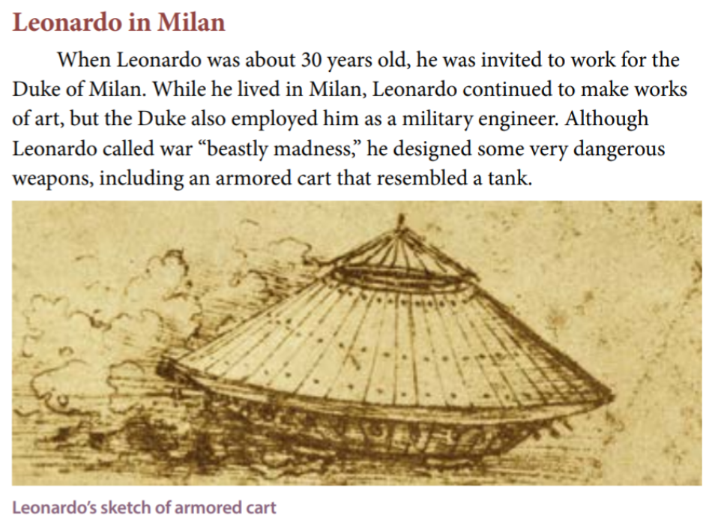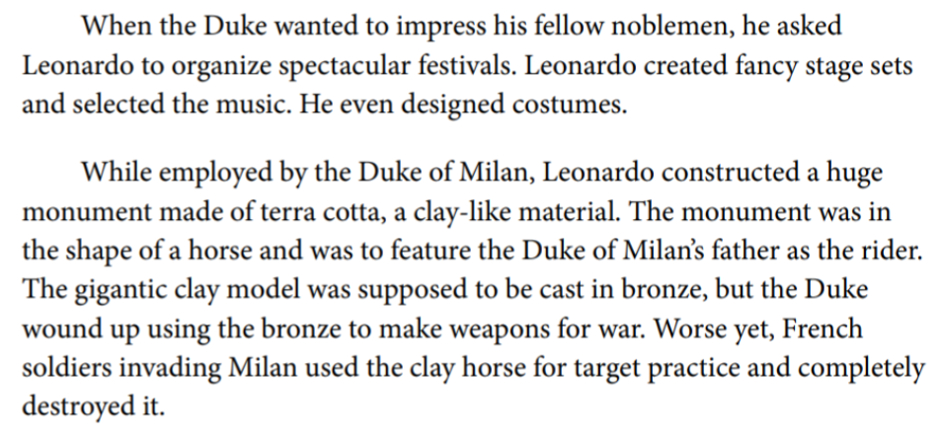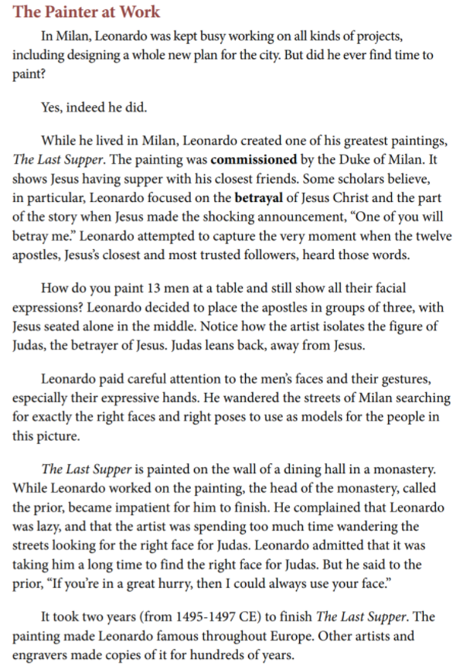

Read the following excerpt of a student work sample. What can we learn from student responses to text? Respond to the following questions to determine what we can learn from the student’s response:
- What does the student’s work demonstrate about his/her understanding of the task?

- What does the student’s work demonstrate about the depth of his/her understanding of the text and topic?

Student work sample
Respond to the following prompt in 5-7 sentences. Include two or more pieces of evidence in your response: How is the spirit of the Renaissance represented in Leonardo Da Vinci’s ideas and accomplishments?

The spirit of the Renaissance is represented in Leonardo da Vinci’s ideas because he believes that if there is something in your head you can do it.

Leonardo establishes his own workshop in Florence. Leonardo da Vinci, he lived in a Rocky hill 60 miles outside of Florence. He makes a lot of paintings and new machines. One of the machines was to help humans fly. But it didn’t work so he broke a leg.

Leonardo Da Vinci showed the spirit of the Renaissance because he always tries to make and invent and paint new things.

