Student Guide – Answer Key

Lesson 3.11: Assessment Data
Name:
Date:
Bellringer:
Match the type of assessment with its correct definition and when it is used.
Diagnostic  Formative  Summative  Interim | Assessment used at the end of a learning sequence to determine to what extent students met the learning objectives; evaluative.  Assessment used at different checkpoints throughout the year to measure student understanding of a broader span of student expectations and learning targets to monitor progress, predict summative performance, and identify students for intervention.  Assessments are used to determine student progress while learning is still happening (during a learning sequence) and to inform the next steps in a learning progression.  Assessments are used to collect information about a student’s strengths and weaknesses in a particular skill area and are usually given at the beginning of a new unit.

Notes: Assessment Data
Assessment Type | Explanation | Most Common Item Type | Example
Cold Assessments | Texts and topics the students have NOT read or are unfamiliar with | Multiple Choice | STAAR passages
Warm Assessments | Texts that students have NOT read, but on related topics or related texts | Multiple choice & open-ended | Curriculum embedded
Hot Assessments | Familiar texts that students have read and studied | Open-ended response | Curriculum embedded

Practice: Card Sort
Analyze the assessment cards to determine if each assessment is cold, warm, or hot.
Card # | Assessment Type
1 (PAST Assessment) | Warm
2 (Check for Understanding) | Warm
3 (Word Reading in Isolation) | Cold
4 (Domain Assessment) | Hot
9 (5th Formative Assessment) | Hot
5 (Story Reading Assessment) | Cold
6 (STAAR Assessment) | Cold
7 (Exit Ticket) | Hot
8 (CKLA End of Year Assessment) | Cold
9 (Formative Assessment) | Hot
10 (Core Knowledge Diagnostics) | Warm
11 (Formative Assessment Letter Check) | Hot

Notes: Assessment Data, Part 2
Assessment Type | To Support Students: | Common Pitfalls
Cold Assessments | - Track longer term student growth.  - Evaluate program effectiveness.  - Evaluate school-wide and classroom effectiveness; plan school-wide interventions | - Attempting to improve cold read performance with more cold read practice.  - Assessing too frequently  - Aligning instruction and reteach to discrete, skills- based lessons
Warm/Hot Assessments | - Identify root causes of learning gaps to provide students targeted support.  - Look ahead to emphasize curriculum-embedded scaffolds  Plan Tier 1 and Tier 2 supports for  - students in upcoming units | - Disaggregating data based on discrete comprehension standards.  - Inserting skills-based mini lessons

Practice: Lesson Analysis
Read the excerpt from An Amazing Apprentice and read the excerpt of a student work sample to determine what we can learn from student responses to the text.
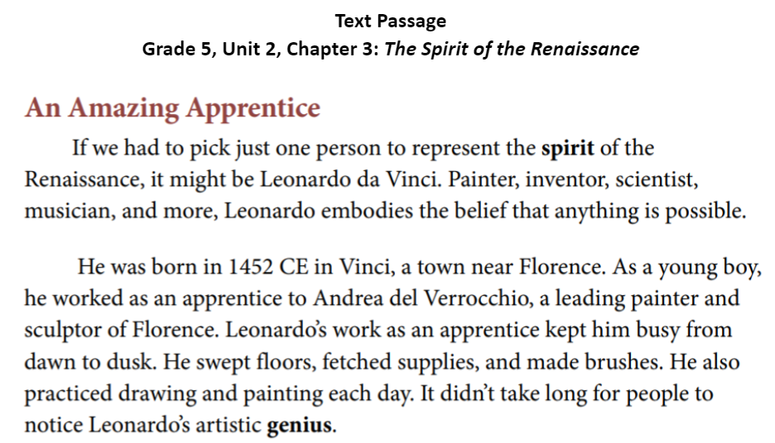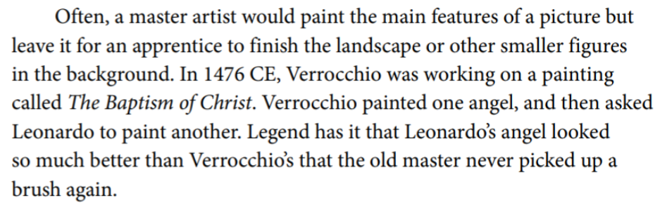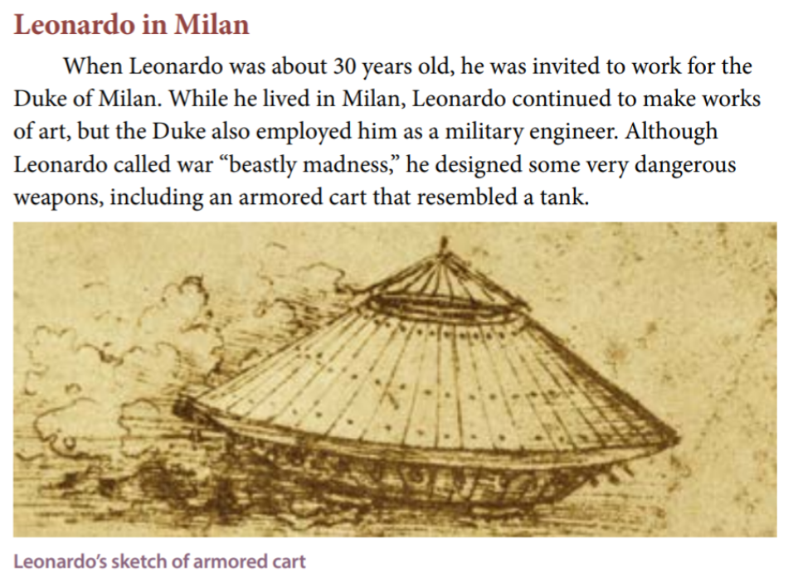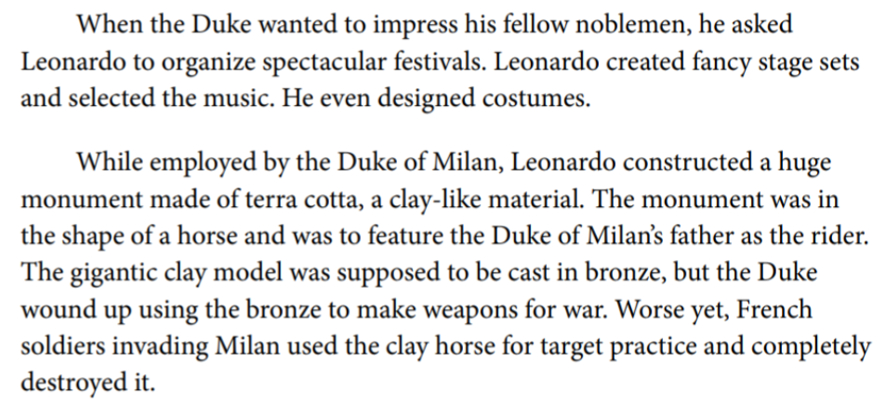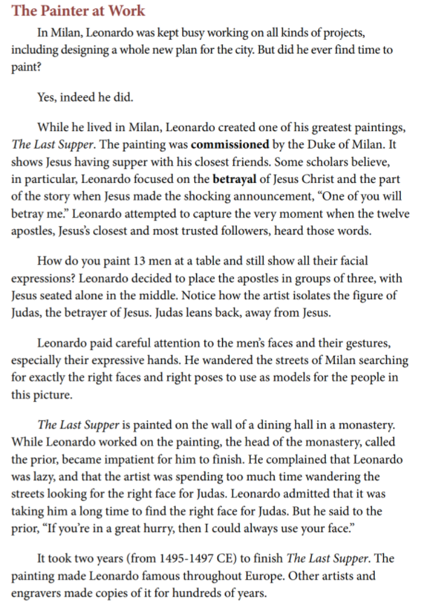
Read the following excerpt of a student work sample. What can we learn from student responses to text? Respond to the following questions to determine what we can learn from the student’s response:
- What does the student’s work demonstrate about his/her understanding of the task?
The students included evidence to support their response to the question because the evidence was limited and was not all evidence from the text. The student started listing off facts about Leonardo Da Vinci. This lets us know that the student did not understand the task or did not know how to support their answers with evidence.
- What does the student’s work demonstrate about the depth of his/her understanding of the text and topic? The student provided details to support his/her claim, but the student used details that were not included in the text. The details were also limited and did not show a true understanding of the text or topic.

Student work sample
Respond to the following prompt in 5-7 sentences. Include two or more pieces of evidence in your response: How is the spirit of the Renaissance represented in Leonardo Da Vinci’s ideas and accomplishments?

The spirit of the Renaissance is represented in Leonardo da Vinci’s ideas because he believes that if there is something in your head you can do it.

Leonardo establishes his own workshop in Florence. Leonardo da Vinci, he lived in a Rocky hill 60 miles outside of Florence. He makes a lot of paintings and new machines. One of the machines was to help humans fly. But it didn’t work so he broke a leg.

Leonardo Da Vinci showed the spirit of the Renaissance because he always tried to make and invent and paint new things.

