Exit Ticket - Answer Key

Lesson 3.13: Curriculum Embedded Supports
Name:
Date:
- What is the importance of planning with both HQIM and UDL? How can this approach support learning for all students?
UDL anticipates the challenges for students and includes support so that all students can have challenging and rigorous learning experiences. HQIM is important because it embeds these necessary supports into the curriculum to ensure that teachers have what they need to help every student learn.

- Examine the HQIM provided. Identify at least one example of where the HQIM aligns to each UDL guideline.

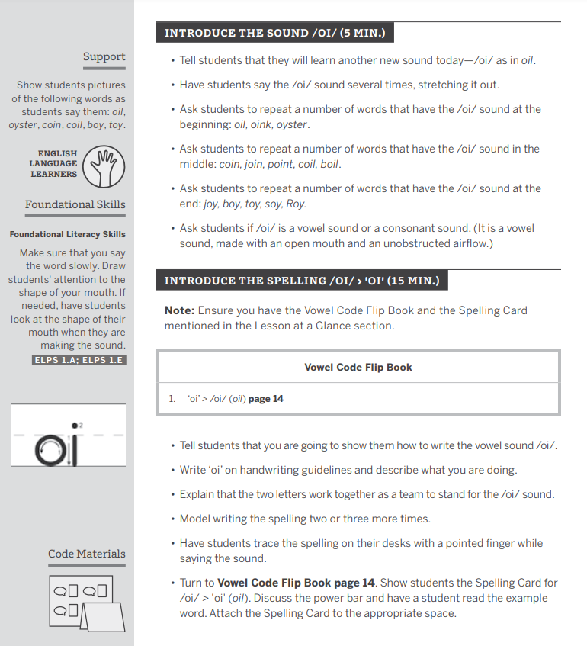
UDL Guideline | Example found in HQIM
Engagement | - Using relevant pictures and materials that support the words taught.  - Introducing the sound before the spelling is an example of supporting persistence and increased effort.
Representation | - Showing pictures of the words as they are said.  - Demonstrating how a vowel sound is made while making it.
Action & Expression | - Modeling the sound and then asking students to complete an example is progress monitoring.  - Having students observe the shape of their own mouth as they are making the sound is graduated levels of support.  - Having the students to trace the spelling with pointed finger before writing it is graduated levels of support.

