Exit Ticket

Lesson 3.13: Curriculum Embedded Supports
Name:
Date:
- What is the importance of planning with both HQIM and UDL? How can this approach support learning for all students?

- Examine the HQIM provided. Identify at least one example of where the HQIM aligns to each UDL guideline.

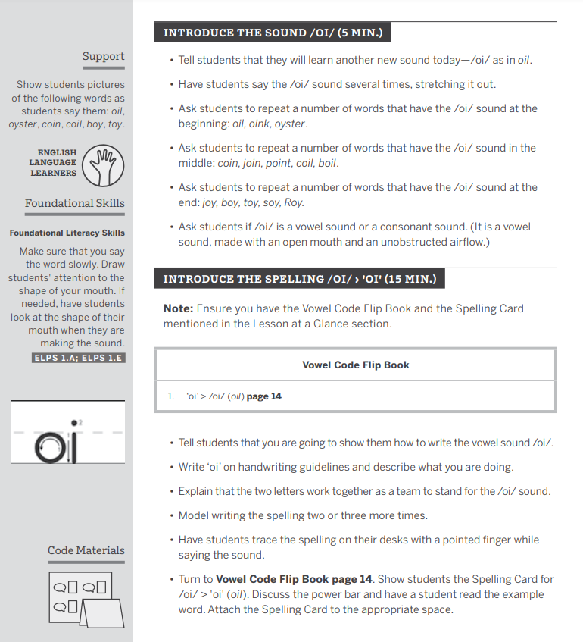

UDL Guideline | Example found in HQIM
Engagement
Representation
Action & Expression

