Unit 3: Research-Based Instructional Strategies (RBIS) Reading Language Arts (RLA)

Lesson 3.13: Curriculum-Embedded Supports

Lesson at Glance
Warm-Up (8 mins)  - Bellringer (5 mins)  - Debrief (3 min) | Instruction (20 mins)  - Notes: UDL and HQIM (10)  - Example: Examining HQIM for UDL guidelines (10) | Application (17 mins)  - Practice: Examining HQIM for UDL Guidelines (10 mins)  - Debrief: (2 mins)  - Exit Ticket (5 mins)

TEKS | 4 | The student understands the learner and the learning process. The student is expected to:  - demonstrate and evaluate effective instructional practices to accommodate diversity such as learning differences, learner exceptionality, and special needs.
Objectives | - Identify examples of curriculum-embedded supports  - Analyze examples of curriculum-embedded supports to determine alignment with UDL guidelines for engagement, representation, and/or action & expression.
Rationale/  Summary | A knowledge of the Universal Design for Learning Guidelines provides a framework to guide teaching and instructional decision-making. In this lesson, students will learn about how the Universal Design for Learning (UDL) approach aligns with high quality instructional materials. Students will examine and analyze HQIM to identify examples of the UDL guidelines.
Formative Assessment and Exemplar Response | - What is the importance of planning with both HQIM and UDL? How can this approach support learning for all students?  - Examine the HQIM below. Identify at least one example for each UDL guideline of where it aligns to the UDL framework.  See Exit Ticket Answer Key for exemplar responses.
Vocabulary | Curriculum-Embedded Supports |  | Scaffolding and support opportunities built into the curriculum that ensure challenging and rigorous learning for all students.

Est Time | Instructional Activities (including formative assessments) | Materials
5 mins | Bellringer:  True or False? If the answer is false, provide an explanation of why it is false.  - Planning instruction with UDL includes anticipating differences in learner abilities and experiences.  - In using a UDL approach, a teacher should reduce the rigor of an activity for students who are performing below grade-level.  - UDL includes two guideline areas: multiple means of engagement and multiple means of action and expression.  S: (Complete activity in student guide) | Student Guide
3 min | T: Turn to a partner and compare your answers to the bellringer questions. Make sure that if you have answered falsely that you can explain why that answer is false.  S: (Compare bellringer answers.)  T: Raise your hand if you and your partner think that question 1 is true.  S: (Raise hands.)  T: Question 1 is true. UDL is an educational framework to guide the development of flexible learning environments that can accommodate individual learning differences through engagement, representation, and expression. The UDL approach ensures all students can access the same information by establishing clear outcomes and provides support for those who may need it by anticipating differences in learner abilities and experiences.  T: What about question 2. Is it true or false?  S: False.  T: Can someone explain why that is false?  S: In UDL, students access the same information. UDL is intended to provide support for learners so everyone can have challenging learning opportunities.  T: UDL use embedded supports and scaffolds to meet learner differences for below and above grade learners to ensure that learning is rigorous for all. What about question 3. True or False?  S: False.  T: Why is question 3 false?  S: There are three guidelines for UDL. Multiple means of engagement, multiple means of representation, and multiple means of action and expression.
10 min | Notes: UDL & HQIM  T: In our previous lesson, we discussed UDL and how instructional planning looks different from traditional methods. Let us quickly review the UDL framework. (Share image below via PPT.)  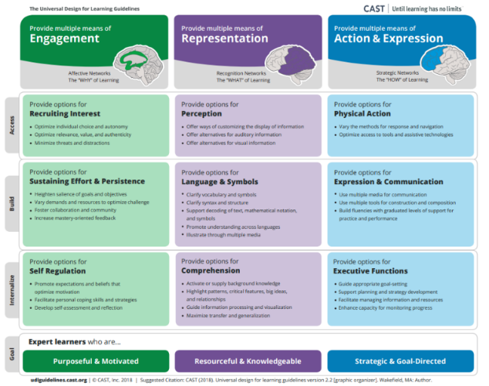  T: To review, we are going to do a quick sorting activity. You have been given 9 different examples of activities or classroom practices that align to the UDL principles in your student guide under the Notes: UDL & HQIM section. I am going to give you 5 minutes to collaborate with a partner to sort those 9 examples into their corresponding UDL principle. For an extra challenge, see if you can identify the specific guideline of the principle it aligns to. You will record your answers in the chart provided below the examples in your student guide. What questions do you have for me?  S: (Ask clarifying questions.)  T: Please find a partner to work with. You may begin. (Set timer for 5 minutes.)  S: (Engage in sorting activity.)  T: Now turn to another group to check your answers.  S: (Turn to another group to check answers.)  T: (Display answers on the ppt.) Were there any that were difficult to identify?  S: (Responses will vary.)  T: In today’s lesson, we are going to look for examples of these UDL guidelines found in HQIM. A key component of HQIM is that they have curriculum embedded support.  T: Curriculum embedded supports are scaffolds and support opportunities built into the curriculum that ensure challenging and rigorous learning for all students. These scaffolds and supports are an important feature of HQIM that aligns to the UDL framework. When examining HQIM for alignment to UDL, we can look for curriculum embedded supports through each of the UDL guidelines of engagement, representation, and action and expression. | Student Guide  PPT
10 mins | Example: Examining HQIM for UDL Guidelines  T: Now let us look at an example of HQIM and see if we can identify examples of alignment to the UDL principles.  T: Find the section titled “Example: Examining HQIM for UDL Guidelines.” You will find an example of a 1st grade lesson that works on Foundational Skills. (Share example via PPT as students follow along in Student Guide.)  S: (Locate example in student guide.)  T: We are going to look for specific examples within this lesson that align to each of the UDL guidelines. Take 2 minutes to review this lesson. Feel free to underline or highlight areas that you think might be an example of one of the guidelines. (Set timer for 2 minutes.)  S: (Review the example in student guide.)  T: Below the example in your student guide, you will notice a chart that lists each of the UDL principles and provides space for you to record examples. Please record the examples in this chart as we identify them together.  T: Let us identify examples of multiple means of engagement first. (Display PPT slide with engagement strategies). Did anyone find something that they think might be an example of engagement?  S: Answers will vary, but should include:  - Supports: gradually reduce support for students (persistence and effort).  - Use of puppet or figurine (recruiting interest)  T: What about examples for representation? (Display PPT slide with representation strategies). Where do we see examples for representation?  S: Answers should include:  - Finger taps represent sounds, and visually show the students hand gestures for blending and segmenting. (Perception)  - showing pictures of bees or cubs to mimic action words or using puppets or small figurines (language and symbols)  T: Now let us look at action and expression. (Display PPT slide with action and expression strategies) Did anyone find an example of action and expression they would like to share?  S: Responses should include:  - Supports: gradually reduce support for students (expression and communication)  - Finger taps (physical action) | Student Guide  PPT
10 mins | Practice: Examining HQIM for UDL Guidelines  T: Now, you are going to examine another example of HQIM with a partner.  S: (Selects partner.)  T: In your Student Guide, find the section titled “Practice: Examining HQIM for UDL Guidelines” and read example HQIM silently. (Set timer for 2 minutes.)  S: (Read HQIM example in Student Guide.)  T: Now, you are going to collaborate with a partner to examine this example of HQIM for alignment to the three UDL guidelines. You should identify at least two examples of each UDL guideline and record those examples in the chart provided below the practice example in your student guide. What questions do you have?  S: (Ask clarifying questions.)  T: You will have about 8 minutes. You may begin.  S: (Complete activity.) | Student Guide
2 mins | Debrief  T: Now that you have had a chance to examine HQIM for the UDL guidelines, what do you think is the importance of planning with both HQIM and UDL? How does it support the learning for all students?  S: UDL anticipates the challenges for students and includes support so that all students can have challenging and rigorous learning experiences. HQIM is important because it embeds these necessary supports into the curriculum to ensure that teachers have what they need to help every student learn.  T: What are some things to look for in HQIM that would be an example of the UDL principle of Engagement?  S: Opportunities for various interests to be supported, authentic and relevant texts and materials, opportunities to foster collaboration, and supports for persistence and increasing effort.  T: What are some things to look for in HQIM that would be an example of the UDL principle of Representation?  S: Support across language needs, various visual and auditory representations, support for vocabulary and building background knowledge and supports generalization and general knowledge building.  T: What are some things to look for in HQIM that would be an example of the UDL principle of Action and Expression?  S: Varied methods for response, graduated levels of support, progress monitoring tools, and support for varied methods of communication and expression.
5 mins | S: (Complete the Exit Ticket.) | Exit Ticket

