Student Guide

Lesson 3.13: Curriculum-Embedded Supports
Name:
Date:
Bellringer:
True or False? If the answer is false, provide an explanation of why it is false.
- Part of using a UDL approach for planning includes establishing clear outcomes and anticipating differences in learner abilities and experiences.

- In using a UDL approach, a teacher should reduce the rigor of an activity for students who are performing below grade-level.

- UDL includes two guideline areas: multiple means of engagement and multiple means of action and expression.

Notes: UDL and HQIM
Curriculum-embedded supports

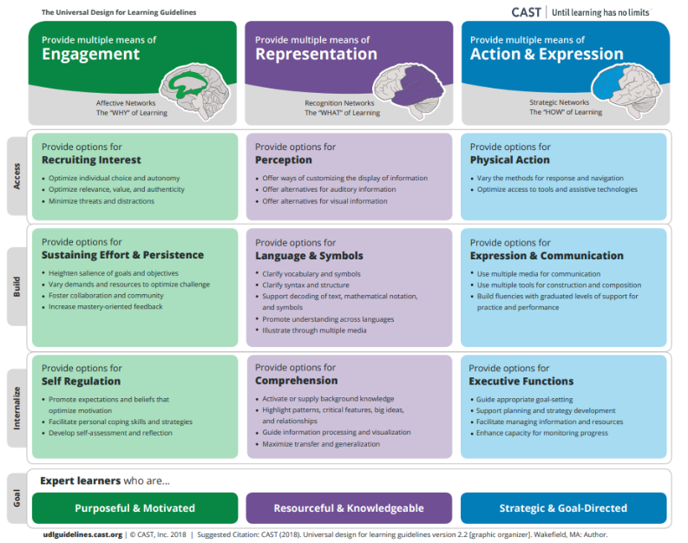
Sorting activity: UDL practices
Sort the following activities and examples into the UDL principle with which it best aligns.
- In a classroom of English Language Learners, the teacher provides text in both their home language and in English.
- Students are asked to self-assess their projects against a provided rubric prior to submitting it for grading.
- A teacher offers both text and a video to help students learn about the concept of animal life cycles.
- Students are allowed to select the subject of their upcoming project in a social studies classroom based on a current event that interests them.
- A teacher utilizes counting blocks in math class to help students learn about the concepts of addition and subtraction.
- At the beginning of a new semester models the development of an academic goal and asks students to set their own academic goals for the class.
- Prior to beginning a new unit, the teacher works with students to complete a K-W-L chart to assess and activate background knowledge.
- A teacher allows students to create their final project using a variety of media such as video, illustrations, music, or written text.
- A teacher slowly removes scaffolds provided to students as they demonstrate mastery.

Engagement | Representation | Action & Expression

Example: Examining HQIM for UDL Guidelines
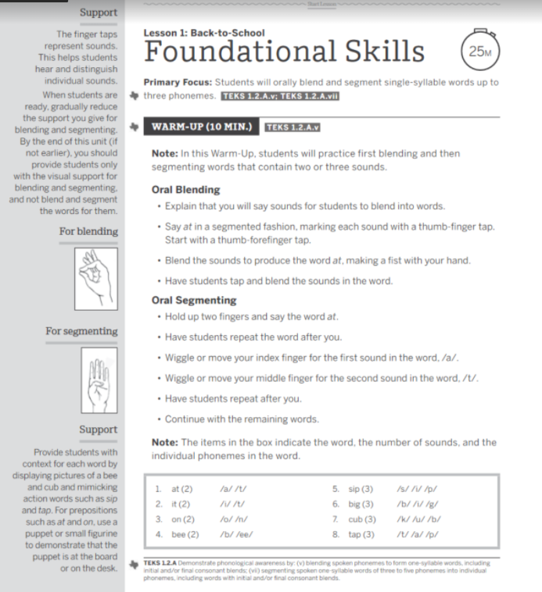

UDL Guideline | Examples found in HQIM
Engagement
Representation
Action & Expression

Practice: Examining HQIM for UDL Guidelines

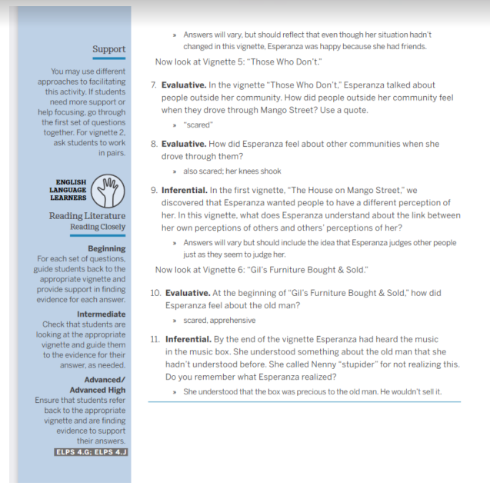

UDL Guidelines | Examples found in HQIM
Engagement
Representation
Action & Expression

