Student Guide – Answer Key

Lesson 3.13: Curriculum-Embedded Supports
Name:
Date:
Bellringer:
True or False? If the answer is false, provide an explanation of why it is false.
- Part of using a UDL approach for planning includes establishing clear outcomes and anticipating differences in learner abilities and experiences. True

- In using a UDL approach, a teacher should reduce the rigor of an activity for students who are performing below grade-level. False, the teacher should utilize grade level appropriate resources with the UDL approach. Using UDL, the teachers should be able to minimize barriers to learning so that all learners can access and participate in meaningful, challenging learning opportunities.

- UDL includes two guideline areas: multiple means of engagement and multiple means of action and expression. False, the UDL approach includes three guideline areas: Multiple means of engagement, multiple means of representation, and multiple means of action and expression.

Notes: UDL and HQIM
Curriculum-embedded supports | Scaffolding and support opportunities built into the curriculum that ensure challenging and rigorous learning for all students.

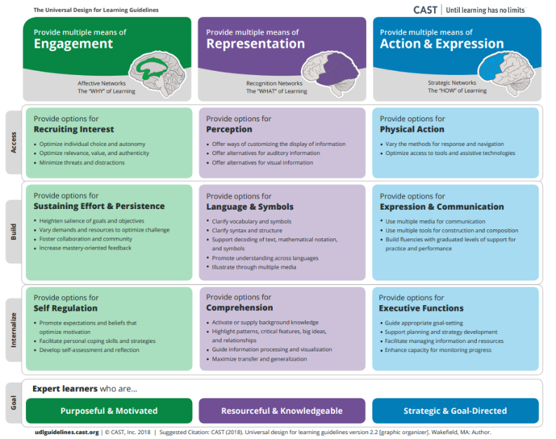
Sorting activity: UDL practices
Sort the following activities and examples into the UDL principle with which it best aligns.
- In a classroom of English Language Learners, the teacher provides text in both their home language and in English.
- Students are asked to self-assess their projects against a provided rubric prior to submitting it for grading.
- A teacher offers both text and a video to help students learn about the concept of animal life cycles.
- Students are allowed to select the subject of their upcoming project in a social studies classroom based on a current event that interests them.
- A teacher utilizes counting blocks in math class to help students learn about the concepts of addition and subtraction.
- At the beginning of a new semester models the development of an academic goal and asks students to set their own academic goals for the class.
- Prior to beginning a new unit, the teacher works with students to complete a K-W-L chart to assess and activate background knowledge.
- A teacher allows students to create their final project using a variety of media such as video, illustrations, music, or written text.
- A teacher slowly removes scaffolds provided to students as they demonstrate mastery.

Engagement | Representation | Action & Expression
B (Self-Regulation) | A (Language & Symbols) | E (Physical Action)
D (Recruiting Interest) | C (Perception) | F (Executive Functions)
I (Effort & Persistence) | G (Comprehension) | H (Expression & communication)

Example: Examining HQIM for UDL Guidelines
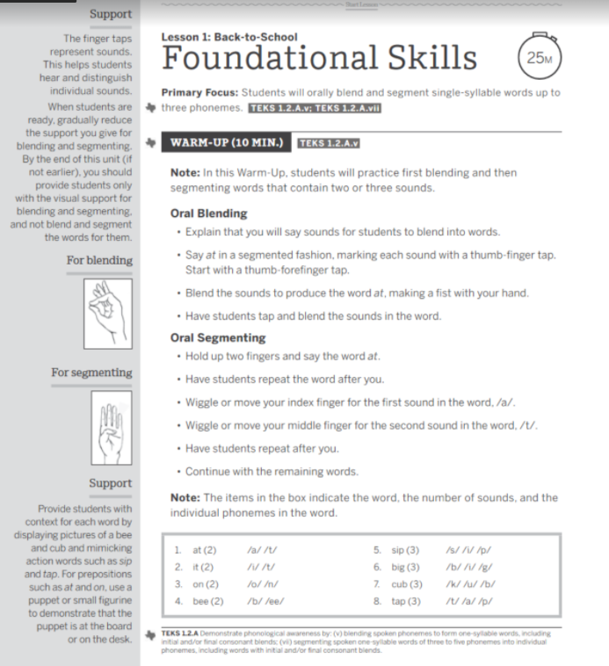

UDL Guideline | Examples found in HQIM
Engagement | - Gradual release of support from finger taps and making the sounds to using only visual repesentations of blending and segmenting  - Using relevant materials such as pictures of bees, cubs, figurines or puppets to demonstrate action words.
Representation | - Using auditory (tapping and making each sound) and visual repesentations (hand gestures)  - Focus on prepositions and common action words is an example of building vocabulary and background knowledge.
Action & Expression | - Repeating the words and actions as demonstrated by the teacher which are varied methods of communication and expression  - The teacher models the process and then provides opportunties for students to tap and blend the sounds as a progress monitoring tool

Practice: Examining HQIM for UDL Guidelines
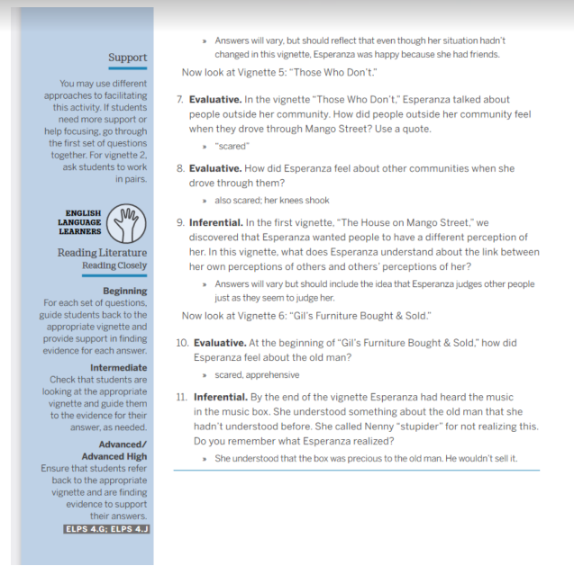
UDL Guidelines | Examples found in HQIM
Engagement | - Support identifies different ways for students to engage from going through the questions together to working in pairs which promotes collaboration.  - The different vignettes provided connect to students and their own experiences making them authentic and relevant
Representation | - In the support section of the lesson, it identifies ways to support English language learners in the beginning, intermediate, and advanced levels which supports different language needs.  - Students are provided different opportunities to respond to the questions either in whole group, pairs, or in writing
Action & Expression | - Graduated levels of support are identified for both language learners and for engagement (whole group/pairs, etc.)  - The lesson uses multiple types of both evaluative and inferential questioning which is an example of progress monitoring. Also, students are expected to give text-based quotes to support answers.

