Student Guide

Lesson 3.08: Evidence-Based Writing
Name:
Date:
Bellringer:
Read the scenario and two prompts below.
Ms. K’s class just finished Not Norman: A Goldfish Story together. The book tells the story of Norman, a goldfish whose young owner wanted a different kind of pet, like a dog.
Prompt #1
Why did Norman’s owner want a pet other than a goldfish?
Prompt #2
Have you ever wanted a different kind of pet than the one you have? Why did you want a different animal?
Identify whether a student can answer each prompt without support from the text or if the text would be needed to answer the question.

Notes: Strengthening Comprehension through Reading, Writing, and Speaking
Student Comprehension

How do we know that reading, writing, and speaking work together to increase comprehension?

Notes: The Value of Evidence-Based Writing
Term | Definition
Evidence-Based Writing

Why is evidence-based writing important?
1
2

Practice 1: Evaluating Assessments for Evidence-Based Writing
Read the two prompts below. Answer the questions that follow.

Prompt #1
Imagine you are one of the characters who met Alice during her adventures. Write a journal entry retelling their encounter from that character’s perspective. Do they like Alice? How did they feel during and after their encounter?

Prompt #2
How did Alice feel upon entering Wonderland? Would you feel the same way if you suddenly found yourself in a new place that is vastly different from our world?

Which prompt includes evidence-based writing?

Where do you see evidence-based writing in the prompts?
Prompt #1 | Prompt #2
Which of these prompts is stronger? Why?

Which of these prompts is more accessible? Why?

Practice 2: Evidence-Based Writing in Action
Read the two prompts below. Answer the questions that follow.

Prompt #1
What is your favorite type of art to make?

Prompt #2
Read the passage below about Michelangelo, a well-known artist from the Renaissance. Why did Michelangelo carve his name into the sculpture that stood in the Vatican in Rome?

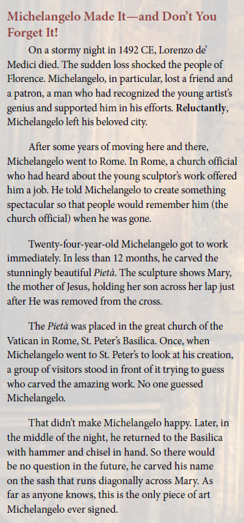

Prompt #2 is from:
Amplify Texas Elementary Literacy Program. (n.d.) Amplify Texas grade 5, unit 2. Access available through registration at https://tea.texas.gov/academics/instructional-materials/tea-available-materials/amplify-texas-elementary-literacy-program

Circle the prompt that is an example of evidence-based writing.

Prompt #1 Prompt #2

How does this prompt require evidence-based writing?

How does this prompt ensure accessibility and fairness for all students?

