Student Guide – Answer Key

Lesson 3.08: Evidence-Based Writing
Name:
Date:
Bellringer:
Read the scenario and two prompts below.
Ms. K’s class just finished Not Norman: A Goldfish Story together. The book tells the story of Norman, a goldfish whose young owner wanted a different kind of pet, like a dog.
Prompt #1
Why did Norman’s owner want a pet other than a goldfish?
Prompt #2
Have you ever wanted a different kind of pet than the one you have? Why did you want a different animal?
Identify whether a student can answer each prompt without support from the text or if the text would be needed to answer the question.
Students cannot answer Prompt #1 unless they have read the book. However, students can answer Prompt #2 even if they have never read Not Norman: A Goldfish Story.

Notes: Strengthening Comprehension through Reading, Writing, and Speaking
Student Comprehension

Speaking
Writing
Reading

How do we know that reading, writing, and speaking work together to increase comprehension?
When students must use what they have read in their writing assignments, they remember what they learned for longer and in more detail.

Notes: The Value of Evidence-Based Writing
Term | Definition
Evidence-Based Writing | Writing activities that engage students in using information from what they have learned to support their answers to prompts.

Why is evidence-based writing important?
1 | It is one of the skills that students need to be successful in their educational pursuits after high school.
2 | It is a strategy that teachers can use to promote accessibility and fairness for all students.

Practice 1: Evaluating Assessments for Evidence-Based Writing
Read the two prompts below. Answer the questions that follow.

Prompt #1
Imagine you are one of the characters who met Alice during her adventures. Write a journal entry retelling their encounter from that character’s perspective. Do they like Alice? How did they feel during and after their encounter?

Prompt #2
How did Alice feel upon entering Wonderland? Would you feel the same way if you suddenly found yourself in a new place that is vastly different from our world?

Which prompt includes evidence-based writing?
Both prompts do.
Where do you see evidence-based writing in the prompts?
Prompt #1  To answer the question, you need to know what happened in the story when Alice met the characters. | Prompt #2  To answer the question, you need to know what happened when Alice got to Wonderland.
Which of these prompts is stronger? Why?
The first one because it is all about evidence-based writing. In the second one, part of the question asks for evidence-based writing, but part of it asks about how a student would respond if they were in a new place.
Which of these prompts is more accessible? Why?
The first one is more accessibly. In the second one, students need to think about how they would respond if they were in a brand-new place. What about students who always go to places in their town? They might not know how to answer the question.

Practice 2: Evidence-Based Writing in Action
Read the two prompts below. Answer the questions that follow.

Prompt #1
What is your favorite type of art to make?

Prompt #2
Read the passage below about Michelangelo, a well-known artist from the Renaissance. Why did Michelangelo carve his name into the sculpture that stood in the Vatican in Rome?

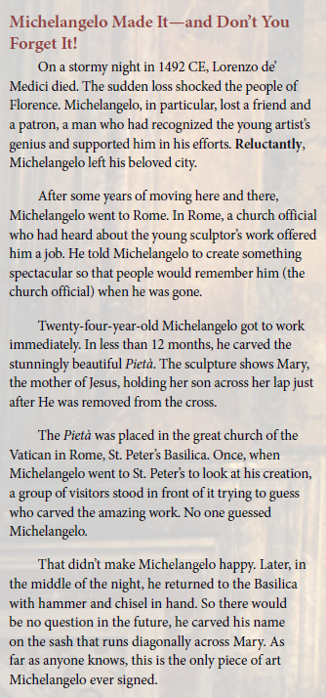

Prompt #2 is from:
Amplify Texas Elementary Literacy Program. (n.d.) Amplify Texas grade 5, unit 2. Access available through registration at https://tea.texas.gov/academics/instructional-materials/tea-available-materials/amplify-texas-elementary-literacy-program

Circle the prompt that is an example of evidence-based writing.

Prompt #1 Prompt #2

How does this prompt require evidence-based writing?
The student needs to use what they read in the text to answer the question.

How does this prompt ensure accessibility and fairness for all students?
Students do not need to know anything about Michelangelo to answer the question. All the information they need is in the text.

