Unit 3: Research-Based Instructional Strategies (RBIS) Reading Language Arts (RLA)

Lesson 3.12: UDL in Literacy Instruction

Lesson at Glance
Warm-Up (5 mins)  - Bellringer (4 mins)  - Debrief (1 min) | Instruction (30 mins)  - Notes: Defining UDL (20 mins)  - Notes: Traditional vs UDL Approach to Planning (10 mins) | Application (17 mins)  - Practice: Scenario Analysis (10 mins)  - Debrief: (2 mins)  - Exit Ticket (5 mins)

TEKS | 4 | The student understands the learner and the learning process. The student is expected to:  - demonstrate and evaluate effective instructional practices to accommodate diversity such as learning differences, learner exceptionality, and special-needs considerations.
Objectives | - Compare a traditional approach to planning with a UDL approach.  - Describe how a UDL approach promotes more accessible outcomes for all students
Rationale/  Summary | A knowledge of the Universal Design for Learning Guidelines provides a framework to guide teaching and instructional decision-making. In this lesson, students will learn about Universal Design for Learning (UDL) and the three UDL guidelines. Students will look at the differences between a traditional approach to planning versus a UDL approach to planning and analyze scenarios to determine which approach was used.
Formative Assessment and Exemplar Response | Students will respond to the following questions.  NOTE: To provide students with multiple means of action & expression, students may respond to the questions below by completing the exit ticket, creating a PPT slide, creating a video explanation, etc.  - How does a traditional approach to planning differ from a UDL approach?  - How does a UDL approach promote more accessible outcomes for all students?  - How have you seen a UDL approach to planning in your own internship experience?  See Exit Ticket Answer Key for exemplar responses.
Vocabulary | Universal Design |  | The design of buildings, products, or environments to make them accessible to people, regardless of age, disability, or other factors.
Vocabulary | Universal Design for Learning (UDL) |  | An educational framework to guide the development of flexible learning environments that can accommodate individual learning differences through engagement, representation, and expression. UDL minimizes barriers and maximizes learning for all students.
Vocabulary | UDL Guidelines |  | A set of strategies that can be applied to any subject or grade level to ensure that all learners can access and participate in meaningful, challenging learning opportunities. (CAST, 2022)
Vocabulary | Multiple Means of Engagement |  | Providing various ways of engaging with material to stimulate interest and motivation for learning
Vocabulary | Multiple Means of Representation |  | Presenting information and content in different ways to support learning for all students
Vocabulary | Multiple Means of Action & Expression |  | Offering options for ways students can demonstrate their learning and express what they know

Est Time | Instructional Activities (including formative assessments) | Materials
 | Note: This lesson may take multiple days to complete based on the amount of time needed for students to complete the concept map and presentations.
4 mins | Bellringer:  The dance instructor of a ballet and tap class is buying new dance shoes for her students. Since the average shoe size for a 16-year-old is a women’s 8.5, she buys everyone the same size dance shoes.  Provide three reasons why this is not a good idea.  S: (Complete activity in student guide) | Student Guide
1 min | T: Why isn’t this the best approach?  S: Because not everyone wears a women’s size 8.5 shoe. By putting all dancers in the same shoe size, the dancers will not be able to perform at the same level as they normally would. If the shoes are too big, it might cause a dancer to get injured. If the shoe is too small, it would not fit the dancer’s foot, meaning they either would not be able to dance at all or would get blisters from the shoe rubbing their foot.  T: How does this relate to student learning?  S: Students learn things in different ways. What works for one student may not work for another.
20 min | Notes: Defining UDL  T: (Share via PPT) Look at the image. What do you notice?  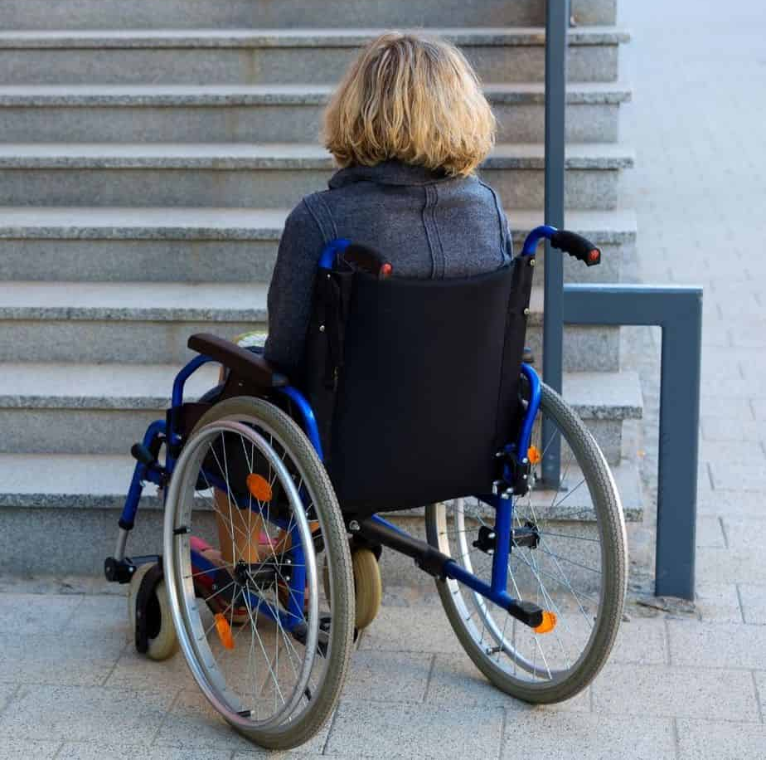  S: Someone is in a wheelchair and cannot get up the steps because there is not a ramp or a way for them to get up the steps.  T: Look at the next image. What do you notice?    S: There are stairs, ramps, handrails, and benches so everyone can get where they need to go.  T: In the first image, you saw a picture of someone in a wheelchair who was unable to get to where they needed to go because they could not access the steps and there was not another path or way for them to access the upper level. In the second image, you saw multiple ways for people to maneuver between the upper and lower levels no matter their disability or preference. The second image is an example of Universal Design. Universal design is the design of buildings, products, or environments to make them accessible to people, regardless of age, disability, or other factors.  T: How do you think universal design relates to the classroom?  S: Students do not all learn the same way or access the material in the same way.  T: (Share via PPT as student record notes in Student Guide.) When designing instruction, we should create a flexible learning environment where learning is accessible to all students. This is called Universal Design for Learning (UDL). UDL is an educational framework to guide the development of flexible learning environments that can accommodate individual learning differences through engagement, representation, and expression. It is an approach to curriculum that minimizes barriers and maximizes learning by ensuring that all learners can access and participate in meaningful, challenging learning opportunities.  T: Research shows that students learn best using multiple methods that encourage active cognitive processing and promote meaningful learning (Mayer 2003). Because of this, it is important to utilize multiple strategies and techniques to maximize learning for all students.  T: Before we move forward, let us make a clear distinction between UDL and learning styles. The concept of learning styles is often misinterpreted to mean that individuals have fixed and rigid ways of learning. UDL, on the other hand, supports the understanding that all learners benefit from multiple means of engagement, representation, and expression, which are the key guidelines for UDL.  T: (Share image below via PPT.)  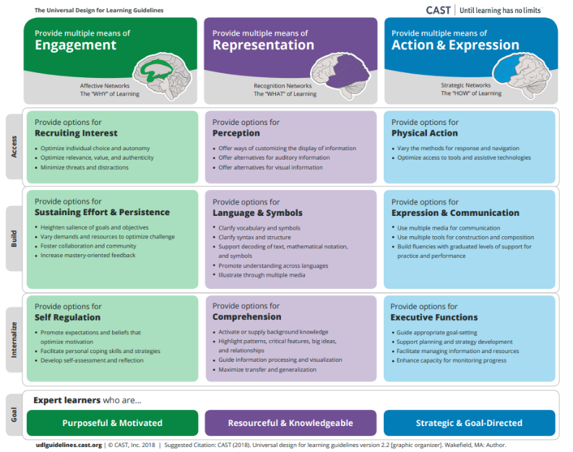  T: In previous courses, you learned that the UDL Guidelines provide a set of strategies that can be applied to any subject or grade level to ensure that all learners can access and participate in meaningful, challenging learning opportunities (CAST, 2022).  T: The guidelines are:  - Multiple Means of Engagement  - Multiple Means of Representation  - Multiple Means of Action and expression  T: These guidelines, when used effectively, help students learn and can help us understand how to best teach so students can learn most effectively.  T: To review these guidelines, you are going to work in groups to develop a concept map or visual representation for one of the guidelines. In your concept map, you should share what the guideline is, specific practices for that guideline, and examples of what each practice might look like in a classroom. You will then share your concept map with the group.  T: Are there any questions?  S: (Ask questions as needed).  T: You will have 15 minutes to complete your concept map. You may begin.  T: (After 15 minutes, stop students and allow time for student groups to share out as students record notes in Student Guide. Discuss key practices for UDL in Literacy Instruction using the suggested responses in green in the Student Guide Answer Key.) | Student Guide  PPT
  Learning Styles | UDL
  - Each student has a fixed and rigid way of learning.  - Not supported by research  - Causes students to become limited in their views of themselves as learners.  - Often leads to less rigorous activities for struggling readers. | - All learners need multiple means of engagement, representation, and expression.  - Supported by research.  - Proactive approach to addressing barriers in the environment and curriculum.  - Makes grade-level content accessible to all learners
10 mins | Notes: Traditional vs UDL Approach to Planning  T: Let us talk about what these guidelines look like in the context of planning literacy instruction.  T: (Share via PPT as students follow along in Student Guide.) Find the section titled “Notes: Traditional vs UDL Approach to Planning.” Review the T-chart and take notes on what you notice and wonder about the two different approaches. You have about 3 minutes.  T: What do you notice?  S: Student responses will vary but could include:  - The traditional approach modifies the activity for some students and makes it easier for students who are below grade level.  - The UDL approach ensures all students can access the same information and provides support for those who may need it.  T: What do you wonder?  S: Student responses will vary but could include:  - How do you best support students without giving lower-level activities?  - What are embedded supports and how are they used?  T: How have you seen a UDL approach to planning used in your field site?  S: Student responses will vary based on experience.  T: To close foundational skill gaps in literacy, students simultaneously need core instruction in grade level content AND just in time intervention on prerequisite skills, with constant monitoring to determine if additional support remains necessary. Unfortunately, many teachers provide struggling students with below grade level activities which is not going to help them close their skill gaps.  T: To ensure all students can access grade level content, students need support. This support should be provided through embedded support within the curriculum. In our next lesson, we will talk about what curriculum-embedded support looks like. | Student Guide  PPT
  Traditional Approach to Planning | UDL Approach to Planning
  - Plan for grade-level, general education students first  - Modify activities for some learners.  - Reduce rigor of activities for students performing below-grade level | - Establish clear outcomes.  - Anticipate differences in learner abilities and experiences.  - Use embedded supports to meet learner differences for below and above grade level learners.  - Provide embedded scaffolds and support as needed to support access while maintaining rigor.  - All students have full access to learning opportunities
10 mins | Practice: Scenario Analysis  T: Now, we are going to read a few scenarios to determine if the approach is a traditional approach or a UDL approach to planning.  T: In your Student Guide, find the section titled “Practice: Scenario Analysis” and read the first scenario silently.  S: (Read scenario in Student Guide.)  T: In this scenario, I read that the teacher gave her students leveled texts about owls based on their reading level, so they were not all given access to the same vocabulary and depth of knowledge about the owl.  T: Based on this, do you think this is a traditional approach or UDL approach? Why?  S: Traditional approach because the teacher gives students different leveled texts instead of providing students with scaffolds and support to access the same text. The text the lower-level students are reading will likely have easier vocabulary and not as much detail as the text the higher-level students are reading.  T: How does this impact the lower-level readers?  S: Lower-level readers are not given the opportunity to build background knowledge and vocabulary that is going to help strengthen their reading abilities.  T: Now, you are going to work with a partner to discuss the remaining scenarios. For each scenario, determine if it is a traditional or UDL approach and provide an explanation for how you know. You may choose how you would like to respond to these questions, whether written, verbally, presentation, video, etc.  T: Are there any questions?  S: (Ask questions as needed)  T: You will have about 8 minutes. You may begin.  S: (Complete activity.) | Student Guide
2 mins | Debrief  T: What does it look like to have a UDL approach to planning?  S: It means:  - Establish clear outcomes.  - Anticipate differences in learner abilities and experiences.  - Use embedded supports to meet learner differences for below and above grade level learners.  - Provide embedded scaffolds and support as needed to support access while maintaining rigor.  - All students have full access to learning opportunities.  T: How does a UDL approach to planning provide full access to learning opportunities?  S: Students have access to the same information, vocabulary, content, etc. The content is not made easier for lower-level students. All students are given scaffolds and support to ensure they can access the grade-level content.
5 mins | S: (Complete the Exit Ticket.) | Ticket

