Student Guide – Answer Key

Lesson 3.12: UDL in Literacy Instruction
Name:
Date:
Bellringer:
The dance instructor of a ballet and tap class is buying new dance shoes for her students. Since the average shoe size for a 16-year-old is a women’s 8.5, she buys everyone the same size dance shoes.
Provide three reasons why this is not a good idea.
- Not everyone wears a women’s size 8.5 shoe. By putting all dancers in the same shoe size, the dancers will not be able to perform at the same level as they normally would.
- If the shoes are too big, it might cause a dancer to get injured.
- If the shoe is too small, it would not fit the dancer’s foot, meaning they either would not be able to dance at all or would get blisters from the shoe rubbing their foot.
Notes: Defining UDL
Universal Design | The design of buildings, products, or environments to make them accessible to people, regardless of age, disability, or other factors.
Universal Design for Learning (UDL) | An educational framework to guide the development of flexible learning environments that can accommodate individual learning differences through engagement, representation, and expression. UDL minimizes barriers and maximizes learning for all students.
UDL Guidelines | A set of strategies that can be applied to any subject or grade level to ensure that all learners can access and participate in meaningful, challenging learning opportunities. (CAST, 2022)

Learning Styles | UDL
- Each student has a fixed and rigid way of learning.  - Not supported by research  - Causes students to become limited in their views of themselves as learners.  - Often leads to less rigorous activities for struggling readers. | - All learners need multiple means of engagement, representation, and expression.  - Supported by research.  - Proactive approach to addressing barriers in the environment and curriculum.  - Makes grade-level content accessible to all learners

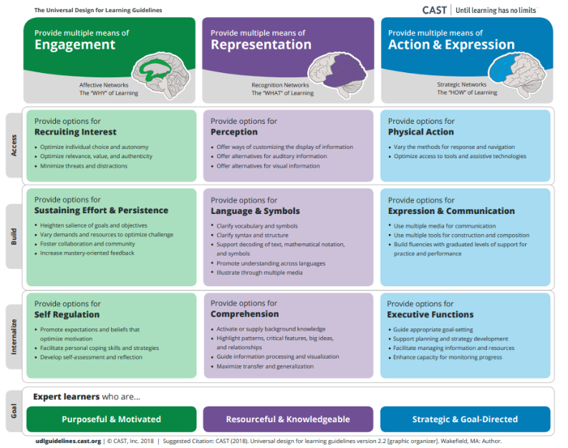

Concept Map
Student responses for the concept maps will vary but should include reference to the following information.
Multiple Means of Engagement | Multiple Means of Representation | Multiple Means of Action & Expression
Providing various ways of engaging with material to stimulate interest and motivation for learning | Presenting information and content in different ways to support learning for all students | Offering options for ways students can demonstrate their learning and express what they know
Examples:  - Provide choice boards (also called menu options and playlists)  - Offer a choice in how students work, such as listening to audio text, e-reader, etc.  - Use examples aligned to student hobbies.  - Connect content to something relatable to students.  - Incorporate a variety of materials and resources, such as different types of texts.  - Provide reading opportunities for learners on a variety of levels, topics, and features (sound books, flap books, big books, etc.)  - Provide a clear purpose for why the content matters in the real-world.  - Provide choice in the sequence or pace for completing tasks. | Examples:  - Provide materials that allow students to modify the size of texts and graphics, colors, and layout.  - Provide materials that allow students to change the rate of speech or sound and vary the pace and sequence of information.  - Show visuals.  - Provide scaffolds.  - Provide opportunities for students to build background knowledge and vocabulary.  - Provide closed captioning for videos.  - Provide written transcripts from videos.  - Offer tactile alternatives for sound effects.  - Use audio to accompany texts.  - Provide descriptions for images and graphics.  - Provide tactile resources | Examples:  - Provide flexibility with time, pacing, and range of motor action required to interact with instruction materials.  - Allow students to type an essay instead of writing it by hand.  - Provide multiple ways for students to respond, compose, or select material.  - Integrate sensory-rich learning opportunities.  - Allow customized overlays for touch screens and keyboards.  - Model the use of assistive technologies and accessibility tools

Notes: Traditional vs UDL Approach to Planning
Traditional Approach to Planning | UDL Approach to Planning
- Plan for grade-level, general education students first  - Modify activities for some learners.  - Reduce rigor of activities for students performing below-grade level | - Establish clear outcomes.  - Anticipate differences in learner abilities and experiences.  - Use embedded supports for below and above grade level learners.  - Provide embedded scaffolds and support as needed to support access while maintaining rigor.  - All students have full access to learning opportunities

I notice… | I wonder…
Student responses will vary but could include:  - The traditional approach modifies the activity for some students and makes it easier for students who are below grade level.  - The UDL approach ensures all students can access the same information and provides support for those who may need it. | Student responses will vary but could include:  - How do you best support students without giving lower-level activities?  - What are embedded supports and how are they used?

Practice: Scenario Analysis
Read each scenario to determine if it is a traditional or UDL approach to planning. Provide an explanation for how you know.
Scenario | Approach | Reasoning
A 5th grade teacher plans to have her students read an article about an owl that was stuck in the Rockefeller Center’s Christmas tree. Knowing she has students on various reading levels, she decides to use leveled texts. All her students will read and learn about the Rockefeller Christmas tree owl, but the texts will be modified to different reading levels. The students reading on grade level will receive the text on a 5th grade level. Students who are just below grade level will receive the text on a 4th grade level. Students who are significantly below grade level will read the text on a 3rd grade level. | Traditional | Traditional approach because the teacher gives students different leveled texts instead of providing students with scaffolds and support to access the same text. The text the lower-level students are reading will likely have easier vocabulary and not as much detail as the text the higher-level students are reading.
The teacher conducts a read-aloud on a book about orcas. Throughout the read aloud, she pauses and asks questions about what they have learned about orcas during the reading. She models how to record this information in a graphic organizer while students record the information on their own graphic organizer. When she encounters a caption, she briefly explains what the structure is, explains that a caption explains a picture, and asks what the picture and caption help students understand about whales. Throughout the read aloud, she has students turn-and-talk using sentence starters to support students in the conversation. | UDL | UDL because the teacher recognizes the varying levels in her room. She models and provides support such as sentence starters and a graphic organizer. She provides clear explanations for students.
In a 3rd grade class, students are working in groups to develop presentations about orcas. After engaging in a read-aloud as a whole class and having a teacher model on how to record key facts about orcas in the graphic organizer, students read non-fiction books about other types of whales, completing a graphic organizer to capture key facts about the animals as they read. Students then have the option to share their learning through a written assignment, PowerPoint presentation or video. | UDL | Students are provided direct instruction and modeling before engaging in practice with a group. All students are completing the same activity no matter their level of understanding. Students have a graphic organizer as a support to organize their thinking. Students have a choice in how they share their learning.
Ms. T is planning a lesson on the human body. Knowing that many of her students are below-grade level, she does not want to overwhelm them with difficult vocabulary. She decides to use a lower-level text to teach them the basics about the human body and then uses the grade-level text with her more advanced students during a small group later in the literacy block. | Traditional | The teacher uses a below-grade level text to teach her students about the human body. The higher-level students are given the grade-level text in a small group, but the lower-level students never can engage in the grade-level text.

