Exit Ticket

Lesson 4.07: Productive Struggle: Strategies in Action
Name:
Date:
Review the mathematics questions below and respond to the questions that follow.
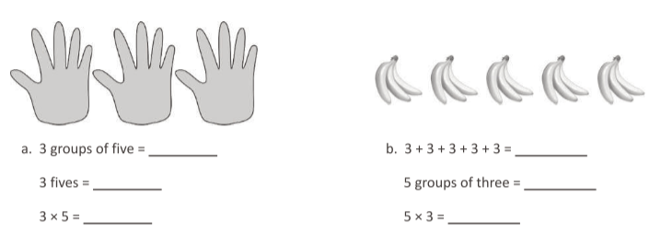
Question from Eureka Math: TEKS Edition, Grade 3, Modules 1 & 2. Learn Book.
Do these questions align with the mathematics TEKS for third grade that we reviewed in class?

Do these questions provide multiple entry points for a student? If so, how?

How might students struggle with these questions? How would you help struggle productively through those challenges?

