Exit Ticket - Answer Key

Lesson 4.07: Productive Struggle: Strategies in Action
Name:
Date:
Review the mathematics questions below and respond to the questions that follow.
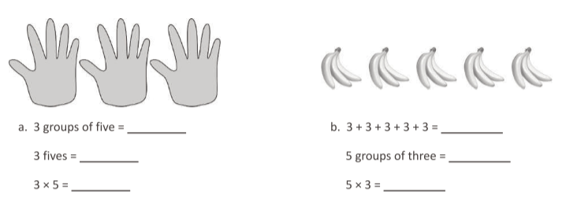
Question from Eureka Math: TEKS Edition, Grade 3, Modules 1 & 2. Learn Book.
Do these questions align with the mathematics TEKS for third grade that we reviewed in class?
Yes
Do these questions provide multiple entry points for a student? If so, how?
All the answers for question (a) are the same, and all the answers for question (b) are the same. However, the prompts ask the students to think about multiplication in different ways, which gives them options for how to solve the questions.
How might students struggle with these questions? How would you help struggle productively through those challenges?
They might not understand that the questions are asking the same thing (i.e., 3 groups of five = 3 fives = 3 X 5). During the lesson, you could emphasize that multiplication is the idea of equal groups of objects and that the idea can be represented in different ways.

